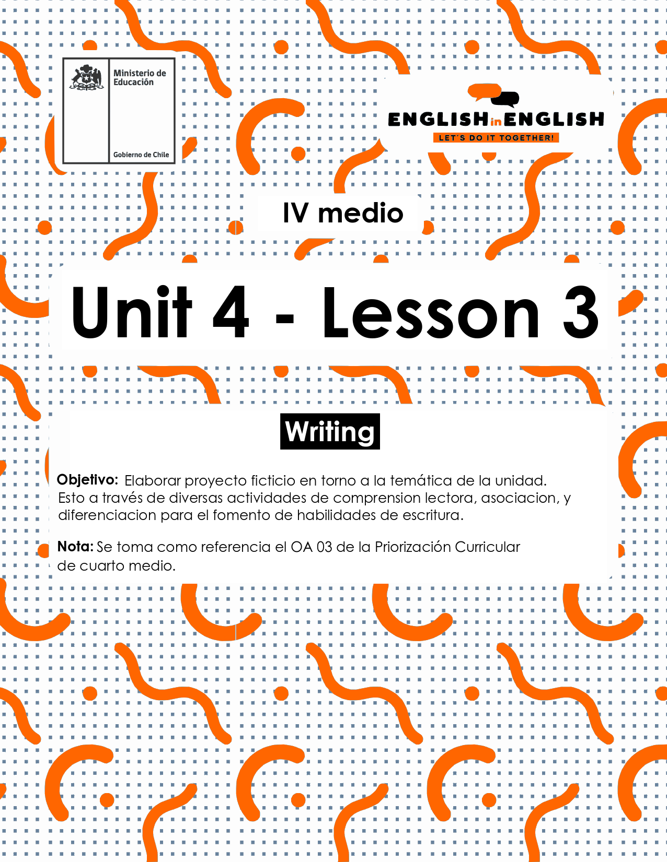

UNIT 4
LESSON 3

SECTION 1: SETTING THE CONTEXT

Hello Students, welcome back to lesson 3. In this lesson we will rehearse writing skills by considering the topic of successful technological gadgets.
- Look at the following images of creative, innovative and successful technological gadgets and answer the following questions.
. 
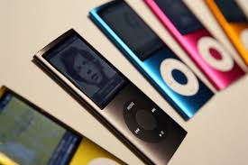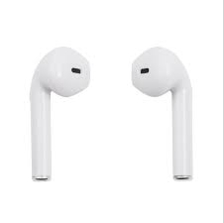
- Why do you think these gadgets are successful?

- Which one would you consider the most creative one(s) and why?

- Which one (s) would you consider the most innovative and why?

- Which one(s) do you like the most and why?

- People say that the fastest-changing gadgets are cellphones. They started as very large devices to call other people and evolved into very small smartphones. Thinking of the evolution and change of this device, answer the following questions:
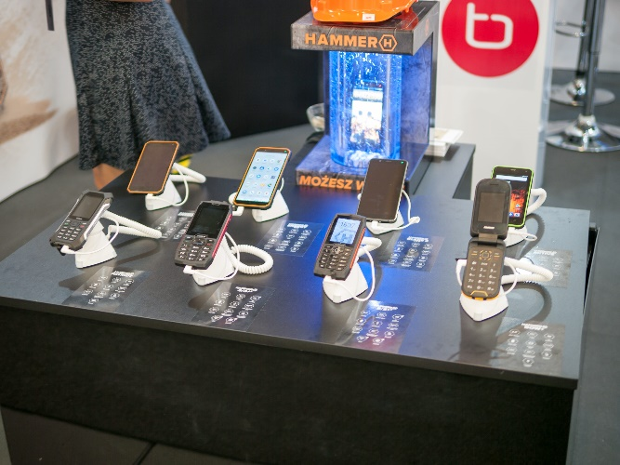

  - When you change your phone, what do you look for in the new one?

  - Does the brand and the model mean something for you to select a new phone? Please explain.

  - What do you value the most, a low price cellphone that may not be as good as you think, or a very good quality cellphone that is more expensive? Why?

SECTION 2: LET’S PRACTICE
- For a gadget to be successful it needs to have several positive features. For example, it needs to be practical, it needs to be light and it needs to be economic. Read about these TOP innovative gadgets for cell phones and answer the following questions:

- Digital Highlighter
This device works as a highlighter, but it's even better because it helps store the parts of the text you need to highlight in a digital format. So much for conventional highlighters!
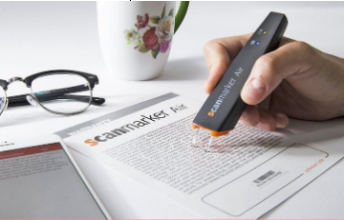 | How would you use the digital highlighter for your studies?

Projector
A smartphone projector! This is totally cool for those who prefer watching TV shows and movies on a small screen. Turn a wall in your room into a cinema – all you need is this amazing gadget!
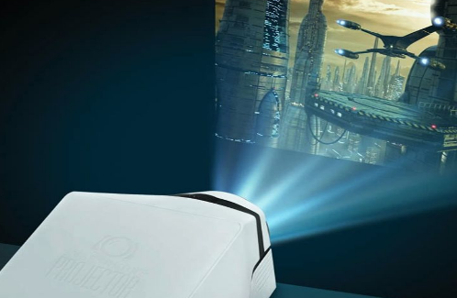 | What would you project first using this gadget?

Smartphone Sterilizer
There have been many reports on how unhygienic smartphones are, so here is a whole new device to sterilize your gadget. Say bye-bye to bacteria!
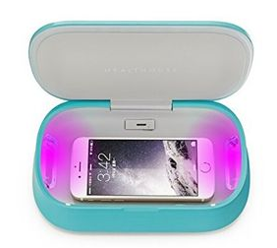 | Can you give a good reason for using this device?

Smartphone with keyboard projector
Keyboard projectors are a new hit in the smartphone gadget industry. Some of the manufacturers have even introduced phones with this inbuilt technology
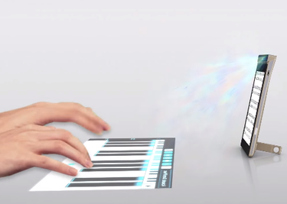 | Why would people be interested in buying this gadget?
Adapted from https://gforgadget.com/best/smartphone-accessories-and-gadgets/
- Create a list of positive features for gadgets to be successful in the market. Use the letters given to complete the features.

A successful gadget needs to be | F | Example. Fun
A successful gadget needs to be | R
A successful gadget needs to be | E
A successful gadget needs to be | B
A successful gadget needs to be | D | Dynamic
A successful gadget needs to be | A
A successful gadget needs to be | U

- Now, it is time for you to create sentences by using the words your complete.

FUN | Example. Gadgets are fun, I really love them!
Reliable
Excellent
Best
Dynamic
Awesome
Useful

- “Ballie” was the most successful gadget this 2020. Read the text, look at the picture and give 2 reasons for Ballie’s success:
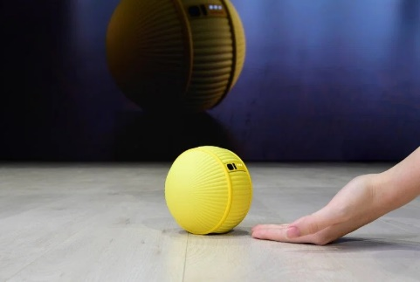
The worldwide famous Korean brand “Ballie” is an interesting combination between smart home device and robotic companion. The ball-shaped gadget, equipped with cameras and sensors used to follow you around, can control various smart home features, take photos, send you updates about your home when you’re away, and even function as a fitness assistant. Designed to be an “all-around life companion,” Ballie might be cute enough give your pup a run for its money.

Reason 1 for success

Reason 2 for success
Taken from https://time.com/5761770/best-ces-2020/

SECTION 3: LET´S CONSTRUCT AND APPLY OUR KNOWLEDGE

- For this week project. You need to create a handbook that includes key tips for a gadget to be successful, effective, innovative, etc.… For this,
  - Brainstorm as many positive adjectives you can in one minute.
Example,

Beautiful, colorful, flexible, light,

  - Make statements with the adjectives by using structure It needs to have + adjective and the structure It needs to be + adjective
Example:
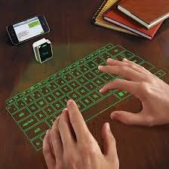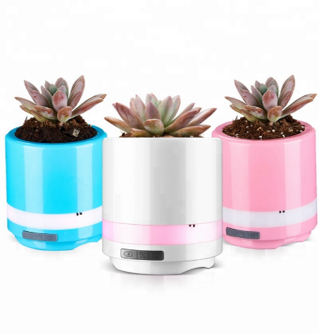

It needs to have advanced technology it needs to be colorful!

C. Create your handbook with at least 8 tips. Use this template.
My 10 tips handbook for a gadget to be successful

- It needs to have a good price.

SECTION 4: Extra activity

- Think about 2050 and make a drawing of the evolution of these gadgets and write one unique feature.

This Gadget in 2020 | Gadget Drawing for 2050

