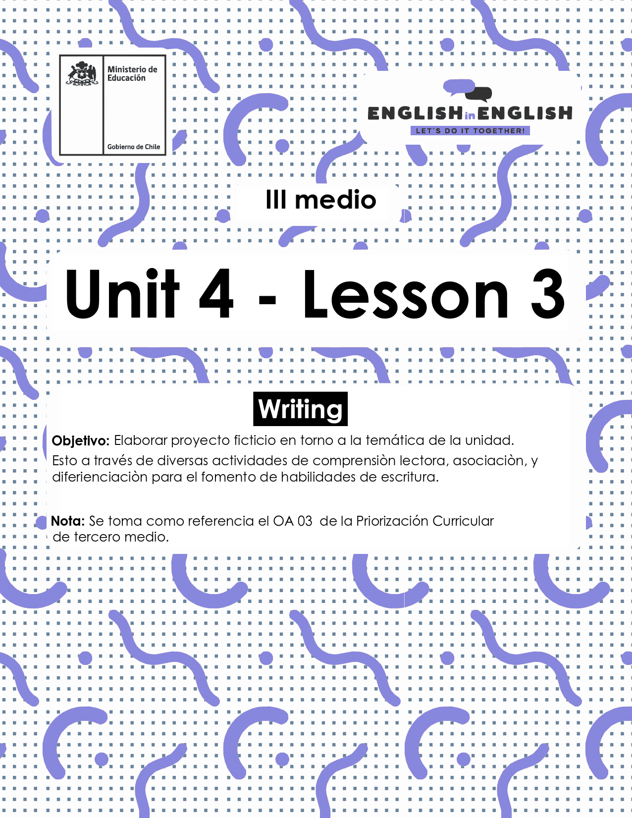

UNIDAD 4
LESSON 3

ÚTILES

- Texto del estudiante de 3° medio.
- Diccionario de inglés.
- Lápices
- Cuaderno de asignatura.

SECTION 1: SETTING THE CONTEXT

Hello Students, welcome back to lesson 3. In this lesson we will rehearse our writing skills by creating a fictious volunteer programme that considers your interest and ideas.
- In Chile, there are different international volunteer opportunities for people interested in helping others without receiving an economic retribution. Read the following charts with Volunteer opportunities and fill in the gaps with words from the box.
Services- Everyone- Protests- Skills- Emergencies- Nature

Volunteer Opportunities
GREENPEACE
Area of volunteer programme | World and protection
Objective | working for a green and peaceful future for __________________
Logo or Motto of the programme | 
Activities they do | They do street campaigning, event management, lectures, petitions, , and fundraising

REDCROSS
Area of Volunteer programme | Health S
Objective | to deliver vital services – from providing relief and support to those in crisis, to helping you be prepared to respond in E .
Logo or Motto of the programme | Sleeves Up. Hearts Open. All Inn.
Activities they do | provide compassionate care, donate blood, teach life-saving S , among others
Adapted from https://www.redcross.org/volunteer/become-a-volunteer.html and https://workfor.greenpeace.org/volunteer/

- Look at the following pictures about the National Volunteer Centre (NVC) from PIAP in Chile and answer the following questions.
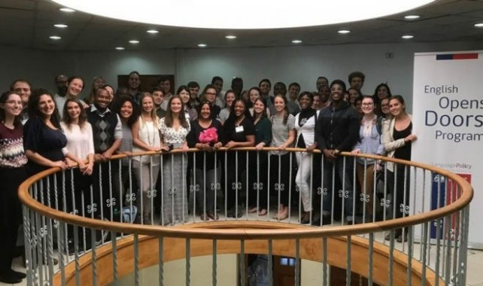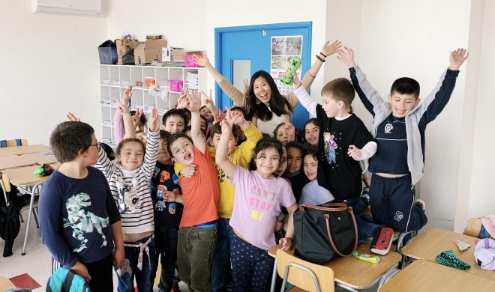
Answers may vary
- What do you think the National Volunteer Center (NVC) do in Chile?

- Can you guess the number of volunteers the programme brings to Chile every year?

- Can you guess the nationalities the volunteers come from?

D) Can you guess some requirements volunteers need to comply with to be accepted at CNV?

E) Why do you think these volunteers come to Chile?

- In the last week worksheet, you created an acrostic poem with the word VOLUNTEER. Now, you need to create three sentences with the following acronym.
Answers may vary
National | Example:  The National volunteer center is a good programme for Chile as it supports education in Chilean schools.
Volunteer
Center

SECTION 2: LET´S PRACTICE

- Read the following text and check if you guessed correctly in the previous exercise. If not, please correct your answers:
The National Volunteer Center is an educational volunteer programme, and part of the English Opens Doors Program, supported by the Chilean Ministry of Education and the United Nations Development Programme-Chile. The National Volunteer Center recruits native and near-native English speakers from all over the world with the objective of working as teaching assistants in Chilean classrooms, specifically to help students’ listening and speaking skills. The volunteering programme lasts for 6 months, although they can extend for the time they want, and most of them stay for a full year because they love the experience. The motto of the programme is “Dare to share!” because they know that sharing is caring.
Every volunteer works with a Chilean teacher of English, helping them creating activities for their classroom. They also help to increase their students’ motivation to learn and use English because they only use this language to interact with them.
Volunteers also assist their teachers and students with other initiatives of the English Opens Doors Program, such as debates, English Weeks for students, and English Camps.
Volunteers teach and encourage the study of English while living with Chilean host families and interacting with members of the local community. Up to this date, the National Volunteer Center has helped over than 25.000 students!
Texto adaptado de http://centrodevoluntarios.cl/the-english-opens-doors-program/

- Answer the following questions based on the reading:
- What type of work do volunteers do with the Chilean students?

- How long is the volunteer programme?

- What do you think “Dare to share? means”

- Why do you think volunteers motivate students by using English?

- What are the three activities that volunteers help with?

- Why do you think that volunteers live with host families?

- Imagine that you apply to have a volunteer from the National Volunteer Center in your school, then answer the following questions:
- How would a volunteer benefit your English classes?

- How many students would the volunteer benefit?

- What semester would be the best time to have a volunteer? Why?

- What extra activities does your school have that the volunteer would help you with? For example, English day, English week, Debates tournament

- Why is your local community good for a volunteer?

- Having a good and attractive motto is an excellent way to promote a volunteer programme. What do you think these mottos are from?
Read the following mottos and write the area of volunteer work they belong to.
Answers may vary.
Mottos | Volunteer work area
The last step, the most important | e.g. Health services
Nurture peace, global disarmament and non-violence
One of the greatest gifts you can give is your time to them
It takes hands to build a house, but it takes hearts to build a home

SECTION 3: LET´S CONSTRUCT AND APPLY OUR KNOWLEDGE.

- For this week final project, you will create a fictious volunteer programme by considering your interest and ideas of activities to support people in your country.

- Start by brainstorming all your interest to design a volunteer programme. Take a couple of minutes and select one

Examples:

Education

- Give a reason for your choice:

- Create a programme overview by considering the lasting of the implementation, activities included, resources to be used, people and sponsors involved, etc. You can also add pictures or drawings to make your programme attractive.

(Add the Title of you volunteer programme)

Area of volunteer programme
Objective
Logo and Motto of the programme
Country of implementation
Lasting of the implementation
Number of people the programme will help
Resources needed
Key Sponsors
Key activity 1
Description
Key activity 2
Description
Key activity 3
Description

Add Photos or drawings from your programme


SECTION 4: SPONGE ACTIVITY

Complete the chart with the activities the pictures show. Answers may vary
REDCROSS | PIAP Volunteer Programme | GREENPEACE

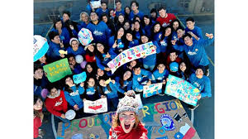 |  | 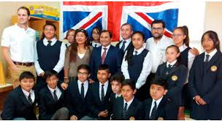
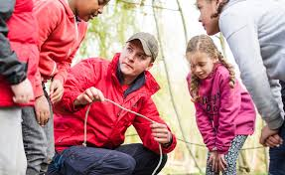 | 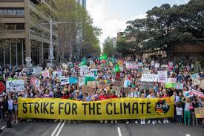 | 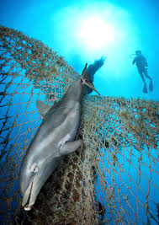
 | 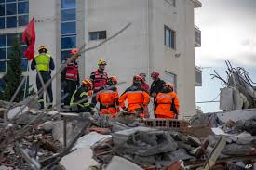 | 

