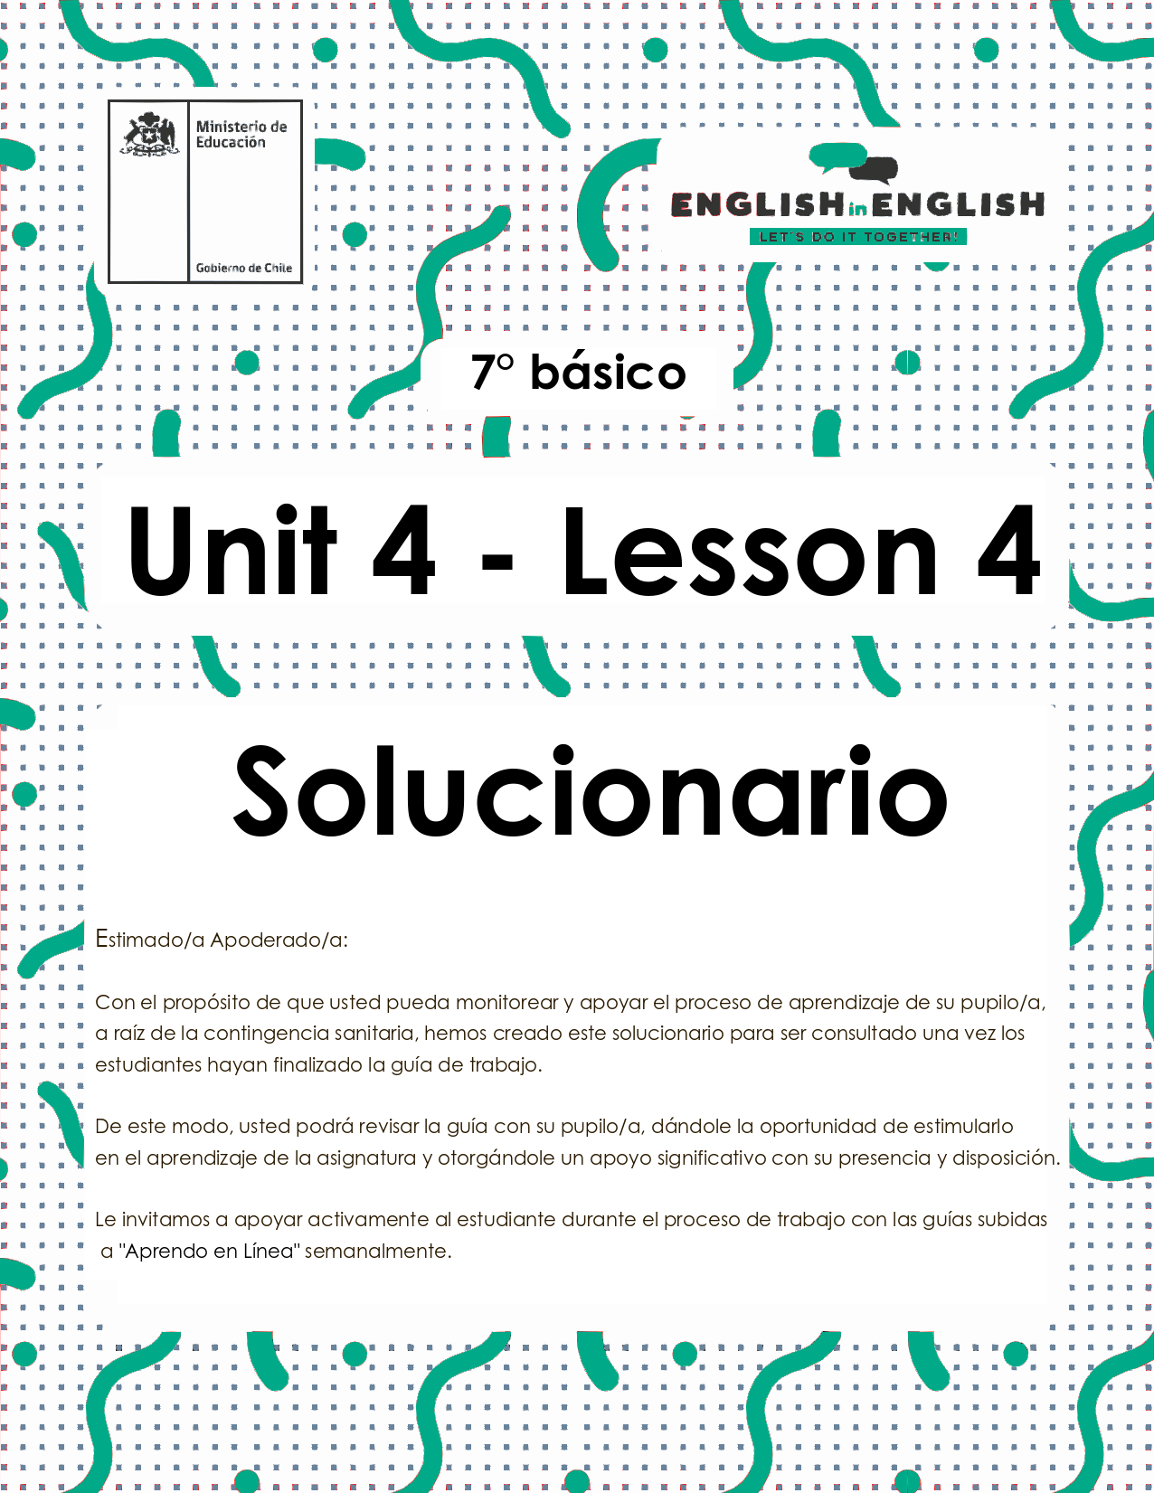
UNIT 4
LESSON 4

GUÍA PARA USAR EL SOLUCIONARIO

- ¿Qué es un solucionario?
- Un solucionario incluye las respuestas a todas las preguntas y actividades.
- Algunas de las preguntas tienen más de una posible respuesta.
- Algunas de las preguntas tienen una sola respuesta.

- ¿Cómo revisar mis respuestas?
- Encontrarás los títulos:
- Respuestas
- Respuestas abiertas

- Las respuestas pueden estar en:
- Negrita
- Subrayado
- Sombreado con colores
- Encerradas
- Destacadas
- Tachadas

- Ejemplos:

1. What are the people doing?
Respuesta abierta.
Example: They are recycling to take care of the environment.

Respuestas:
__B__ | a-People who buy plastic bags could keep on doing so.
SECTION 1: SETTING THE CONTEXT
Our environment
1. Read this statement and answer.
- Lee este enunciado y responde.
“Take care of the environment and
it will take care of you”
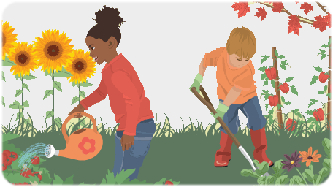

- How can you help to take care of the environment? Give 2 examples.
Respuesta abierta.
Examples:
- Using cloths bags instead of plastic bags.
- Switching off electronic devices after using them.

B. Why is it important to take care of the environment?
Respuesta abierta.
Example: Saving our earth and its environment becomes highly important as it provide us food and water to sustain life.

C. What environmental problems do you know? Mention 2.
Respuesta abierta.
Examples:
- Deforestation
- Air pollution

2. Identify the possible solutions for the corresponding environmental problems. Match them.
- Identifica las posibles soluciones para los correspondientes problemas medioambientales. Relaciónalos.
Respuestas:

Possible solutions
- Use renewable energy
- Protect wetlands
- Plant trees near bodies of water
- Create biodiversity action plans
- Replace fossil fuels with solar and wind energy
- Separate residential zones from noisy places like airports.

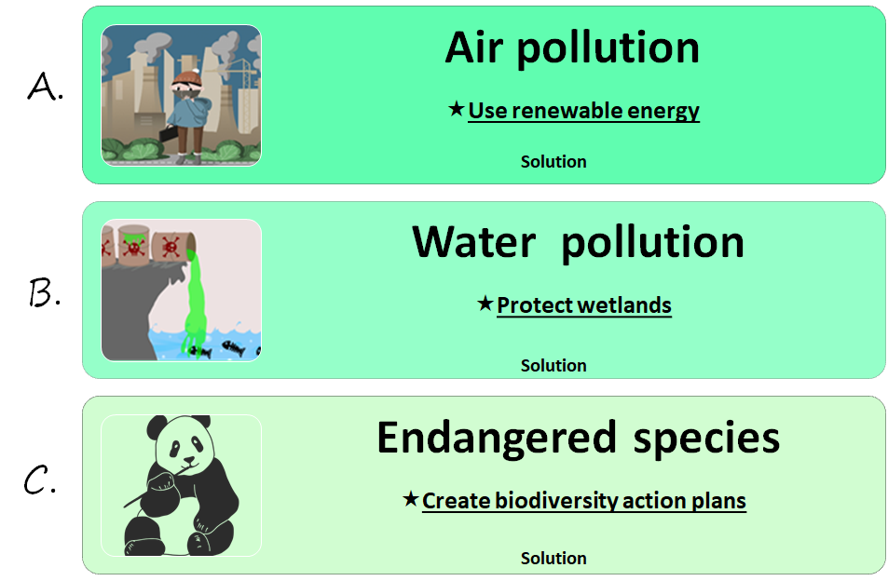
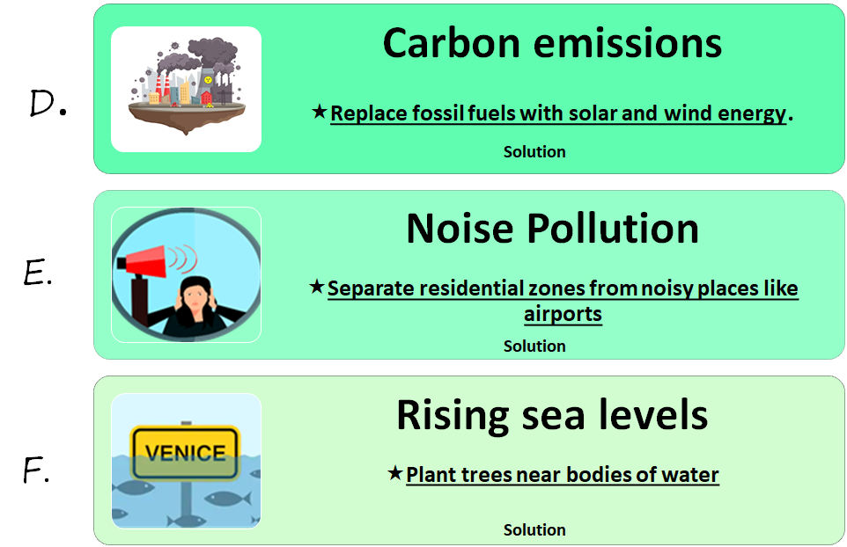
3. Read the following statements and mark them as (G) good or (B) bad for the environment.
- Lee los siguientes enunciados y márcalos como buenos (G) o malos (B) para el medio ambiente.
Respuestas:

__B__ | a-People who buy plastic bags could keep on doing so.
__G__ | b-Cars could emit less carbon dioxide by using other types of fuel.
__B__ | c-Urban areas could throw more waste in the sea.
__G__ | d-People should donate old clothes and books.
__B__ | e-We should buy toxic products such as motor oil and pesticides.
__G__ | f-Set up a compost container at home.

SECTION 2: LET'S PRACTICE
Why should we recycle?
1. Before reading the text, answer the questions.
- Antes de leer el texto, responde las preguntas.
Respuesta abierta.
Examples:

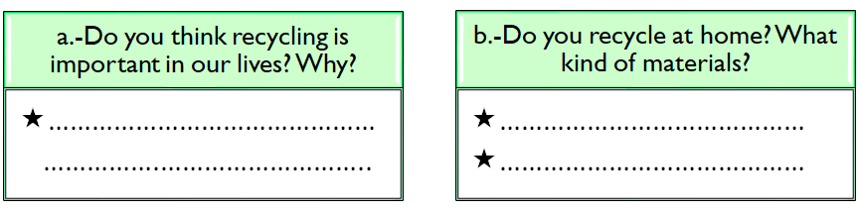
Yes, it is important because we can save energy and reduces de greenhouse carbon emission.
Paper
Glass and plastic bottles

2. Read the text.
- Lee el texto.
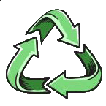
Why should you recycle?
If everyone reduced, reused, and recycled, we could make Earth's resources go an awful lot further. Recycling saves materials, reduces the need to landfill and incinerate, cuts down pollution, and helps to make the environment more attractive. It also creates jobs, because recycling things takes a bit more effort than making new things. Recycling doesn't just save materials: it saves energy too. Manufacturing things uses a lot of energy from power plants—and hungry power plants generally make global warming worse. We can save a surprising amount of energy by recycling. If you recycle a single aluminum can you save about 95 percent of the energy, it would take to make a brand new one. That's enough energy saved to power your television for about 3 hours! You'll often hear people say that over half the trash we throw away can be recycled. Looking at the chart below, you can see that we currently recycle somewhere between 30–90 percent of the various different materials we use. Just imagine if everyone were recycling most of their garbage: together, we'd be making a tremendous reduction in the amount of raw materials and energy we use—and doing a lot of good for the planet.
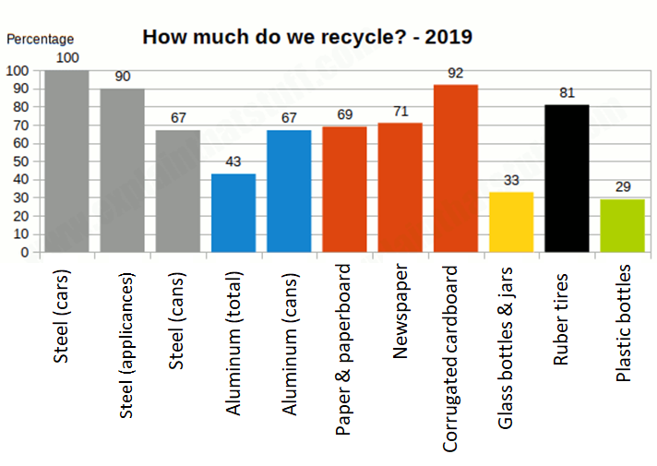
https://www.explainthatstuff.com/recycling.html
Vocabulary:
raw materials: materias primas go an awful lot further: ir mucho más lejos

3. Decide if these sentences are Correct (C) or Incorrect (I) according to the text.
- Decide si estas oraciones son correctas (C) o incorrectas (I) de acuerdo al texto.
Respuestas:
___C___ | - Humans should recycle to make the environment more attractive
___C ___ | - Power plants increase global warming
___I____ | - Humans recycle between 20 to 40 percent of different materials
___I____ | - Newspapers are the most recycled materials by people
___C___ | - Plastic bottles are the less recycled materials
___I____ | - Recycling just saves materials

4. Complete the drawing with information from the text.
- Completa el dibujo con información del texto.
Respuestas:
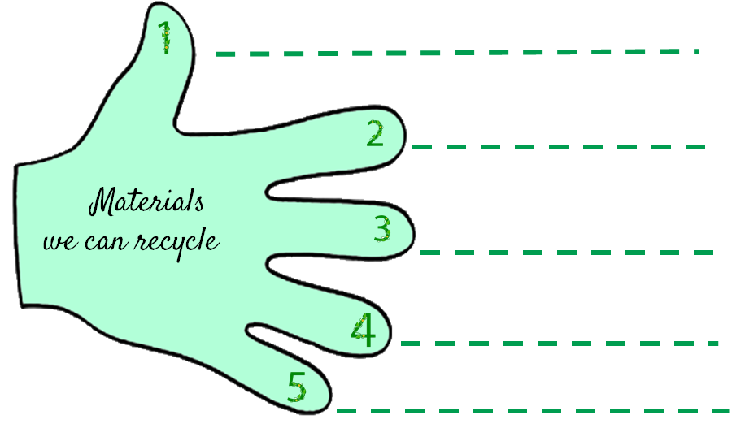
Newspaper
Plastic bottles
Corrugated cardboard
Glass bottles
Aluminum cans
SECTION 3: LET´S CONSTRUCT AND APPLY OUR KNOWLEDGE
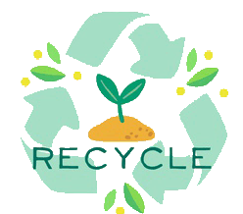
How green am I?
- Complete the organizer.
- Completa el organizador.

Respuesta abierta.
Example:

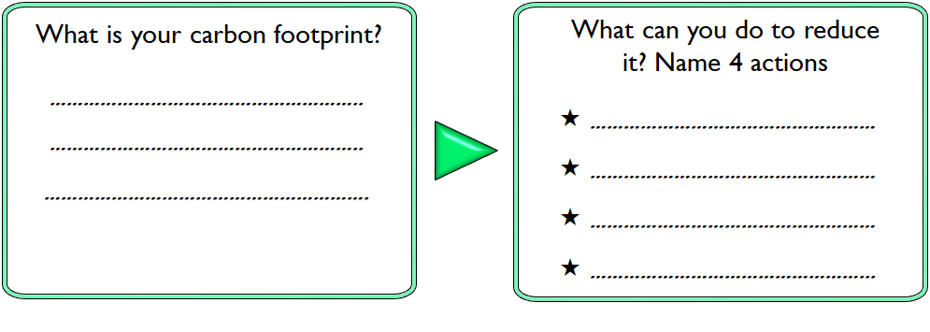
Set up a compost container.
Reduce food waste.
Eat less meat and dairy.
Using LED light bulbs.
My carbon footprint is the total amount of Greenhouse gases generated by my action or activities.

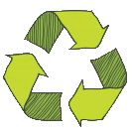
- Complete the chart about how to reduce your carbon footprint.
  - Completa el cuadro acerca de cómo reducir tu huella de carbono.

Respuesta abierta.
Example:

 | Reduce | Reuse | Recycle
Definition | Minimize the amount of material and good we consume. | Using items more than once. | Putting a product to a new use instead of throwing it away.
Examples at home | 1. Eating less meat and dairy products.  2.Reduce buying non- essential items. | 1. Reuse clothing to 2. Make cloth bags. | 1.Buying recycled items.  2. Food waste.
Examples at school | 1.Reduce energy waste.  2. Eat less dairy products | 1. Reuse books.  2. Reuse paper | 1. Set up a glass, plastic, paper and aluminum collectors.  2. Recycling program.

- Answer the questions.
  - Responde las preguntas.

Respuestas abiertas.
Example:

HOW GREEN ARE YOU?

- Do you sort out glass, paper, plastic bottles and cans?
- Yes, always
- Sometimes
- Never
- Do you buy fair trade products or organic or local food?
- Yes, always
- Sometimes
- Never
- Do you use your own shopping bags?
- Yes, always
- Sometimes
- Never
- Do you recycle light bulbs and used batteries?
- Yes, always
- Sometimes
- Never
- Do you always dispose of garbage in a proper way?
- Yes, always
- Sometimes
- Never
- Do you bother picking up other people´s litter?
- Yes, always
- Sometimes
- Never
- Do you switch off the lights when you leave a room?
- Yes, always
- Sometimes
- Never
- Do you switch off other electric appliances at night? (TV, computer…)
- Yes, always
- Sometimes
- Never
- Do you put on warmer clothes when it's cold instead of putting on the heating?
- Yes, always
- Sometimes
- Never
- Do you have showers instead of baths?
- Yes, always
- Sometimes
- Never
- Do you close the tap while you brush your teeth?
- Yes, always
- Sometimes
- Never
- Do you leave the fridge door closed when you do the cooking?
- Yes, always
- Sometimes
- Never

Points | Yes, always |  | 3
Points | Sometimes |  | 2
Points | Never | 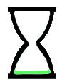 | 1

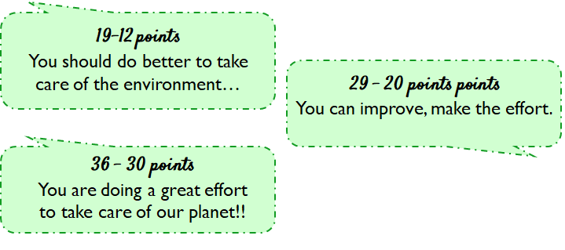

Total points: 32
You can improve, make the effort.

SECTION 4: EXTRA ACTIVITY
3 R’s Poster
1. According to the three R’s to protect the environment against global warming, design a poster using the 3 R’s and the imperative form of the verbs: “reduce, reuse and recycle”.

- De acuerdo a las 3 R’s para proteger el medio ambiente contra el calentamiento global, diseña un póster usando las 3 R’s y la forma imperativa de los verbos: “reduce, reuse and recycle”.
Example:
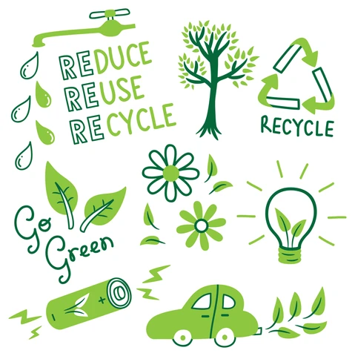

SECTION 5:
Digital Resources
Take a look at these links!

- https://bdescolar.mineduc.cl/info/cleaning-up-the-earth-00046337
- https://learnenglishkids.britishcouncil.org/word-games/environment
- https://www.nationalgeographic.org/education/
- https://www.nationalgeographic.org/education/resource-library/?q=&page=1&per_page=25&subjects=Conservation
- https://kids.britannica.com/kids/article/environment/399445
- http://www.recycling-guide.org.uk/
- https://bdescolar.mineduc.cl/info/recycling-earths-resources-00046329

NO OLVIDAR REPASAR EL CONTENIDO CON UN ADULTO

