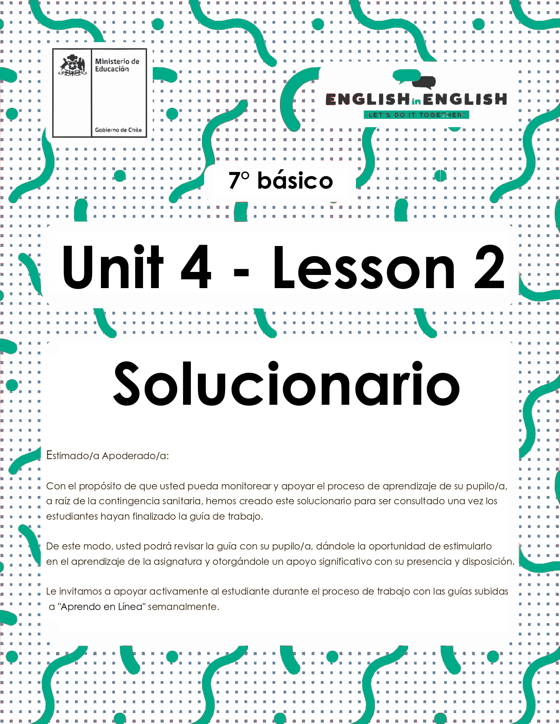

UNIT 4

LESSON 2

GUÍA PARA USAR EL SOLUCIONARIO

- ¿Qué es un solucionario?
- Un solucionario incluye las respuestas a todas las preguntas y actividades.
- Algunas de las preguntas tienen más de una posible respuesta.
- Algunas de las preguntas tienen una sola respuesta.

- ¿Cómo revisar mis respuestas?
- Encontrarás los títulos:
- Respuestas
- Respuestas abiertas

- Las respuestas pueden estar en:
- Negrita
- Subrayado
- Sombreado con colores
- Encerradas
- Destacadas
- Tachadas

- Ejemplos:
Respuesta abierta.

Respuestas:
“Electric cars get creative sounds so they could replace engine noise.”
- a problem
- a solution
- a problem and a solution

SECTION 1: SETTING THE CONTEXT
Pollution

- Observe the image and answer the questions.
- Observa la imagen y responde las preguntas.

Respuesta abierta.

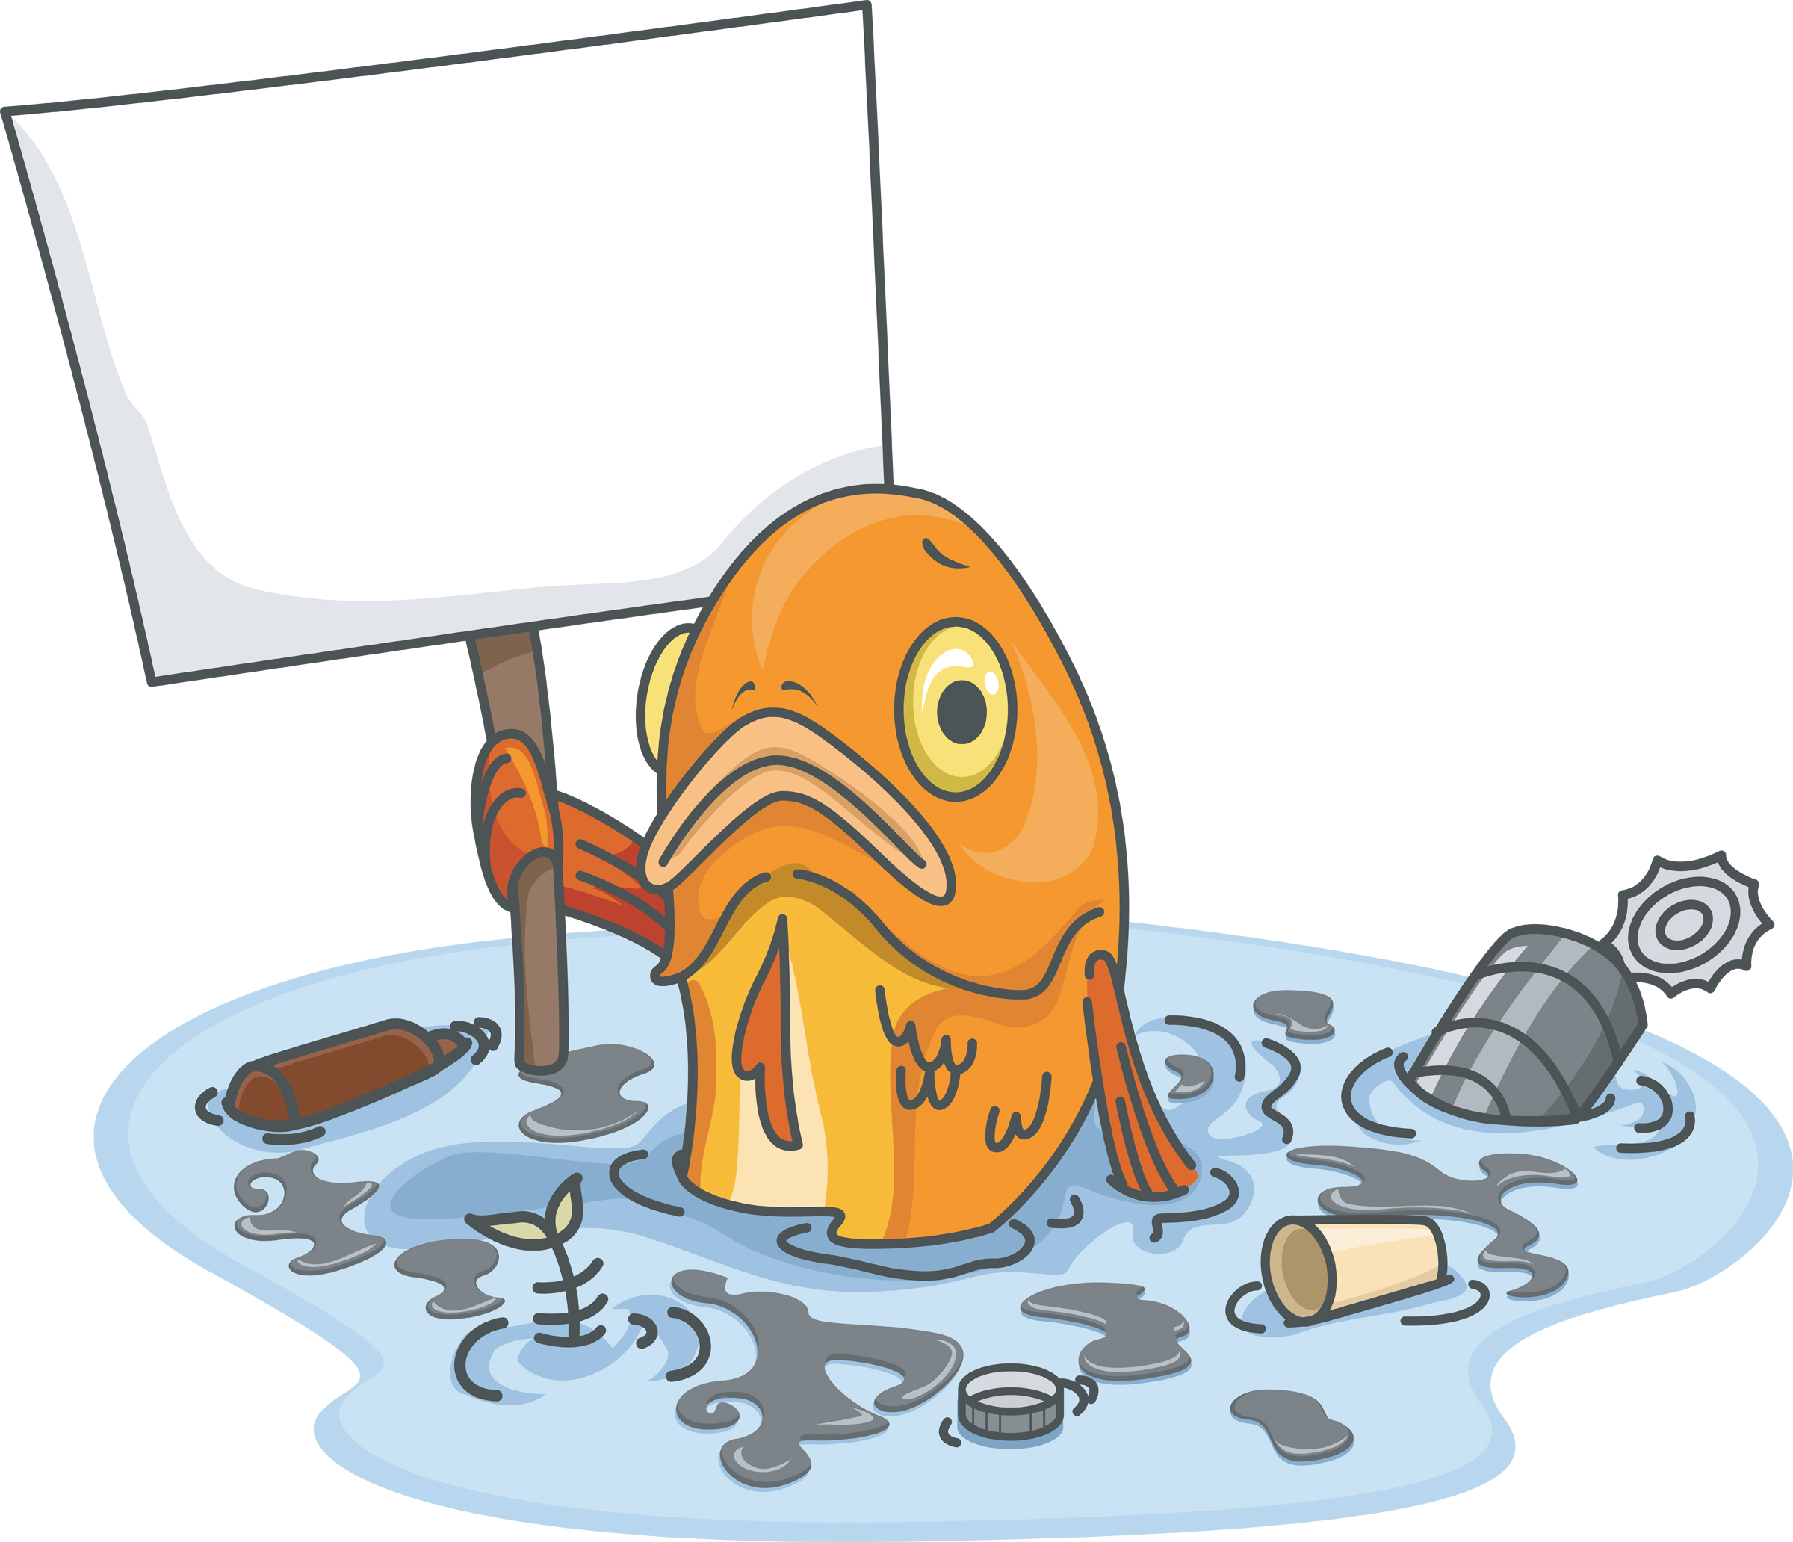 | - Do you remember What is the meaning of pollution from lesson1? Write 2 associated words related to it:  - Water  2) Land  - What types of pollution do you know? Name at least 2:  1) Noise Pollution  2) Air pollution  - In your opinion, what is the fish trying to say/express?  The fish is asking to save and protect it  - What type of pollution does the image represent?  It represents water pollution

2. Match the images with the corresponding types of pollution.
- Une las imágenes con los tipos de contaminación correspondiente.
Respuestas:
Type of pollution |  | Image
- Air pollution |  | 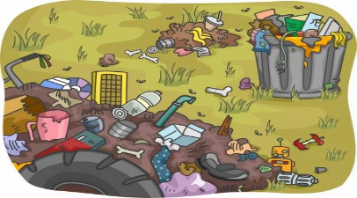  Land /soil pollution
- Water pollution |  | 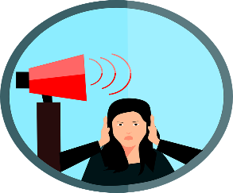  Noise Pollution
3) Land/soil Pollution |  | 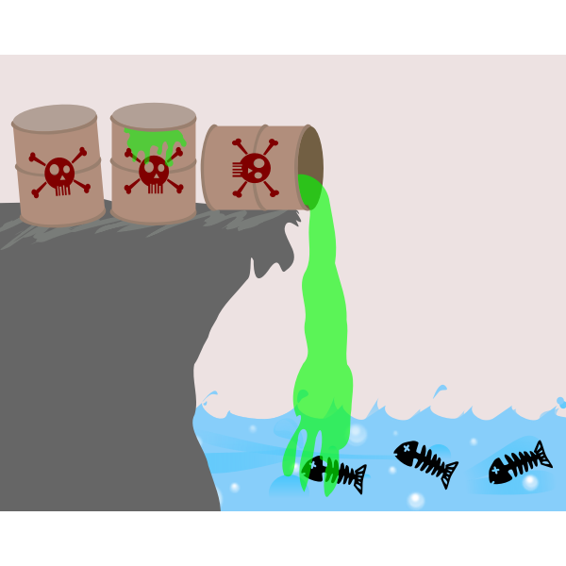  Water Pollution
4) Noise pollution |  | 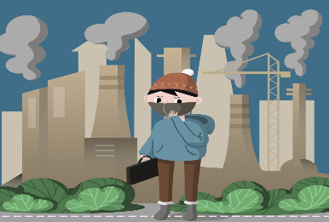  Air pollution
3. Observe the images and the sentences. What do they represent? Choose the correct alternative. Follow the example.
- Observa las imágenes y las oraciones. ¿Qué representan? Elige la alternativa correcta. Sigue el ejemplo.

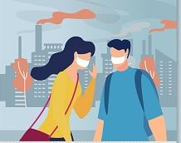 Respuestas: “To fight against air pollution, we could plant more trees”
Problem Solution
- a problem
- a solution
- a problem and a solution

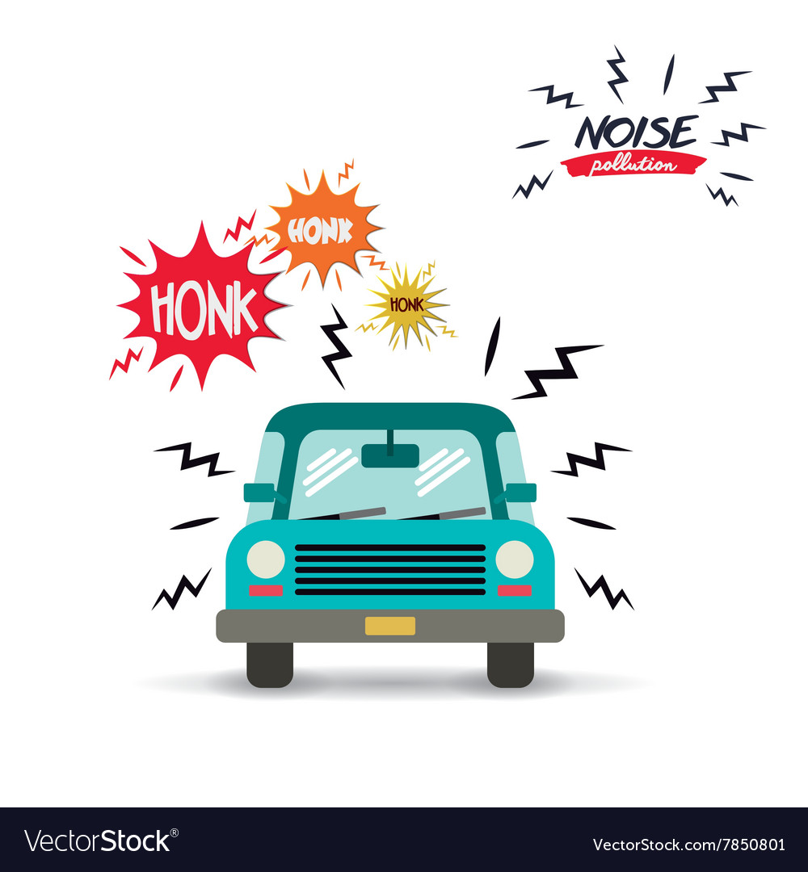 “Electric cars get creative sounds so they could replace engine noise.”
- a problem
- a solution
- a problem and a solution

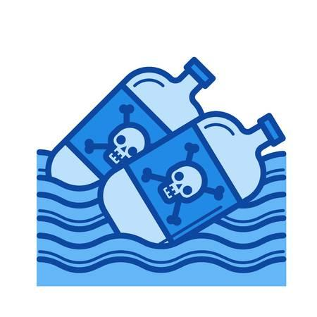“The littering of plastic in the lakes and rivers has made the river water dirty and toxic”
- a problem
- a solution
- a problem and a solution
4. Match the phrases from column A with phrases from column B in order to get a meaningful sentence.
- Une las frases de la columna A con las frases de la columna B para obtener una oración significativa.

Respuestas:

A |  | B
The mining industry |  | could burn less chemicals.
People who buy plastic bags |  | could emit less carbon dioxide.
Factories |  | could not throw waste in the sea.
Cars |  | could use renewable energy.
Urban areas |  | could switch to other materials.
Answers
Example: The mining industry could use renewable energy.

1-. People who buy plastic bags could switch to other materials.
2-. Factories could burn less chemicals.
3-. Cars could emit less carbon dioxide.
4-. Urban areas could not throw waste in the sea.

SECTION 2: LET'S PRACTICE
Water Pollution

1. Observe the image below and answer the questions.
- Observa la imagen de abajo y responde las preguntas.
Respuestas abiertas.
Examples:

a) What is happening in the image? Water is contaminated.
b) What do you think the topic of the text will be? It will be about water pollution.
c) How can it affect the environment? Give an example It can affect killing sea life.
2. Read the text.
- Lee el texto.

What is water pollution?
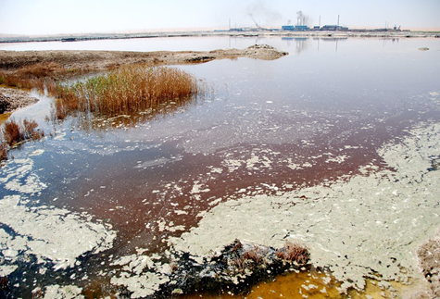
1. First, water pollution is the contamination of water bodies (lakes, rivers, oceans, aquifers and groundwater), very often by human activities. Water pollution occurs when pollutants (particles, chemicals or substances that make water contaminated) are discharged directly or indirectly into water bodies without enough treatment to get rid of harmful compounds. Pollutants get into water mainly by human causes or human factors. Water pollution can be a point-source, non point-source, or transboundary in nature.
2. Second, water pollution is the second most imperative environmental concern along with air pollution. Any change or modification in the physical, chemical and biological properties of water will have a negative consequence on living things.
The water covers over 70% of the Earth’s surface. It is a very important resource for people and the environment.
3. Next, water pollution affects drinking water, rivers, lakes and oceans all over the world. In many developing countries, it is usually an important cause of death, by people drinking from polluted water sources.
More to this, water pollution affects not only individual living species but also populations and entire functioning ecosystems that exist in the waters.
4. Finally, Humans have now realized the importance of clean water as a foundation for life. In recent times, more and more organizations and councils are working hard to educate, protect, restore waterways and encourage practices that help keep waters from contamination, and also to preserve water ecosystems from destruction. So if you want a better world for your family, take care of the water. That is the only way to stop this problem.
Taken from: http://eschooltoday.com/pollution/water-pollution/what-is-water-pollution.html
Vocabulary
pollutants: contaminantes - water bodies: masas de agua - sources: fuentes -
point-source: fuente puntual transboundary: transfronterizo

3. Read the text carefully and decide if the following sentences are correct (C) or incorrect (I).
- Lee el texto cuidadosamente y decide si las siguientes oraciones son correctas (C) o incorrectas (I).
Respuestas:
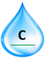 | Water pollution is the contamination of water bodies caused by humans.
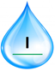 | Water covers over 7% of the Earth's surface.
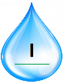 | Water pollution affects a small part of non developing countries.
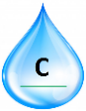 | Air and water pollution are the most imperative environmental concerns.
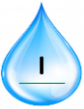 | Humans have not realized yet about the importance of keeping water from contamination.
 | The only way to stop water pollution is to take care of it.

4. Complete the diagrams with information from the text.
- Completa los diagramas con información del texto.
Respuestas:
Water bodies | - Lakes  - Rivers  - Oceans  - Aquifiers  - Groundwater

Pollutants | - Particles  - Chemicals  - Subtances

5. Write a possible solution for water pollution based on the text.
- Escribe una posible solución para la contaminación del agua basada en el texto.

Respuesta abierta.

Example: To fight against water pollution, we could avoid to throw pollutants into the sea.

6. After reading the text, answer these questions.
- Después de leer el texto, responde estas preguntas.
Respuesta abierta.

- Can we live without water? | No, we can’t. Water is the main foundation of life.
- What images are in your mind after reading the text? | There are contaminated oceans, sick people and institutions helping people  keep water from contamination.

SECTION 3: LET´S CONSTRUCT AND APPLY OUR KNOWLEDGE
Pollution: causes and solutions

1. Make a mind map using the given concept.
- Haz un mapa mental usando el concepto dado.

Respuesta abierta.

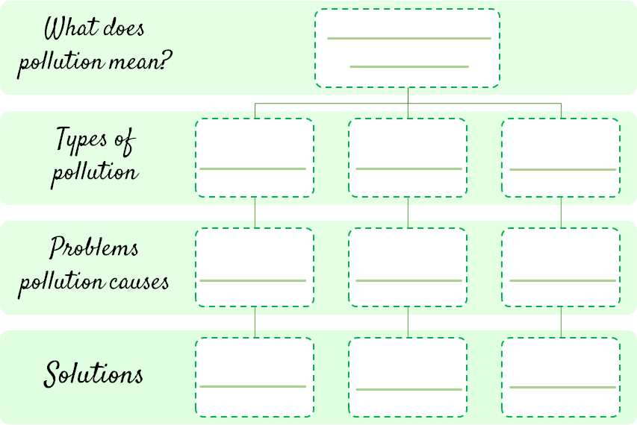
Greenhouse Effects
The introducción of
contaminants into
the natural enviroment
that cause adverse changes
Recycling
Save Water
Save Energy
Global Warming
Deforestation
Land
Water
Air

2. Match the environmental problems with their possible solutions.
- Une los problemas medioambientales con sus posibles soluciones.

Respuestas:

Environmental problems
____C____ Global warming
____A__ _ Endangered species
____D____ Rising of the sea levels
____B____ Rainforest destruction - deforestation

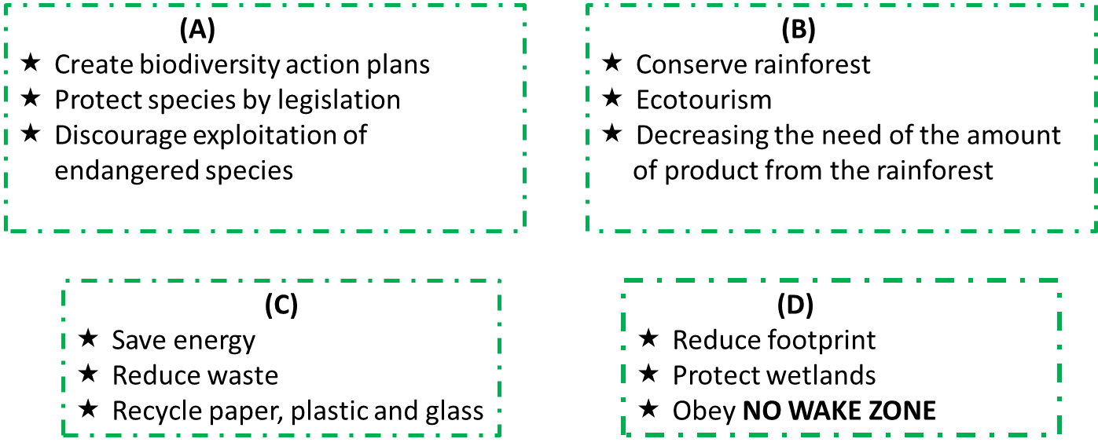

3. How do you think our environmental future will be? Answer the questions, add the points for your answers and check your score.
- ¿Cómo piensas que será nuestro futuro medio ambiental? Responde las preguntas, suma los puntos de tus respuestas y revisa tu resultado.

Respuesta abierta.

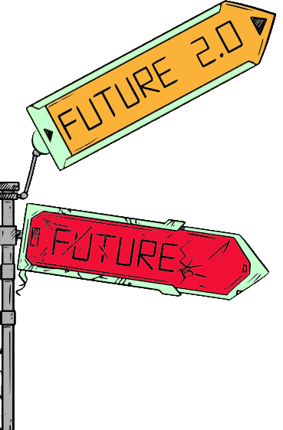
Possible answers
5 points | Yes, definitely
4 points | Yes, it probably
3 points | Maybe
2 points | No, I don´t
1 point | Definitely not

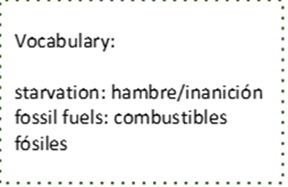
- Do you think there will be less pollution in 20 years? 4
- Do you think people will be healthier in 50 years? 4
- Do you think starvation will be eliminated in 20 years? 2
- Do you think global warming will be stopped in your lifetime? 2
- Do you think the world will be a better place to live in 50 years? 4
- Do you think we will have stopped using fossil fuels in 50 years? 3
- Do you think we will be driving electric cars in 20 years? 5
- Do you think there will be more ecological education in 10 years? 5
- Do you think we will have stopped using plastic bottles in 20 years? 4
- Do you think we will have decreased global warming in 15 years? 2
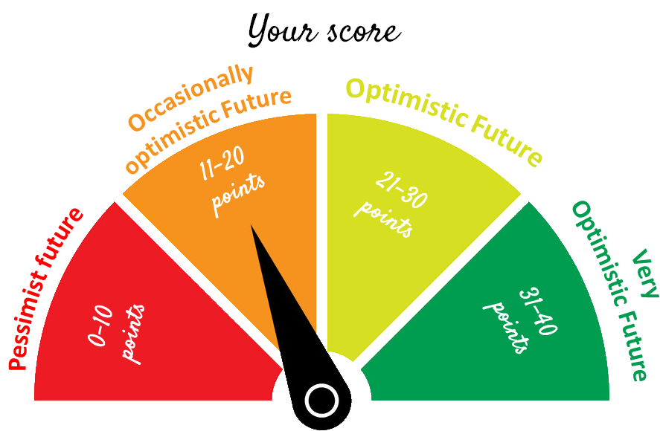

Total points: 35
Very Optimistic Future

SECTION 4: EXTRA ACTIVITY
My polluted city

1. Identify a type of pollution that is affecting your city. Complete the following information: Type of pollution, cause(s), effects and solution(s) and finally draw a poster that represents the type of pollution and a possible solution.
- Identifica un tipo de contaminación que está afectando a tu ciudad. Completa la siguiente información: Tipo de contaminación, causa(s), efectos y solución(es) y finalmente dibuja un póster que represente el tipo de contaminación y una posible solución.

Respuesta abierta.

Example
Type of pollution: “Water pollution” | Poster
- Cause: Mining  - Effects on human, animals and plants, diseases, destruction of the whole ecosystem.  - Solution: Replace fossil fuels by renewable energies. | 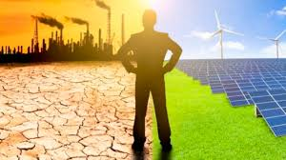

SECTION 5:
Digital Resources
Take a look at these links!
- https://bdescolar.mineduc.cl/info/cleaning-up-the-earth-00046337
- https://learnenglishkids.britishcouncil.org/word-games/environment
- https://www.nationalgeographic.org/education/
- https://www.nationalgeographic.org/education/resource-library/?q=&page=1&per_page=25&subjects=Conservation
- https://kids.britannica.com/kids/article/environment/399445

NO OLVIDAR REPASAR EL CONTENIDO CON UN ADULTO

