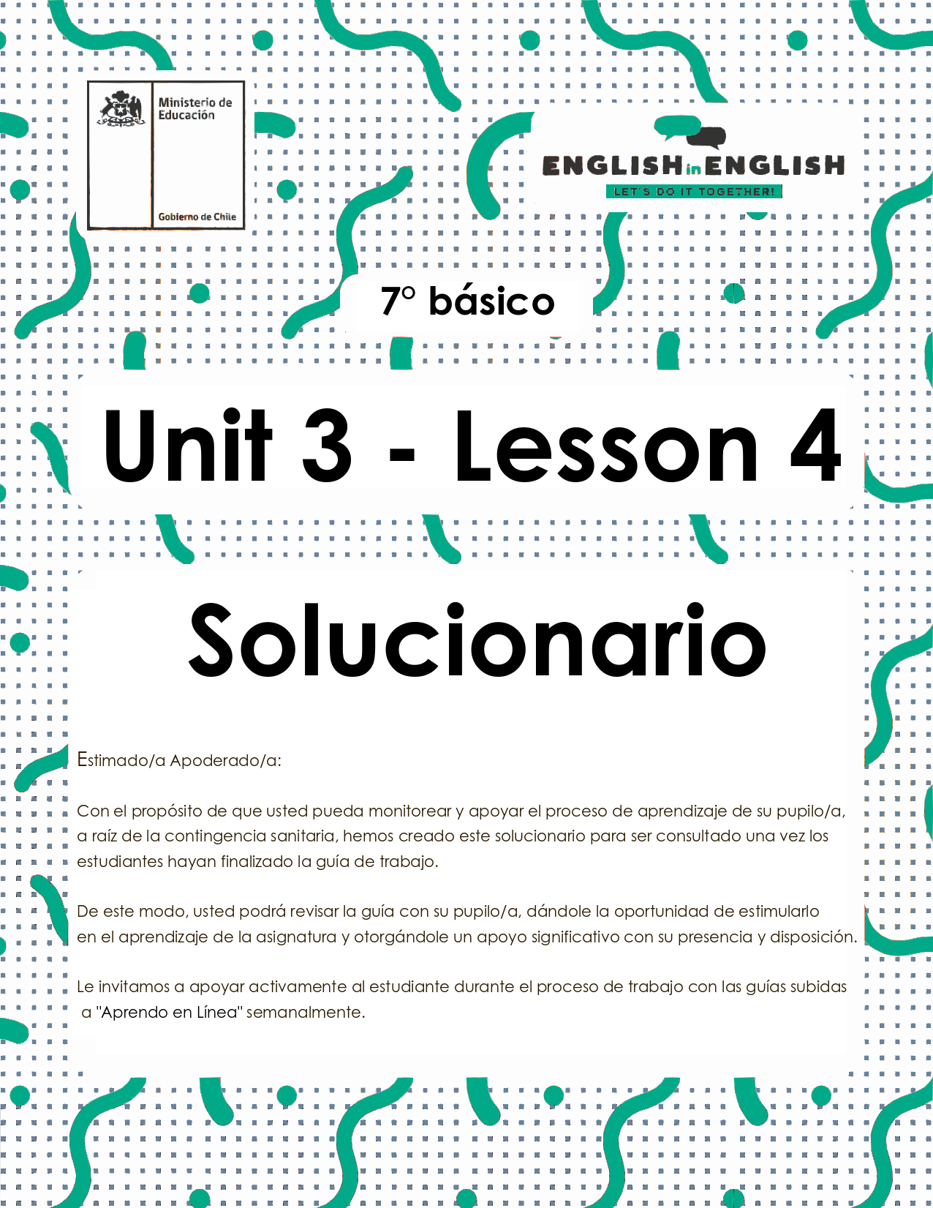
UNIT 3
LESSON 4

GUÍA PARA USAR EL SOLUCIONARIO

- ¿Qué es un solucionario?
- Un solucionario incluye las respuestas a todas las preguntas y actividades.
- Algunas de las preguntas tienen más de una posible respuesta.
- Algunas de las preguntas tienen una sola respuesta.

- ¿Cómo revisar mis respuestas?
- Encontrarás los títulos:
- Respuestas
- Respuestas abiertas

- Las respuestas pueden estar en:
- Negrita
- Subrayado
- Sombreado con colores
- Encerradas
- Destacadas
- Tachadas

- Ejemplos:

Respuesta abierta.
Example: Playing guitar /Collecting stamps/ Taking pictures

Respuestas:
False Tennis started off as an outdoor game.

SECTION 1: SETTING THE CONTEXT

- Read this statement and answer.
- Lee este enunciado y responde.

“Having free time is as healthy as practicing sports and doing exercise”


a) What free time activities do you do? Give two examples.
Respuesta abierta.
Example: Playing guitar /Collecting stamps/ Taking pictures
b) Do you think that practicing sports is important? Why?
Respuesta abierta.
Example: Yes, I think sport is important for our health.

- Complete the name of the sports and free time activities according to the images.
- Completa el nombre de los deportes y actividades de tiempo libre de acuerdo a las imágenes.
Respuestas:

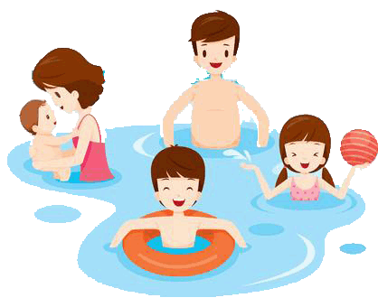 | 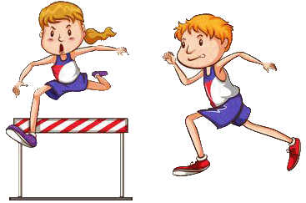 | 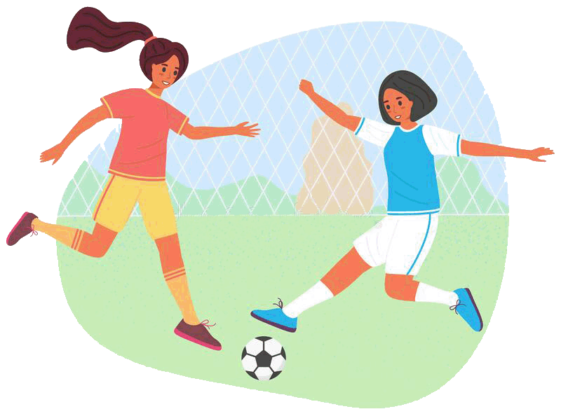
S W I M M I N G | A T H L E T I C S | P L A Y I N G  F O O T B A L L
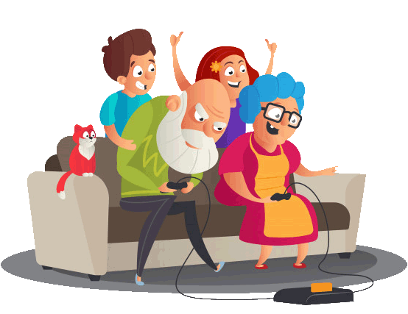 |  | 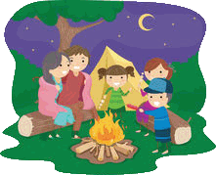
P L A Y I N G  V I D E O  G A M E S | M E E T I N G  F R I E N D S | G O  C A M P I N G

- Write True or False according to the statement. You can use
previous worksheets to help you.
- Escribe Verdadero o Falso según el enunciado. Puedes usar guías
anteriores para ayudarte.
Respuestas:
False Tennis started off as an outdoor game.

True María Fernanda Valdés was part of the Chilean Olympic team in 2017.

False Alexis Sánchez scored the winning goal at Copa America using a bat and a glove.

False Individual sports are: cricket, football, basketball and baseball.

True To practice badminton, you need the following equipment: badminton shoes, grip, t-shirts and shorts, wrist band, headband, badminton racket and a shuttlecock.
True Indoor activity refers to something that happens inside a building; for example: playing card or board games, puzzles or playing video games.

SECTION 2: LET'S PRACTICE
Girls playing football in Kenya

- Before reading the text, write 3 parts of the equipment you need to play football.
- Antes de leer el texto, escribe 3 partes del equipamiento que necesitas para jugar fútbol.
Respuestas:

- T- shirts
- Shorts
- Football shoes

- Read the text carefully.
- Lee el texto cuidadosamente.

Football changes girls' lives in rural Kenya


“We can do it” is the slogan of an organization in Kenya called “Moving the Goalposts”. It uses football to increase self-confidence in girls in Kenya and aims for nothing less than changes in the society. The sound of girls playing football and clapping wildly when they score goals is not a sound often heard in rural Kenya. But here in the Kilifi district, north of the city of Mombasa, it has become fairly common. In this region, around 3,000 girls play football.
Today, on a dusty pitch in the village of Sokoke, 22 girls are playing in a training session, half in blue shirts, and half in red ones. Many are barefoot. The weather is very hot, but the girls are constantly in motion.
But these girls are learning a lot more than just how to pass, kick and score: they are learning how to think in new ways, ways that are unusual for young women in this part of the world.
"It is about a teenage girl realizing her goals in life, making her own decisions, including sexual decisions," Margaret Belewa, program manager of the Moving the Goalposts project said. "Most of the time, those decisions are made by the parents or by the husband. Now, can we help them so that they can take control of their life?
Moving the Goalposts (MTG) aims to empower girls and young women in Kilifi, one of the poorest districts in Kenya, through football.

Key words
increase: aumentar - self-confidence: auto-confianza - aims: intenta barefoot: descalza - empower: empodera

Texts taken and adapted from
https://en.islcollective.com/english-esl-worksheets/grammar/past-simple-or-past-continuous-tense/football-and-extreme-sports/3282

- According to the text, decide if these sentences are Correct (C) or Incorrect (I)
- De acuerdo al texto, decide si estas oraciones son correctas (C) o incorrectas (I).
Respuestas:
- “Moving the Goalposts” is a football team (I)
- It is very common that girls from Kilifi district play football (C)
- “We will play it” is the slogan of the organization (C)
- Girls play football without any shoes (C)
- Kilifi is one of the richest areas in Kenya (I)
- Football helps girls to increase their self-confidence (C)

- Explain this slogan.
- Explica este slogan.
Respuesta abierta.
Example:
“We can do it”
Everything is possible to do it.
SECTION 3: LET´S CONSTRUCT AND APPLY OUR KNOWLEDGE
In my free time, I...
- Write the sport or free time activity under the corresponding category and match them with the description.
- Escribe el deporte o actividad bajo la categoría que corresponde y relaciónalos con la descripción.
Respuestas:
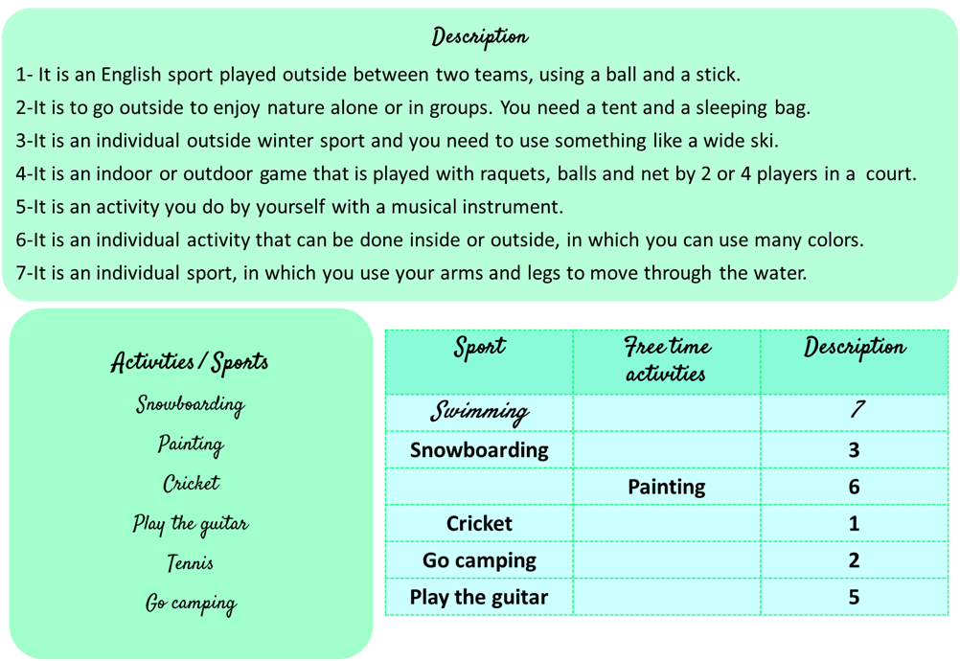

- Read the table and complete the story.
- Lee la tabla y completa la historia.

What did I do last week?
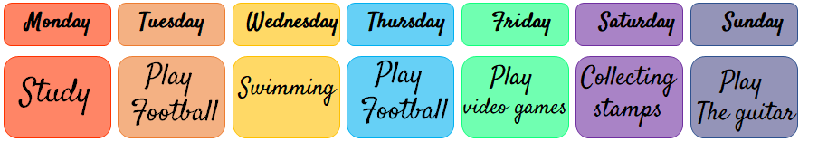
Respuestas:

Last week was a very nice and busy week. On Monday, I had study for my classes.
On Tuesday and Thursday, I went to play football with my friend Susan. We play on the same team.
I also went swimming with my friend Joseph, on Wednesday.
I really like to practice with him at the Olympic pool.
Last Saturday I received new stamps from my aunt in Europe.
I love collecting stamps, from many different countries.
Surfing the internet and play video games are cool too, last Friday I stayed up late playing with my friends.
On Sunday afternoon, I play guitar with my father.
It was a really busy week!!

- Write a paragraph about your last week's activities.
You can organize the information considering the following aspects and use activity Nº2 as an example.
- Escribe un párrafo sobre tus actividades de la semana pasada.
Puedes organizar la información considerando los siguientes aspectos y usando la actividad Nº2, como ejemplo.

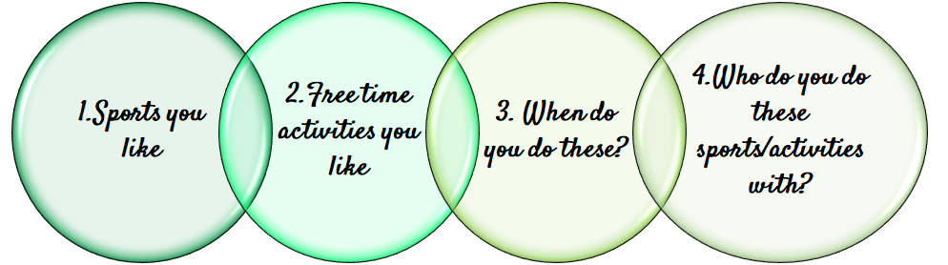

Respuesta abierta.
Example:
Last week was really amazing. I went to play basketball with my cousins in the park on Saturday.
I also went to ride bicycle with my sister Rossy near to the beach on Tuesday afternoon.

SECTION 4: EXTRA ACTIVITY
My favorite...
1. Choose your favorite sport or a free time activity to motivate your friends to do or practice it, considering or including these aspects:
a) Collect and classify the information to show them the benefits of it (at least 5 benefits).
b) Use images in your poster related to your favorite sport or free time activity.
c) Establish a purpose for your poster and add a title for it.
- Elige tu deporte o actividad de tiempo libre favorita para motivar a tus amigos a hacer o practicar este/a, considerando o incluyendo estos aspectos:
- Recopila y clasifica información para mostrarles los beneficios de este/a (al menos 5 beneficios)
- Usa imágenes en tu póster relacionadas a tu deporte o actividad de tiempo libre.
- Establece el propósito del póster y añade un título.

Respuesta abierta.
Example:

My favorite sport is: Cycling | My favorite free time activity is: Reading books
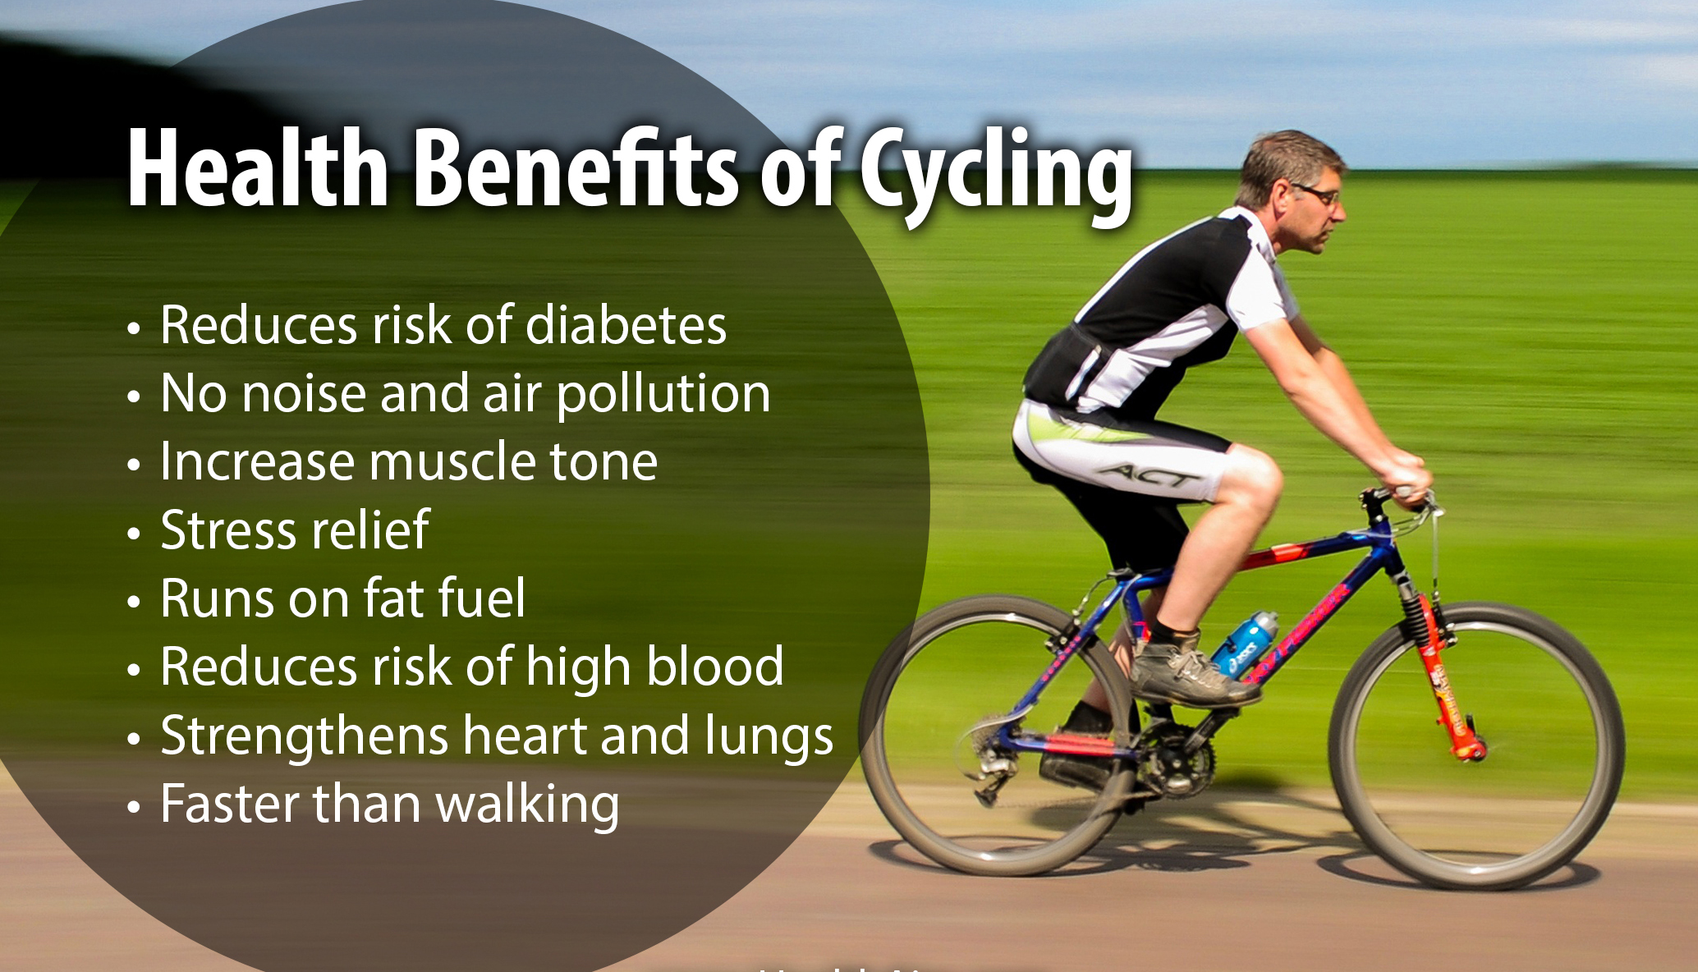 | 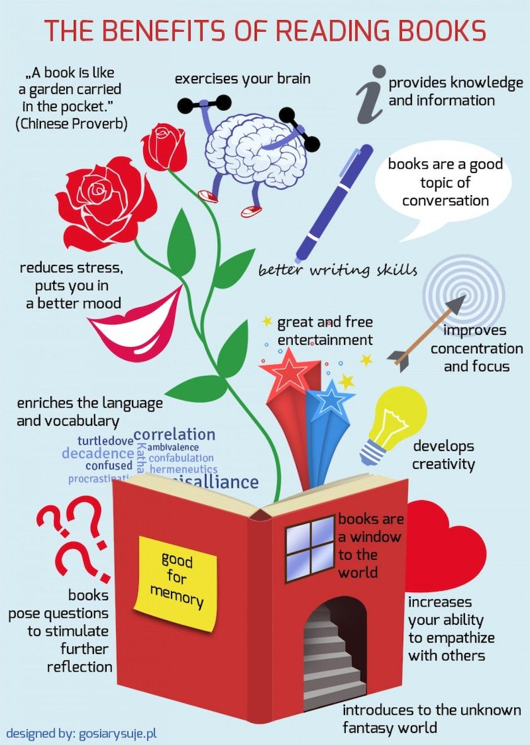

SECTION 5:
Digital Resources
Take a look at these links!
- https://learnenglishkids.britishcouncil.org/word-games/free-time-1
- https://learnenglishkids.britishcouncil.org/word-games/free-time-2

NO OLVIDAR REPASAR EL CONTENIDO CON UN ADULTO

