UNIT 2

LESSON 4

Unidad 2: Customs and traditions all over the world
Objetivo: Aplicar, diferenciar, buscar y revisar contenidos previos relacionados a tradiciones y costumbres en el mundo y su vocabulario, a través de actividades de contraste, reconocimiento de verbos modales, deducción e inferencia de información, entre otras.
Nota: Este objetivo está basado en los Objetivos de Aprendizaje priorizados del Programa de Estudio de 3° medio.

Lesson 4
Review

ÚTILES

- Texto del estudiante de 3° medio.
- Diccionario de inglés.
- Lápices.
- Cuaderno de asignatura.

ICONS FOR ACTIONS



VOCABULARY SECTION: 

Hello students! Welcome back to the review lesson for unit 2.
In this unit we will be working toward a practice project where you will create your own traditional celebration.

- First, let´s match the following pictures with the descriptions below.
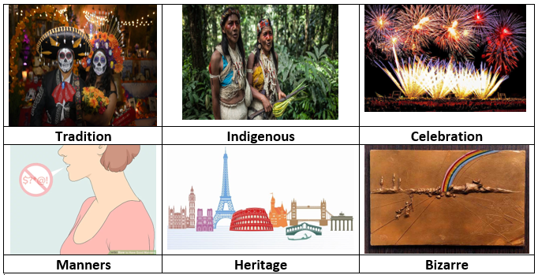
- Quechua, Atacameño, Kolla, Diaguita, Rapanui, Mapuche, Yagán, Kawésqar refers to _INDIGENOUS_people.

- Being helpful to others in your home, saying 'please' and 'thank you', respecting other people's property and their rooms, and helping the family by doing your chores are examples of good __MANNERS___.

- Chile’s Fiesta de la Tirana, Easter Island‘s Tapati Festival, the Cuasimodo festival in central Chile and the Mingas in Chiloé are some traditional CELEBRATION___ in our country.

- Rapa Nui National Park, the churches of Chiloé, the Historic Quarter of the Seaport City of Valparaíso, Humberstone, Sewell Mining Town and the Andean Road System are UNESCO World _HERITAGE__ sites.

- El Colacho – The Baby Jumping Festival in Spain and the Mosquito festival in Texas are good examples of __BIZZARE__ festivities.

- Dancing cueca and eating “empanadas” are part of our ancestral _TRADITION_in Chile.

- Do you remember the main difference between a fact and an opinion? Read the following statements and write F (for fact) or O (for opinion):

- Rio Carnival in Brazil is celebrated every year in February or March__F___
- Among the typical outfit people wear in the Fondas is a chupalla ___F____
- Typical food people eat and share in Fondas is cazuela and corn pie__O___
- Fogata del Pescador in Valparaiso gathers many people every September_F_
- Valdivian week is the greatest Chilean street festival. _O_
- The cheapest and most exotic Chilean wines are found at the Grape Harvest Festival in central Chile. ___F___

- Find 3 ingredients for this delicious Chilean recipe and complete the text.
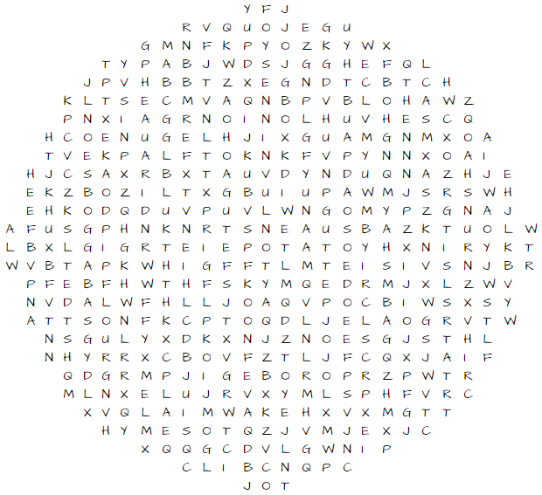
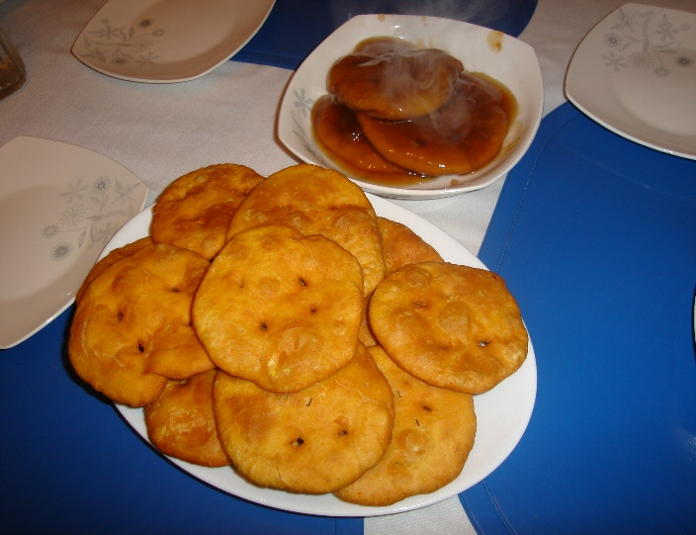
Sopaipillas are one of the cheapest, delicious, and popular food in our country. They can be very fattening and unhealthy if you eat a lot of them in a daily basis, but most of the ingredients are healthy. For instance, we add _PUMPKIN_ which is a highly nutritious vegetable and particularly rich in Vitamin A. We also add __FLOUR__ that is an excellent source of protein, vitamins, fibre and complex carbohydrates, we often make bread with this ingredient. In addition, we recommend frying the sopaipilla in _____VEGETABLE OIL ______because are naturally trans-fat free.

FUNCTIONS SECTION 

- Matching: match the modal verb in column A, with the corresponding use in column B, by writing the correct word on the line in column C:
A: Modal verb | B: Use | C
- Must | to express obligation | __A___
- Should | to express possibility | __D___
- Might | to give advice and recommendation | __B___
- May | express (un) certainty | ___C__

5. Read the following and rewrite them with the words in brackets:

- Every time someone goes to Fiesta de San Pedro in Valparaiso, it would be a good idea to bring a professional photo camera. (should bring)
Every time someone goes to Fiesta de San Pedro in Valparaiso, it SHOULD BRING a professional photo camera

- Right now, the clouds in the sky are dark and low. I think I will bring a raincoat if the weather changes during the winter party. (may-rain)
Right now, the clouds in the sky are dark and low. I MAY bring a raincoat if IT RAINS. (may-rain)

- Due current circumstances, perhaps we will not celebrate Chile's annual national celebration of independence. (might not)
Due current circumstances, we MIGHT NOT celebrate Chile's annual national celebration of independence

d. During celebrations, it is forbidden to park inside the indoor parking. (must
not park)
During celebrations, you MUST NOT park inside the indoor parking

Practice Project: MY OWN TRADITION

6. Now it’s time for you to practice everything you learnt in the last 3 worksheets. Do you remember that we talked about traditions, customs, and how different cultures are? Well, now it’s your turn to show your own culture and background.
We want to invite you to create your own tradition or celebration. Your celebration or tradition can be about anything you want, and it does not matter if you or other people may think it is bizarre or unimportant because this is your own celebration. So, you are free to decide, and you can do it in any format you want, but you must include:

- The name of your tradition or celebration.
- The reason behind your celebration and the reason why people should celebrate it.
- The date, when is it celebrated? Why did you choose that date?
- The typical outfit people should wear.
- Typical food people should eat and share.
- Extra information you would like to include.

You can write a paragraph or create a poster and then post it on social media, or maybe make a video!

Here are some examples:

“The Monkey Buffet Festival in Thailand is celebrated every year in November, to bring luck to the people of the city of Lobpuri. Even though there is no reason for the date, people gather every year to celebrate. Some people dress in monkey costumes, and everyone brings fruits for the animals, gathering more than 3.000 kilograms of food every year as a gift for the monkeys of the city, who are “the owners” of the place. Typically, people share fruits and vegetables, and they also provide food for the numerous monkeys that live in the city. Also, there are artistic performances, music, and many other art manifestations because this festival gathers more and more people every year”
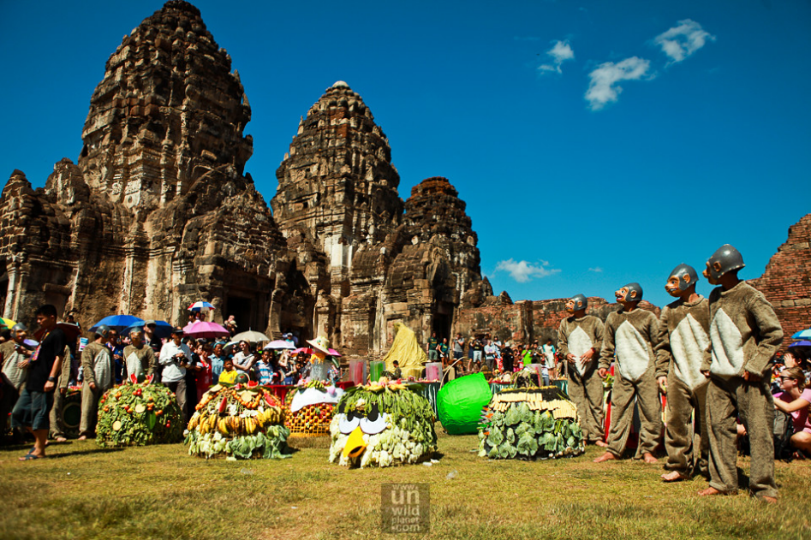
Texto modificado de https://tripivent.com/events/monkey-buffet-festival-lopburi/#:~:text=of%20delicious%20food.-,Where%20does%20the%20Monkey%20Buffet%20Festival%20take%20place%3F,%2C%20in%20November%2029%2C%202020.

This hilarious expression below is what gurning looks like and it is a rural English tradition celebrated since 1267. There even existed a World Gurning Championship in England in which participants make the most grotesque face possible. If you think this is a silly tradition, you couldn't be more wrong. Four-time world gurning champion Peter Jackman got his teeth removed to make his expressions easier. Talk about dedication!
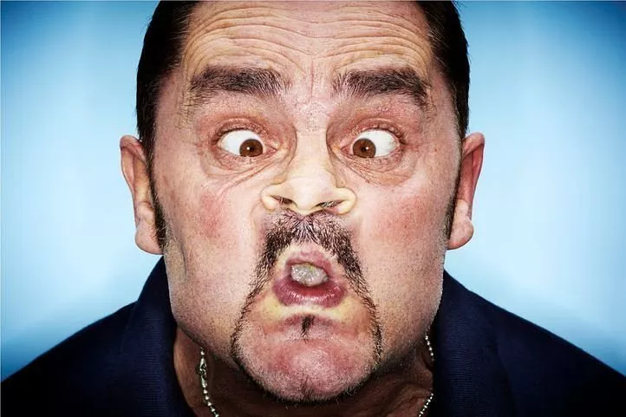
Texto obtenido de https://www.scoopwhoop.com/inothernews/weird-customs/

Now it’s your turn to tell us about your own tradition!
SEE EXAMPLE ABOVE ________________________________________________________________________________________________________________________________________________________________________________________________________________________________________________________________________________________________________________________________________________________________________________________________________________________________________________________________________________________________

