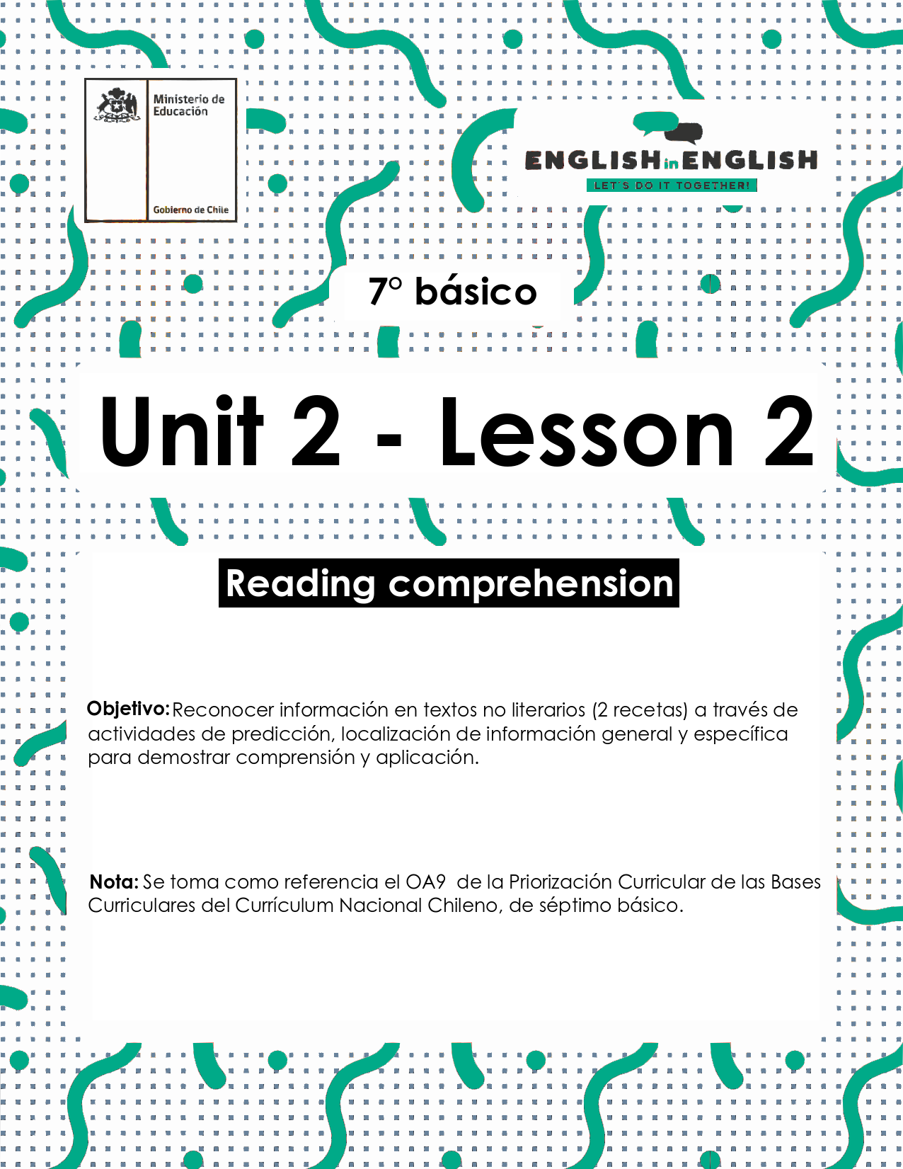
UNIT 2
LESSON 2

ÚTILES RECOMENDADOS:
- Texto del estudiante 7° básico.
- Cuaderno de inglés o 2 hojas en blanco.
- Lápiz grafito y goma.
- Diccionario de Inglés físico / online https://dictionary.cambridge.org/es/diccionario/espanol-ingles/

SECTION 1: SETTING THE CONTEXT

Cooking

1. Observe the image and answer the questions.
- Observa la imagen y responde las preguntas.

2. Observe the images and match them with the corresponding verbs.
- Observa las imágenes y únelas con los verbos correspondientes.

Cut - peel - mix - shape - heat - slice - place - cook - cover - serve

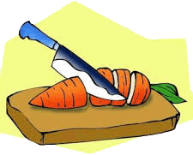 | 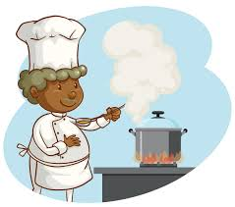 | 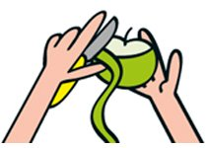 | 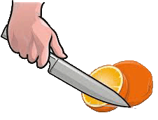 | 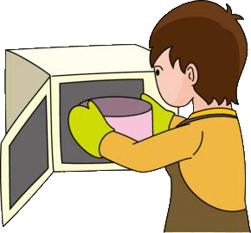
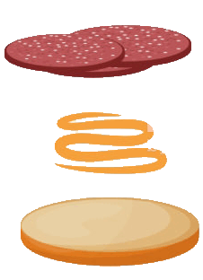 | 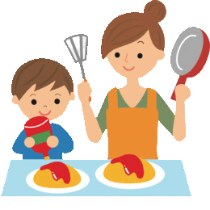 | 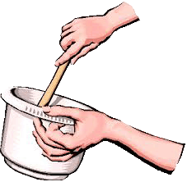 | 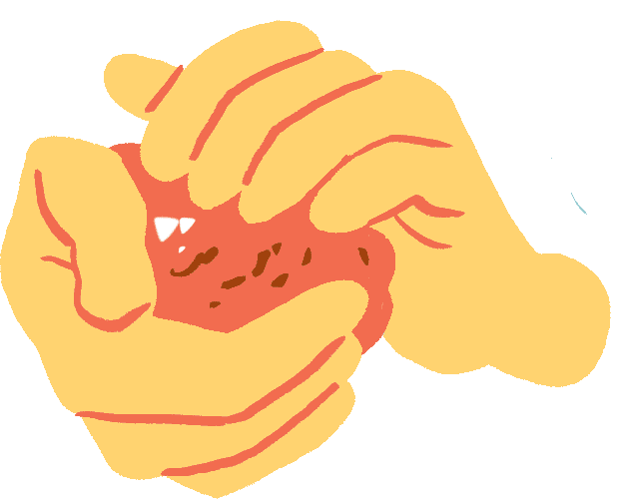 | 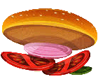

3. What do you think you will read? Choose an alternative.
- ¿Qué crees que leerás? elige una alternativa...

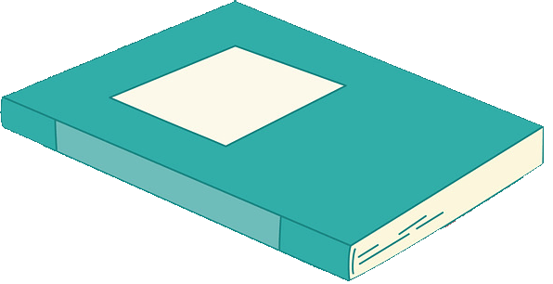
- a story b) a recipe 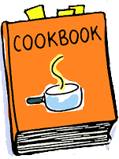 c) an email  d) a letter 

SECTION 2: LET´S PRACTICE

Recipes
1. Read the texts quickly and answer the questions.
- Lee los textos rápidamente y responde las preguntas.
- What type of texts are these? __________________________________
- Which one do you think is a healthy recipe? _______________________
- Which one do you think needs more ingredients? ___________________
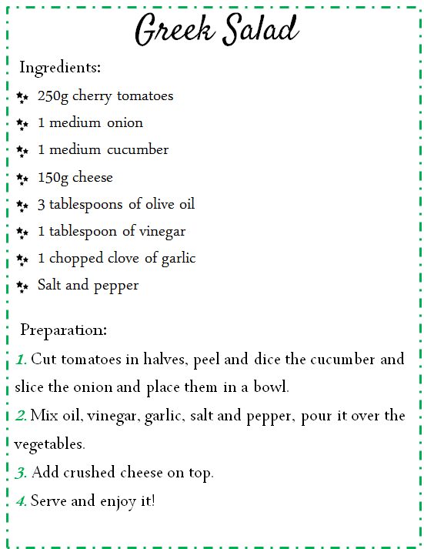
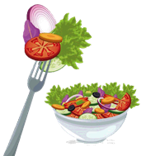
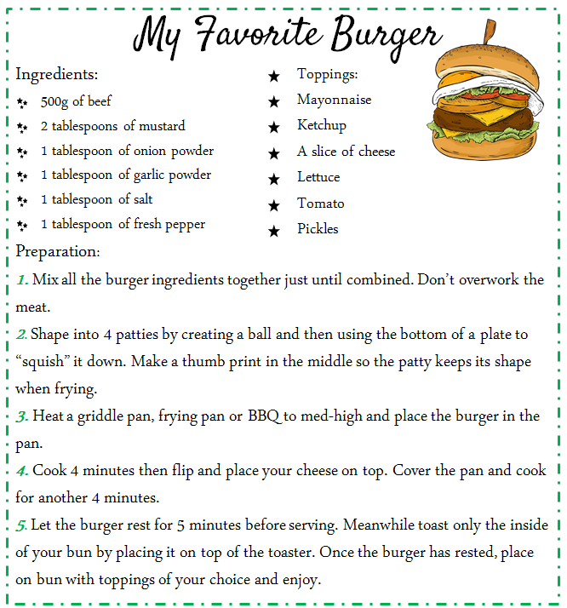

Vocabulary
Tablespoon: cuchara sopera | patties: croquetas | squish: aplastar | bun: bollo
Toppings: aderezos | chopped: cortado en trocitos | crushed: aplastado | clove of garlic: diente de ajo
Text taken from tamaras-table.com/2017/01/17/ts-burger/
https://en.islcollective.com/english-esl-worksheets/search/recipes

2. Read the texts again and underline all the food items you can find.
- Lee los textos nuevamente y subraya todas las palabras relacionadas con alimentos que puedas encontrar.

3. Read the recipe about Greek Salad and complete the sentences with the words from the box.
- Lee la receta sobre Greek Salad y completa las oraciones con las palabras de la caja.

- First
- Second
- Next
- Finally
Greek Salad

_________________Cut tomatoes in halves, peel and dice the cucumber and slice the onion and place them in a bowl.

_________________Mix oil, vinegar, garlic, salt and pepper, pour it over the vegetables.

_________________Add crushed cheese on top.

_________________Serve and enjoy your salad

4. Read the recipe about “My Favorite Burger” and complete the sentences with the corresponding verb.
- Lee la receta sobre “My Favorite Burger” y completa las oraciones con el verbo correspondiente.

Mix - shape - heat - place - cook

- _______ a griddle pan, frying pan or BBQ to med-high.
- _______ all the burger ingredients together just until combined.
- Once the burger has rested _________ on bun with toppings of your choice.
- Cover the pan and ________ for another 4 minutes.
- ________ into 4 patties by creating a ball.

5. Read both recipes (Greek Salad and My Favorite Burger) again and complete the table.
- Lee ambas recetas (Greek Salad y My Favorite Burger) nuevamente y completa la tabla.

Questions | Greek Salad | My Favorite Burger
How many ingredients are necessary? Write a number
Is this a healthy or an unhealthy recipe?
Does it require a lot of time preparation?
Does it use an oven?
What kind of vegetables are necessary? Write them

SECTION 3: LET´S CONSTRUCT AND APPLY OUR KNOWLEDGE

My own recipes

1. Read the recipe “My Favorite Burger” again and make healthy changes to its ingredients and preparation.
- Lee la receta “My Favorite Burger” nuevamente y haz cambios saludables a sus ingredientes y preparación.

 | “My favorite burger” recipe | Healthy recipe
Ingredients
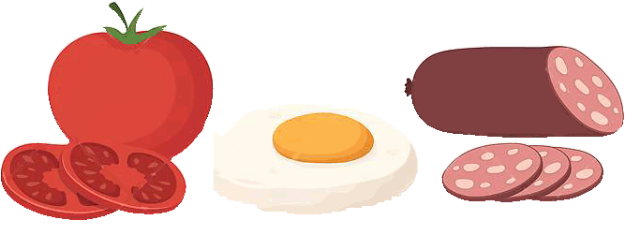
Preparation
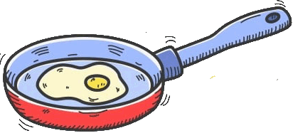

2. Choose your favorite food and write the recipe considering these aspects.
- Elige tu comida favorita y escribe la receta considerando estos aspectos.

Recipe ………………………………………..
Ingredients:
……………………………………………………………... ………………………………………………………...
………………………………………………………........ ………………………………………………………...
……………………………………………………………... ………………………………………………………...
………………………………………………………........ ………………………………………………………...

Servings…………………………………………….
Prep time…………………………………………….

Preparation
……………………………………………………………………………………………………………………………………………………………………………………………………………………………………………………………………………………………………………………………………………………………………………………………………………..
……………………………………………………………………………………………………………………………………………………………………………………………………………………………………………………………………………………………………………………………………………………………………………………………………………………………………………………………………………………………………………………………………………………
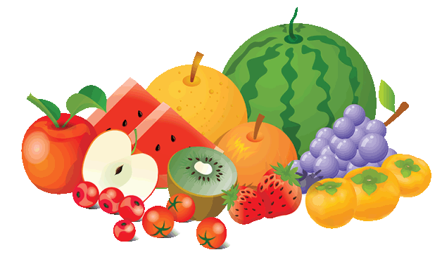
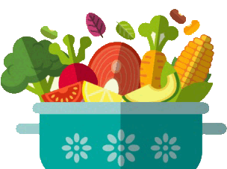

SECTION 4: EXTRA ACTIVITY

Describing my meal

Look at the 2 cards about food and how to cook something. Choose one and describe it according to the information requested. Then you can share it with your family.
- Mira las dos tarjetas sobre comida y como cocinarlas. Elige una y descríbela de acuerdo a la información requerida. Luego puedes compartirla con tu familia.

Card 1
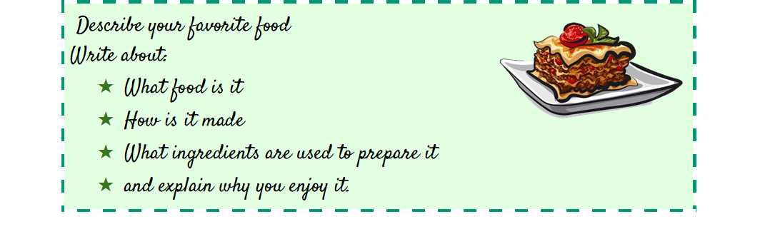
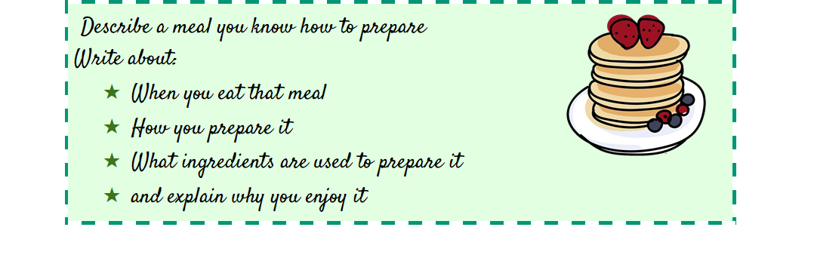
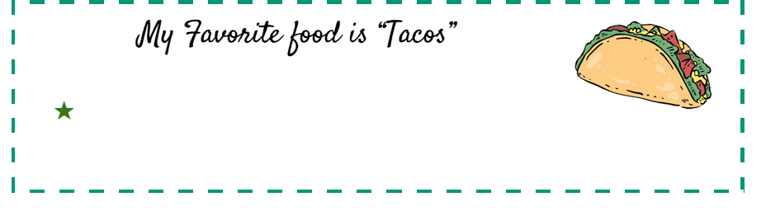
Example
Card 2

SECTION 5: DIGITAL RESOURCES
Take a look at this link!

- https://bdescolar.mineduc.cl/info/delicious-dairy-recipes-00045836

Share it with your friends through social media and  eodp_chile /  Students in Action.

NO OLVIDAR REPASAR EL CONTENIDO CON UN ADULTO

