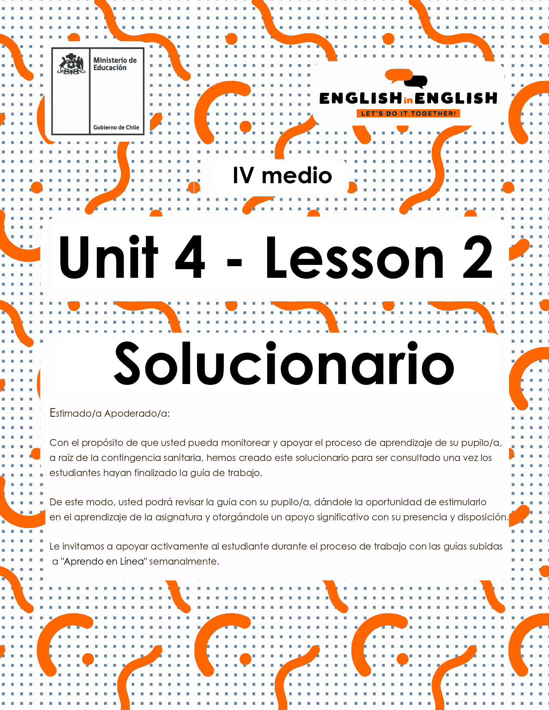

UNIT 4
LESSON 2

GUÍA PARA USAR EL SOLUCIONARIO

- ¿Qué es un solucionario?
- Un solucionario incluye las respuestas a todas las preguntas y actividades.
- Algunas de las preguntas tienen más de una posible respuesta.
- Algunas de las preguntas tienen una sola respuesta.

- ¿Cómo revisar mis respuestas?
- Encontrarás títulos en los encabezados de los ejercicios que dicen “answers” en respuestas cerradas, y en el caso de respuestas abiertas encontraras un encabezado indicando “answers may vary”.

- Las respuestas en ejercicios de verdadero falso, llenado de tablas, unión de letras y dibujos, etc. pueden estar en:
- Negrita
- Subrayado
- Sombreado con colores de formato de guia (purpura, verde, naranjo)
- Encerradas en círculos
red
- Destacadas
- Tachadas

- Ejemplos de respuestas se ilustran a continuación:

I) What is the first thing you think of when you look at it? Why?
Answers may vary.
Example: Art, music, painting. Because there are different people doing these activities.

II) Find the words to complete the sentences using the picture clues. For extra help you can use the Pictionary at the end.

a. The artists used materials like rubber, plaster and styrofoam to make their art.
b. Pomaire pottery is mainly made of clay. Don´t forget to visit this magical village!

SECTION 1: SETTING THE CONTEXT

Hello Students, welcome back to lesson 2. In this lesson we will rehearse reading comprehension skills by considering the topic of technological gadgets.
- Look at the following pictures of gadgets that failed in the market and answer the questions:
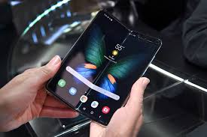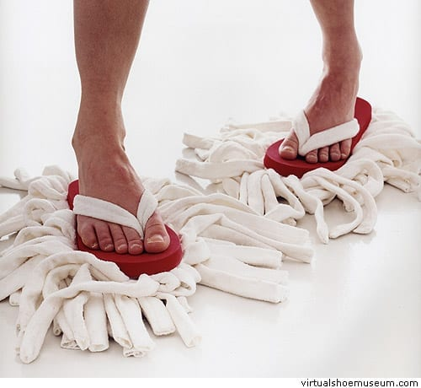
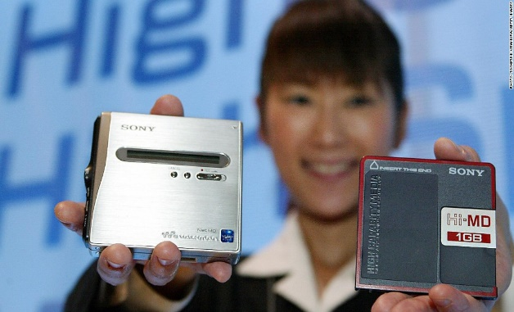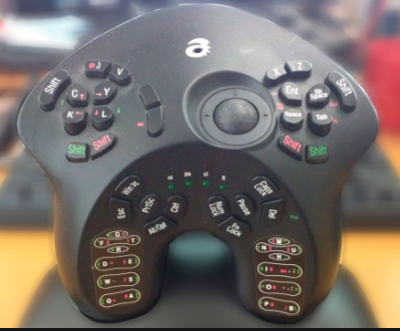
a) What do you think those gadgets were created for?
Answers may vary.
I think they were created to make people's lives easier.

b) What do you think these gadgets have in common?
Answers may vary.
I think all of them are easy to be used.

C) Would you use any of these gadgets? Why/why not?
Answers may vary.
Yes, I would. I love using gadgets all the time.
No, I would not. I prefer traditional devices.

D) Why do you think they failed in the market?
Answers may vary.
Maybe, they were expensive or hard to find.

E) Do you think it would be possible someone could make them useful? Please explain.
Answers may vary.
Yes, I would. I think an expert could improve functions and designs.

- Complete the text with the words on the box.
If necessary, use your dictionary to look up any words that you do not know.
download | batteries | computer | message
headphones | touch | keyboard | photos

Tablet computer
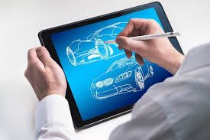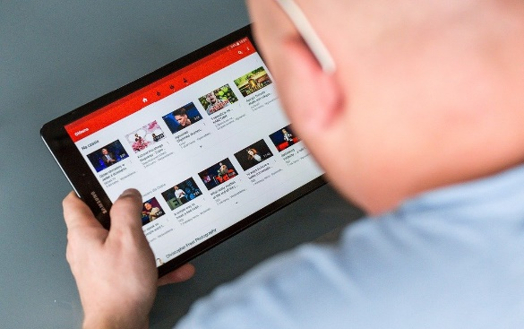
A tablet (a) computer is a small handheld computer with a flat (b)__touch_____ screen. The most popular are iPads and Androids, which allow users to access the web, (c)_download__ applications, view (d) photos and videos, play games and read eBooks, newspapers, and anything on the Internet. You can also plug in external (d)__headphones___ and listen to music. All tablets have rechargeable (e)_batteries___, with an average life of about ten hours in standby mode so it isn’t necessary to switch off the power button. Tablets do not usually have a (f)_keyboard___; if you want to write a (g)_message __, you tap letters and symbols on the screen. You don’t need to set up the tablet when you first open the box
– just turn it on.
Taken and adapted from Tune Up Student’s Book 12th Grade

SECTION 2: LET’S PRACTICE
- Read the following text about incredible gadgets and complete the exercises:

4 Incredible gadgets that really shouldn’t have failed.
By Mark Myerson on May 16, 2019, 5:45 pm EDT under Daily Digest
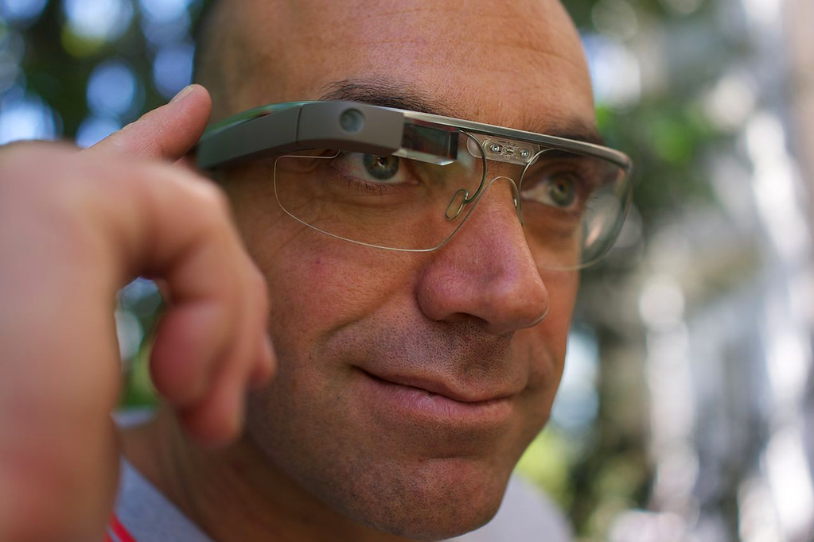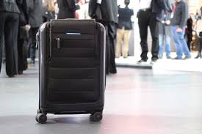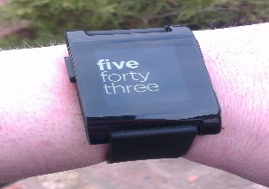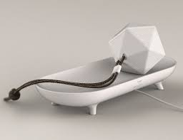

The design and technology world is full of innovation. Unfortunately, not all ideas are well received. Maybe the consumer just wasn’t ready, but these incredible gadgets just failed to succeed.
Why do gadgets fail? Usually it’s due to competition, being overpriced, or failing to meet the needs of consumers. But for every fantastic product, there are plenty that fail. Here are four incredible gadgets that unfortunately failed:
Google Glass AR Glasses
Google’s first step into augmented reality was cool, but too advanced. The consumer version died back in 2015, thanks to limited demand and high pricing. However, the Explorer Edition lives on in the commercial world.
Died: July 2015.
BlueSmart Series 2 Smart Luggage
BlueSmart company produced suitcases with incredible features, such as GPS tracking and device charging. Sadly, regulations banned those power banks.
Died: May 2018
Otto Smart Digital Door Lock
The Otto digital lock allowed people to enter their house without keys thanks to wireless connectivity. Unfortunately, the product was hugely overpriced.
Died: December 2017.
Pebble Smartwatch
Pebble is maybe the greatest success and failure story of all time. This company created a smartwatch with fantastic battery life that broke records on the web. But, eventually, people bought and preferred the Apple smartwatch and other big companies’ names.
Died: December 2016
However, instead of feeling sad about the past, we are looking forward to these future devices:
Google Visual Assistant Artificial Intelligence Projector
This device could operate like a Google smart speaker, with the addition of visuals. You would only need to ask to watch a movie or see live traffic.
Walnut Personal Health Toy
It might be called a toy, but Walnut actually has a very serious purpose. The device contains sensors that test your blood sugar, grip strength, and hand tremors—useful for folks concerned about their health.
Lumigrids Cycling Projector Light
This ingenious bike light beams a blue grid onto the road ahead. This helps to alert drivers and highlight bumps in the road.
(Source: https://thegadgetflow.com/blog/incredible-gadgets-concept-designs/

- In your own words, explain the reason why these gadgets failed: (answer may vary)

- Google Glass AR Glasses: They were expensive, so people did not buy them.

- Pebble Smartwatch: People preferred to purchase smartwatches from better-known companies.

- Otto smart digital door lock: It was too expensive to be bought.

- . Read the text again and state True (T) or False (F):

- _F__ Generally, gadgets mainly fail because of technology trends and consumers' needs.
- _F__ All technology ideas are well received.
- _T__ The BlueSmart Luggage failed because its power bank did not work properly.
- _T__ The Otto digital Look allowed using wireless connectivity.
- _F__ The Pebble Smartwatch had a low battery life.

- Read the text again and label the following gadgets:
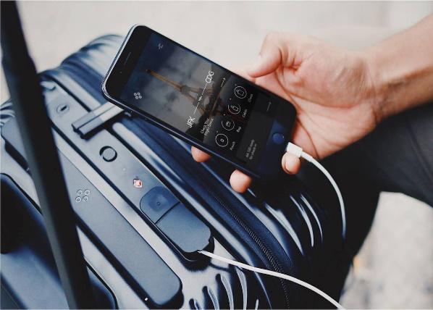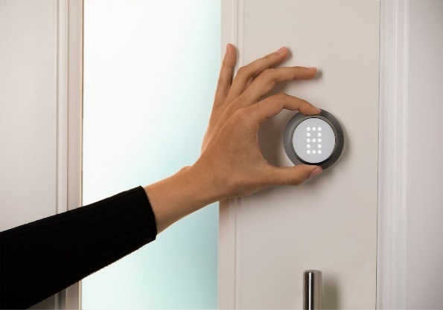
1 BlueSmart Series 2 Smart Luggage 2 Otto Smart Digital Door Lock
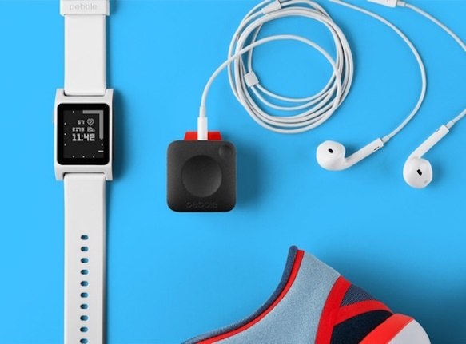
3 Google Glass AR Glasses 4. Pebble Smartwatch

- Read and answer the following:

- Which gadget(s) from the past would you bring back to life?
Answers may vary.
The Lumigrids Cycling Projector Light.

- Why would you do it?
Answers may vary.
To promote cycling.

- Which ones do you think would be the most popular one(s)? Please explain.
Answers may vary.
The Google Visual Assistant Artificial Intelligence Projector because it is related to people´s wellness.

d. Is there any other gadget you believe might help humans to have a
more comfortable and interesting life? Please explain.
Answers may vary.
I think 4D television can bring reality to humans and promote fun and joy

SECTION 3: LET´S CONSTRUCT AND APPLY OUR KNOWLEDGE

- For this week project. You need to give reasons for the failure of some gadgets.

- Look at the following pictures and think about the possible reason for the failure of these gadgets.
Gadget 1: Video Game Gadget 2: Voice recorder
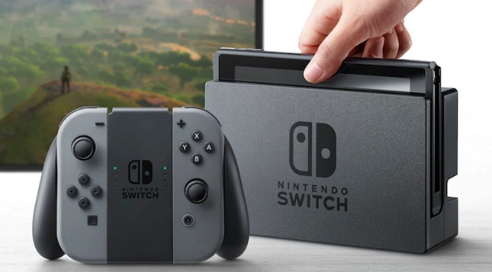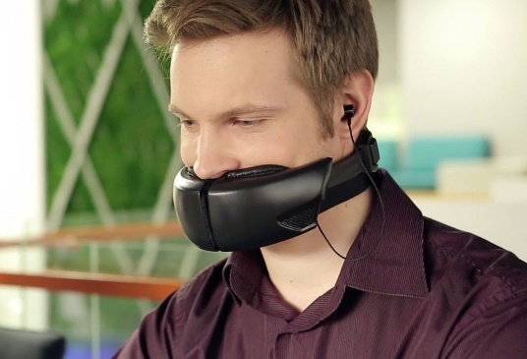
Gadget 3: Toothpick Gadget 4: Lipstick Pendrive


- Now, write the reason you think they did not work in the market
Answers may vary
Gadget 1 did not work because it was too expensive

Gadget 2 did not work because it was complicated to use

Picture 3 did not work because it was not practical

Picture 4 did not work because it was difficult to handle

- Finally, select one of these gadgets and explain how you would make it work:
Answers may vary.
I think gadget __4__ would work if you introduce this as a safety measure to stop the spread of viruses through cross contamination by touching.

SECTION 4: Extra activity

- Do you know what an acrostic poem is? Well, an acrostic poem is a poem where certain letters in each line spell out a word or phrase.

Can you complete this acrostic poem with GADGET related words? Once you finish read it as a poem

G is for Genius
A is for Amazing
D is for Didactic
G is for Good
E is for Exceptional
T is for Transcendent

