​UNIT 4
LESSON 1

Unidad: keeping up with technology

Curso: Cuarto medio

Objetivo: Revisar e introducir vocabulario sobre tecnología - comunicación, y utensilios tecnológicos futuros a través de actividades de comprensión lectora, escritura, organización de información, inferencia, selección y aplicación para el fomento de vocabulario.

Nota: Este objetivo está basado en los Objetivos de Aprendizaje priorizados del Programa de Estudio de Cuarto medio

UNIT 4
LESSON 1

ÚTILES

- Texto del estudiante de 4° medio.
- Diccionario de inglés.
- Lápices.
- Cuaderno de asignatura.

GUÍA PARA USAR EL SOLUCIONARIO

- ¿Qué es un solucionario?
- Un solucionario incluye las respuestas a todas las preguntas y actividades.
- Algunas de las preguntas tienen más de una posible respuesta.
- Algunas de las preguntas tienen una sola respuesta.

- ¿Cómo revisar mis respuestas?
- Encontrarás títulos en los encabezados de los ejercicios que dicen “answers” en respuestas cerradas, y en el caso de respuestas abiertas encontraras un encabezado indicando “answers may vary”.

- Las respuestas en ejercicios de verdadero falso, llenado de tablas, unión de letras y dibujos, etc. pueden estar en:
- Negrita
- Subrayado
- Sombreado con colores de formato de guia (purpura, verde, naranjo)
- Encerradas en círculos
red
- Destacadas
- Tachadas

- Ejemplos de respuestas se ilustran a continuación:

I) What is the first thing you think of when you look at it? Why?
Answers may vary.
Example: Art, music, painting. Because there are different people doing these activities.

II) Find the words to complete the sentences using the picture clues. For extra help you can use the Pictionary at the end.

a. The artists used materials like rubber, plaster and styrofoam to make their art.
b. Pomaire pottery is mainly made of clay. Don´t forget to visit this magical village!

SECTION 1: SETTING THE CONTEXT

Hello Students, Welcome to unit 4!
In this unit we will work on the context of technology and its gadgets.
- Look at the following pictures with technological gadgets and answer the questions.
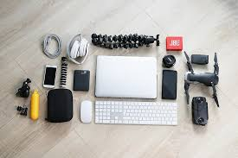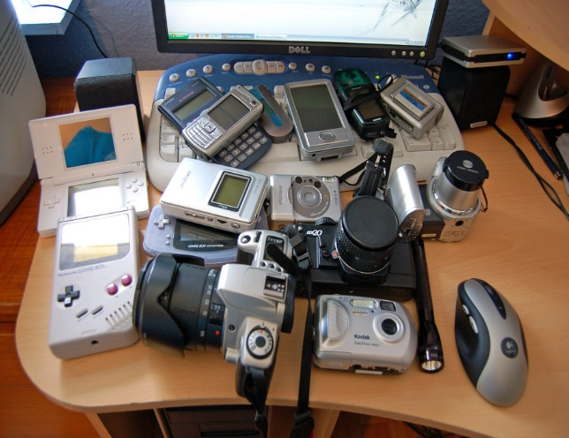
- Do you know what a gadget is?
Answers may vary.
A modern or electronic device
- Can you name in English 5 gadgets from the photos?
Answers may vary.
Cellphone, drone, mouse, camera, notebook, computer.

- Do you have any gadget in your place? Which one is your favourite?
Answers may vary.
My cellphone and my computer.
- What can you do with that gadget?
Answers may vary.
I can talk to my friends, take photos, film videos, download apps.

- The key features of a technological gadget are innovation, creativity and usefulness. Classify the following pictures into these categories. (Answers may vary).
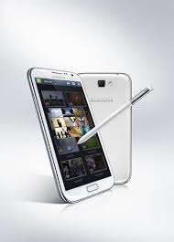Tablet | 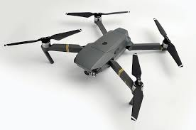Drone | 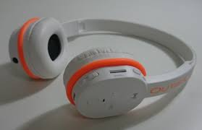Wireless headphones
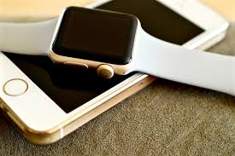Intelligent watch | 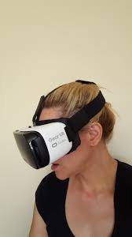Virtual reality lenses | 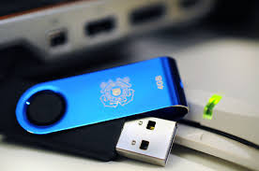  USB Flash Drive
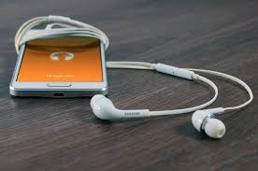Headphones | 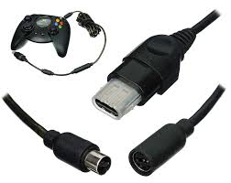Adaptors | 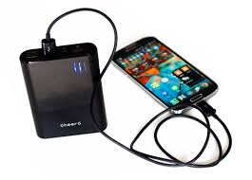  Power bank

Innovation | Creativity | Usefulness
Intelligent watch | Adaptors | Tablet
Headphones | Drone | Power Bank
Wireless headphones | VR Lenses | USB Flash Drive

SECTION 2: LET’S PRACTICE
- Have a look again at the gadgets from exercise 2 and fill in the blanks:

- __Drone__ It is an is an unmanned aircraft that can fly autonomously.
- _USB Flash Drive_ A small data storage device used to move and store information from a computer.
- _Intelligent watch It is a wearable computer in the form of a wristwatch.
- _Adaptor_ A device used to connect several electrical appliances to a single mains socket.
- _Headphones_ An electrical device consisting of two earphones held in position by a flexible metallic strap passing over the head.
- _Power bank_ A portable battery-powered device for charging the battery of a mobile phone or other electronic device.

4. Read the following myths about technology and state if they are True (T) or False (F) for you:

a.__F__ Technology will soon replace every human activity.
b.__T_ Leaving your phone plugged in might damages the battery.
c.__F__ You should always let your mobile battery completely die before recharging.
d.__T_ More megapixels will always mean a better camera.
e.__F_Cell phones might have the potential to cause cancer.

- Now, choose one true and one false statement for you. Then, complete the sentences:

- I think sentence _D_ is true because the higher the megapixel count on a camera sensor, the greater amount of detail that can be captured in a picture.

- I think sentence _A_ is false because technology cannot replace the human touch.

SECTION 3: LET´S CONSTRUCT AND APPLY OUR KNOWLEDGE

- For this first project of the unit, you will have to describe a gadget that you consider useful, innovative and original. Loot at these kitchen gadgets for inspiration, and answer in the box below.
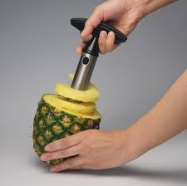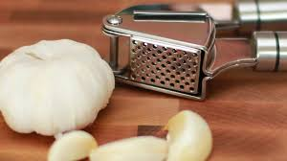
Answers may vary.

SECTION 4: Extra activity
Look around your house and write a gadget for the following consonants and vowels
Vowel | Gadget
F | Fax machine, fan
B | Battery
I | Iron
C | Calculator, Clock
R | Remote control, Radio
T | Tablet, Television

