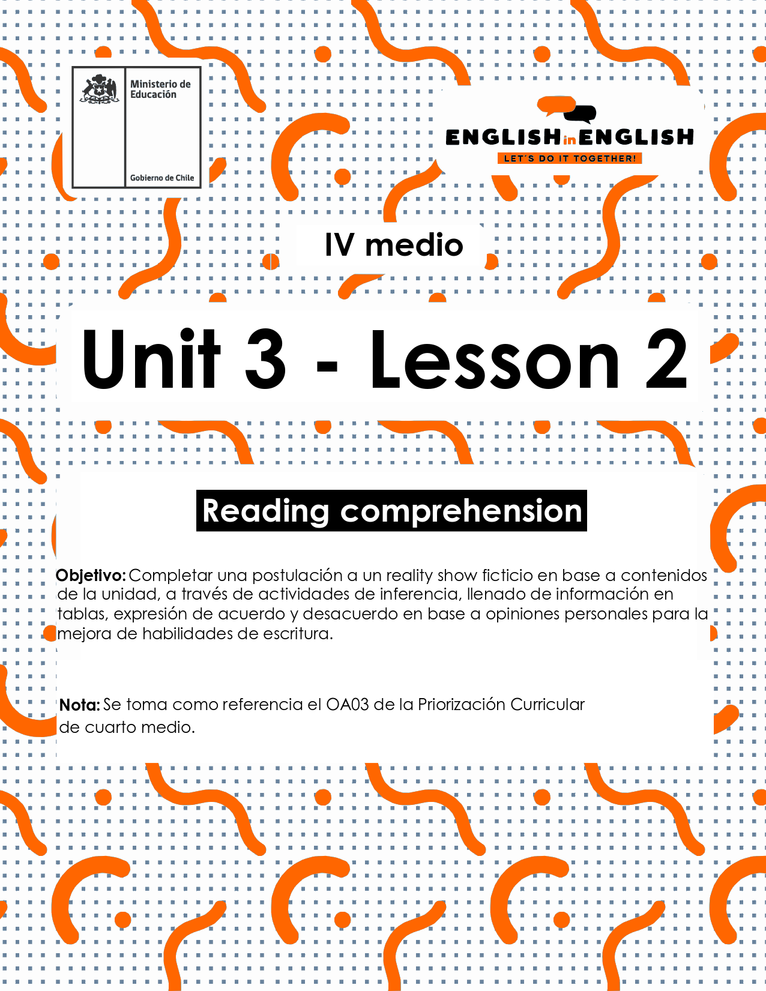

UNIT 3
LESSON 2

ÚTILES

- Texto del estudiante de 4° medio.
- Diccionario de inglés.
- Lápices.
- Cuaderno de asignatura.

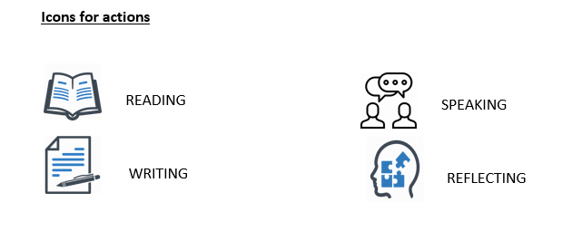

SECTION 1: SETTING THE CONTEXT

Hello students! Welcome back to lesson 3! In this lesson we will be reading, practicing and learning about reality shows and advertising.

- Look at the pictures and answer the following questions. 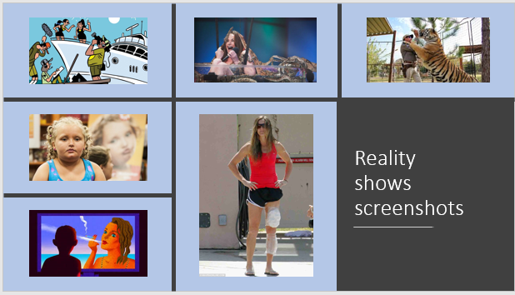
- Do you agree with kids participating in reality shows? Please explain.

- Are you for or against TV shows that put people at risk of injury? Why/why not?

c. Today, alcohol or tobacco can be advertised on television, what is your opinion about that? Please explain.

- An important number of studies have established that reality shows can have a powerful effect on the behaviour of people in society. What do you think about it? Read the sentences and say if they are true (T) or false (F) for you:

Statements | T or F?
- Reality shows promote materialism and excessive partying.
- Reality shows should be forbidden for the youth.
- Watching any reality show cannot affect people's perception of things.
- Reality shows exhibits true stories and teach people how to behave honestly.

Now, read the statements again and choose one true and another false for you. Please justify your answer.

a.

b.

SECTION 2: LET´S PRACTICE
Every time someone participates in a TV program, there are many chances that he or she will get some fame and fortune for a while.
- read the following paragraphs with experiences of participants at reality shows and circle the correct alternative:

- Fernanda, a model says “I have always wanted to be famous. So, I went to every casting I could attend just to appear on TV. I did not care if participating was dangerous. I am not against difficult physical contents as I know that is part of the show and that way rating goes up. No pain, no gain!”
Fernanda agrees with physical danger at reality shows because...
a. It is part of any contest at a reality show.
b. It helps to improve ratings.
c. All of the above
B. Javier, a driver, says “I needed some money to buy a house, so I applied to a social experiment reality show. It consisted on proving the audience that all participants could survive by having no electricity on a deserted island for 12 weeks. It was hard, and I did not win the first place, but I got half of the money I needed. I am not sure if what I did was really worth it.”
Javier cannot say if the experience at the reality show was good or bad because....
a. Living without electricity is complicated.
b. He did not win the first place.
c. None of the above
- Rodrigo, a singer, says “Three years ago I participated at a competition reality show focused on artistic vocal talent. I had recorded some songs before, but I needed the radios played them. I competed against ten participants. Most of them were very talented, but something inexplicable happened: only the ones who had the best looks and more fans got into finals. I felt so disappointed and mad that I did not compete in the final show.”
Rodrigo did not compete in the final show because...
a. He thought it was unfair the way semi-finalists were chosen.
b. He did not have the biggest number of fans.
c. He did not have songs of his own.
- Read Mario´s opinion about reality shows, people at risk and the advertising of alcohol or tobacco on reality shows, then answer the following:
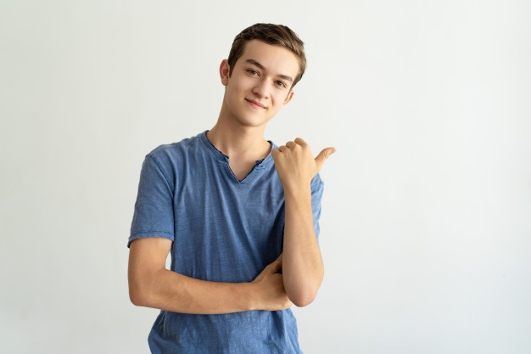 | I have a guilty pleasure with reality shows. I love Britain’s Got Talent, MasterChef, and the Voice. When I was eleven years old, the first reality television series I ever watched was “Protagonistas de la Fama”. It was a group of people living inside a house and arguing most of the time. That was so unexpected for me that I liked it a lot.  Over the years, I watched other shows featuring and showcasing physical violence and strong language. My parents never warned me about watching reality television. Nowadays, I think it can be a bit dangerous if you do not restrict some contents to children. I can argue reality shows can influence behaviours like dinking or smoking, which for me are not good healthy habit.
- What was the first reality show Mario watch? Did he like it?
______________________________________________________
- What does Mario think about smoking and drinking on TV?
______________________________________________________
- What did he like the most about Protagonistas de la Fama Reality show?
_____________________________________________________
- What do you think about Mario´s parents?
__________________________________________________

SECTION 3: LET´S CONTRUCT AND APPLY YOUR KNOWLEDGE

- Imagine a TV Chanel hires you to produce a TV program related to sports, but it must have the reality show format. What and how would you produce it? Use the following cues to make a graphic announcement to be published at social media:

- Number, age and psychological/physical characteristics of each participant.
- Facilities and location.
- Purpose and length of the show
- Contact information

