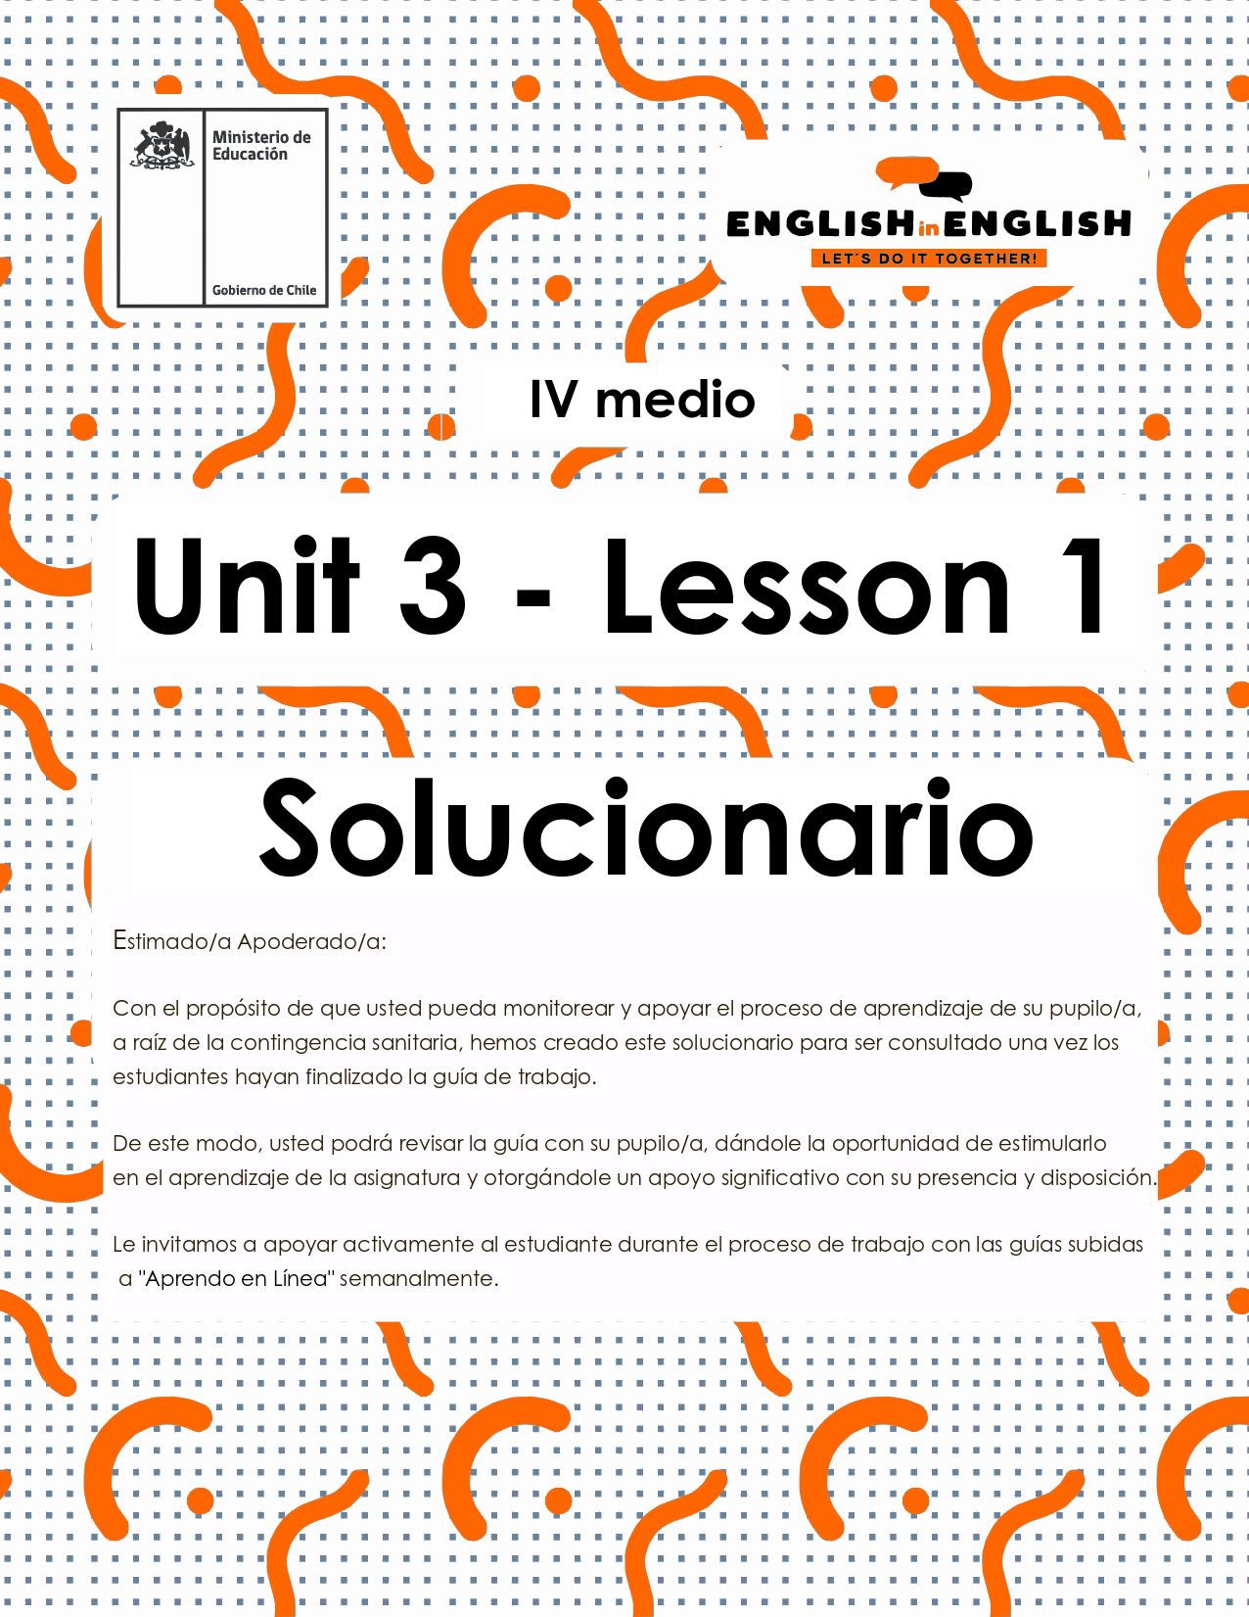

UNIT 3
LESSON 1

ÚTILES

- Texto del estudiante de 4° medio.
- Diccionario de inglés.
- Lápices.
- Cuaderno de asignatura.



SECTION 1: SETTING THE CONTEXT

Hello Students, Welcome to unit 3!
In this unit we will work on the context of television and advertising.
- Look at the following pictures and answer the questions.
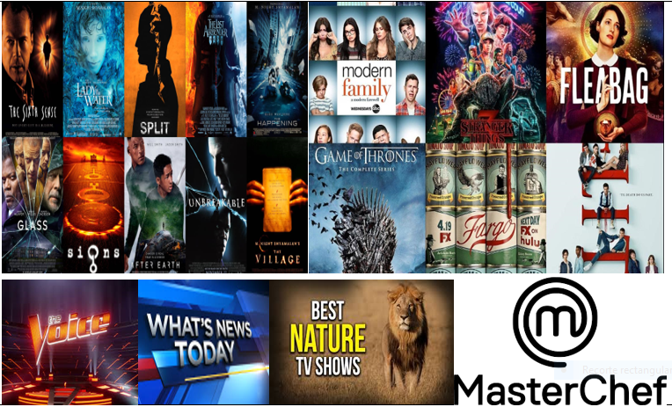
- Among all the TV programs available, what is your favourite one? Please explain why.
I like science fiction ones. They are so interesting! And the situations and special effects immediately catch my attention.
- Have you ever seen a reality show? If so, did you like it? Why/why not?
- Yes, I have. I liked it because it showed a lot of beautiful and exotic places.
- No, I have not. I do not like TV programs where people are locked up.

- Most TV programs include certain features depending on their format. Match the words to their synonyms:
A | B
- Audience  - Showcase  - Advertising  - Team  - Eliminate | __2__Exhibit, display  __4__Group, company, contestants  __5__ Remove, vote off  __1__ Spectators, viewers  __3__ Commercial, message

Choose 3 words from column A to make one sentence about TV shows with each word:
1 The jury will eliminate two contestants this week.
2 Congratulations to the “Red Team” who have advanced to the semi-finals!

3 That talent show will showcase national and internationals contestants.

SECTION 2: LET’S PRACTICE
- Look the following sentences about reality TV, complete them with the vocabulary from the box, and then match to the pictures below:
Voted off – objective – talented – audience - perform
- I think you are such a talented artist
- The latest celebrity to be voted off this year's Master Chef has been revealed.
- The winning contestants will receive a cash prize
- My main objective is to win this competition and receive a cash prize
- I always perform the same show of my dancing
- The concert attracted a large audience who clapped and cheered
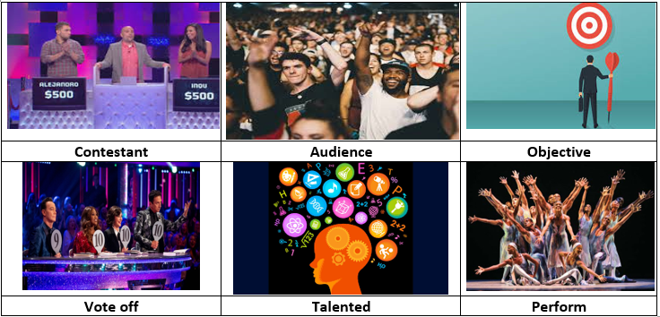

SECTION 3: LET´S CONSTRUCT AND APPLY OUR KNOWLEDGE

- Underline the best option in each sentence

- One of my favourite artists of all times is Andy Warhol. He was such a talented/showcase artist.
- I think that the main objective/perform of art is to emancipate the soul.
- All the audience/contestants in the show were vote off last week.
- For the following challenge you need to work in teams/contestants.
- TV shows are one of the best opportunities to show advertising/commercial.

- listed below are few key words for talking about reality shows. One word in each group does not belong. Which one? Explain why.

- Eliminate – Vote off- Join
- Showcase- perform – audience
- Objective- talented- aim

- Join relates to include someone or something
- Showcase and perform are verbs related to the action of doing something, and audience is a group of people.
- Objective and aim refer to a goal or to the achievement of something

- Read the following text about Reality TV shows and complete chart with related vocabulary.

Top reality TV shows of all time
Reality TV is a category of television programming which supports unscripted context and true events. This genre covers a wide range of formats based on the competitions, game shows, talent showcasing, etc. in the early 2000’s reality shows gained a lot of popularity with TV audiences when production companies started introducing new programmes.
REALITY SHOW GENRES | MOST POPULAR REALITY SHOW | REALITY SHOW KEY VOCABULARY
Cooking | Big brother | Audience
Animal | The voice | Vote off
Lifestyle | Britain got talent | Competition

- Imagine that you and your classmates are in a reality show about your school life, and then answer the questions below. Remember, be creative and respectful!

- Who would be the audience of this reality show?
The audience would be my class 12th grade F
- Who would be the first eliminated, and why?
The first eliminated would be the students with law attendance
- Who would be considered among the most talented in the group?
I would include the whole class in different team or areas of talent
- Who would you like to join you in a team performance?
I would love to join the art team
- What would you showcase?
A performance about the pandemic and the importance of self-protection

