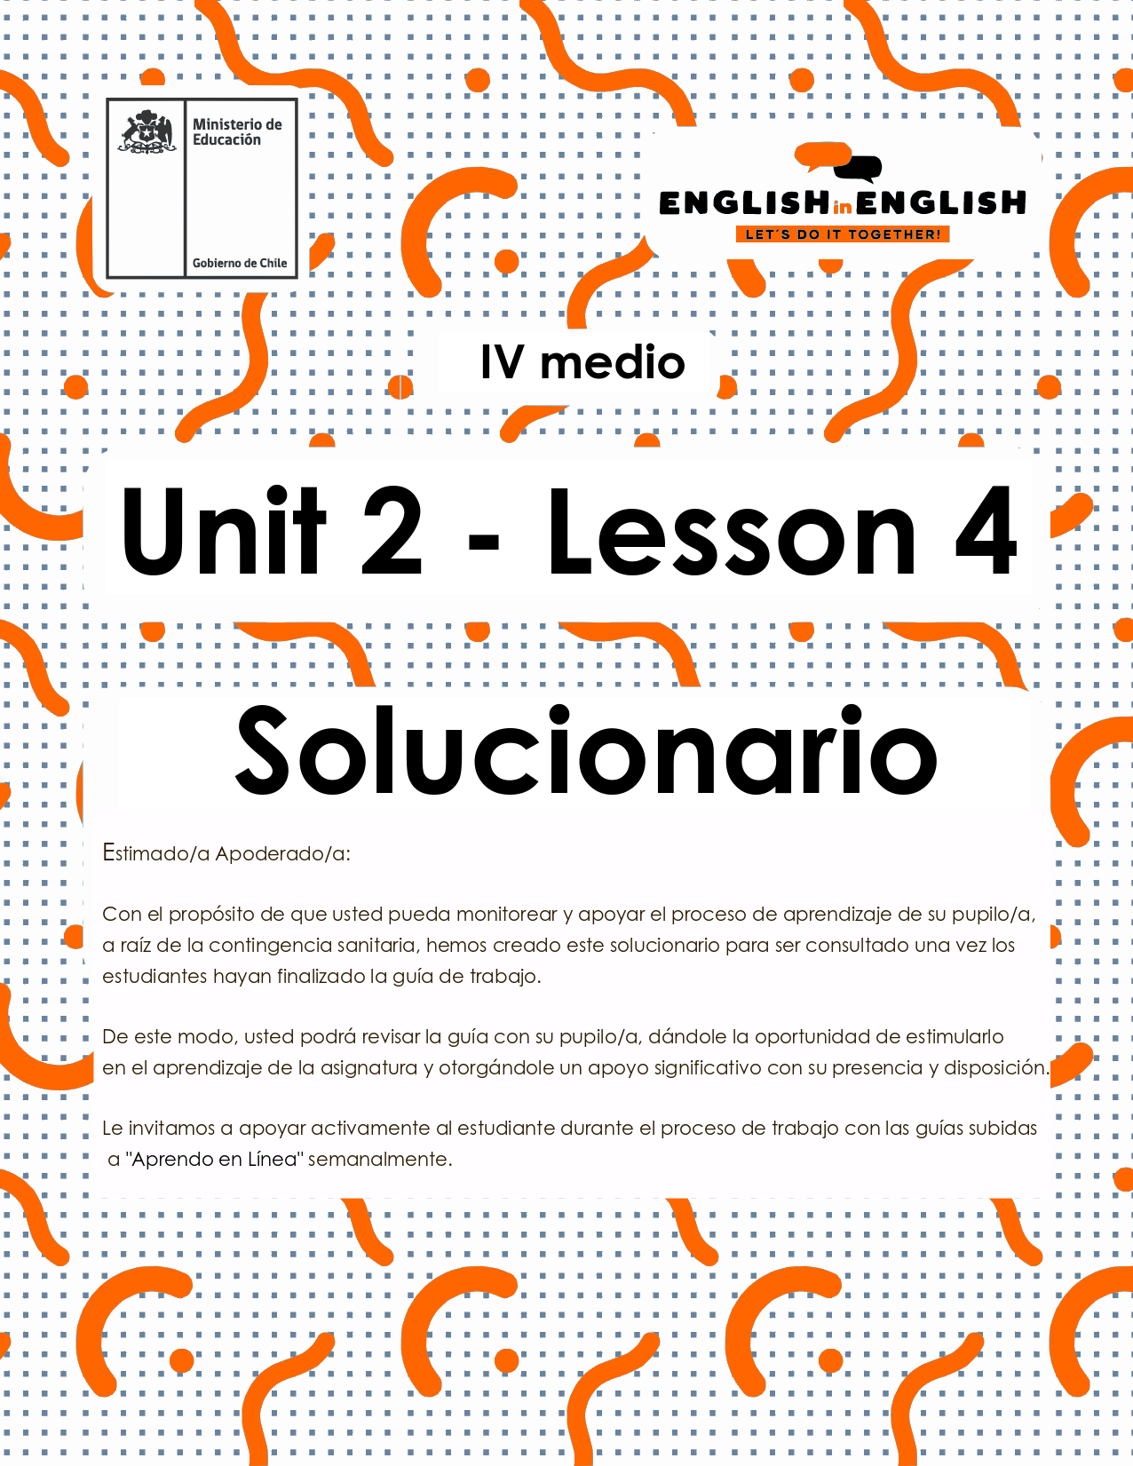

UNIT 2
LESSON 4

ÚTILES

- Texto del estudiante de 4° medio.
- Diccionario de inglés.
- Lápices.
- Cuaderno de asignatura.

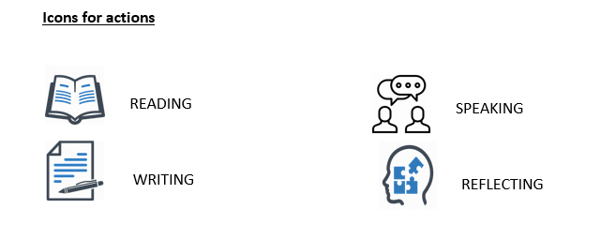

SECTION 1: SETTING THE CONTEXT: 

Hello students! Welcome back to the review lesson for unit 2.
In this lesson we will be working toward a practice project where we will express our artistic ideas to show your art to your community
- First, can you find the music styles and artistic manifestations in this word search activity?
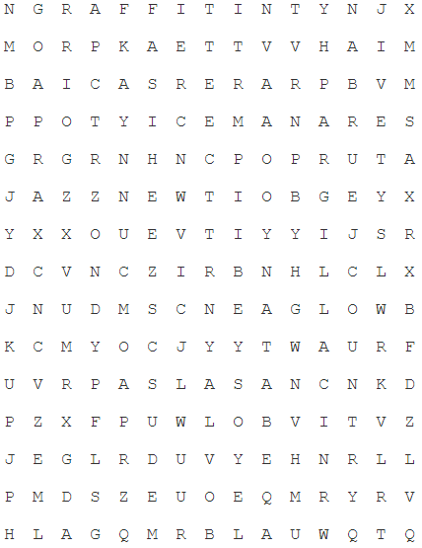 | rock  salsa  techno  jazz  opera  graffiti  intervention  urban  rap  trap  painting  calligraphy  jive  country  exposition
- If you found 15 words you have excellent searching skills.
- If you found less than 10, you need to work harder.
- If you found less than 5, take a rest and try again.

2. Good job! Now read the following words and cross out the odd one out:

a. Historical / ancient / modern / old
b. Social media / communication / individuality / network
c. Pretty / ugly / good-looking / attractive
d. Benefit / risk / menace / threat

3. What about unscrambling the following words? Try to decipher each word from previous activities and worksheets. After that, make a sentence with each word.

MNIAESFATOINT | ORKC | BNURA | VAFELSIT
Manifestation | Rock | Urban | Festival

- Music is a form of artistic manifestation.
- I like rock and salsa. So, what?
- I used to like the urban style when I was young.
- I absolutely love Viña del Mar music festival.

SECTION 2: LET’S PRACTICE 

4. Do you recall the following? In English, as in Spanish, we use different verbs to express preferences. For example, like, love, prefer, enjoy, hate or don’t like are verbs to express preferences. Can you write a sentence with each one?


- HATE: | - LOVE | - LIKE | - DON’T LIKE

A) I hate when people are irresponsible towards their work
B) I love cotton candy and fruits
C) I like dancing, swimming and playing video games.
D) I don’t like all politicians, only some.

5. let´s practice! Imagine you find a diary belonging to Trinidad, a young girl who died 20 years ago. First, read about her and answer True (T) or False (F) for each of the statements below. Then, answer the questions according to your opinion.

Since I was little girl and used to live with my parents, I knew I would devote my life to music. It just makes me feel good and happy. For me, it is a language of emotion in that it can represent my feelings and inner dreams and hopes. I cannot imagine doing anything without listening to a sweet melody! That is what freedom means to me. Doing my favorite things anytime, anywhere. Not only music can make me happy, but also painting and writing poems. But nothing compares to picking up a pencil and a piece of paper and let my creativity flow. I truly believe I will not be able to do anything but compose and show my talent to the rest of the world!

a___T__ Trinidad loves the emotions that music makes her feel.
b___F__ She doesn´t like painting or writing poems.
c___F__ She hates to listen to music all the time.
d___T__ She enjoys the freedom she feels thanks to music.
e___F__ She doesn´t like the idea of dedicating her life to music.

6. Read the paragraph again. Suppose you want to know more about Trinidad to write a composition for your language class. Use your imagination to answer the following:

- How old was she? ____she was 10 years old______.
- Where did she live? ____she lived in South America ______.
- Why did she write those words? ___for homework____.
- When did she write them? ____in her free time_____.
- Who were her parents? ____possibly musicians ____.

SECTION 3: LET’S CONSTRUCT AND APPLY OUR KNOWLEDGE

EXPANDING YOUR ART, SHOWCASING YOUR TALENT

7. Do you remember the work that you did in previous worksheets?
- You talked and discussed about art in many different forms and different artists.
- Also, in the last worksheet you created your own art manifestation, what did you do?
- Do you remember?

Well, now it’s time for you to show your talent to the rest of your community. We want you to create a poster, a piece of news, a video, or anything you want to show your piece of art to your community (it can be your family, your friends, your classmates, maybe your neighbors, whoever you want!). Make sure you include and answer these questions:

- The name of your piece of art
- The materials you used
- The date when you did it
- What does it represent?
- How does it make you feel?
- Why do you think it is important?
- Who do you think it is represented in your piece of art?

Here it is an example:
“My name is Dimitra Milan, and I’m 16 years old. I’m a painter. My parents have given me a lot of advice about creating beautiful art and the creative process. They taught me to be defined from the inside, not the outside. That I find my identity in God, and not what the world or people think about me. I know that beauty starts from within before it manifests where it can be seen. Concerning the creative process, they have taught me that hitting a wall is a natural part of growth as an artist. When you get stuck or frustrated, you take risks and push through until you break through the wall and find a discovery. I paint what I see as beautiful, noble, true, and worthy. I paint women because they are beautiful, and they represent how I feel. I paint animals as symbols and believe they represent a deeper meaning.
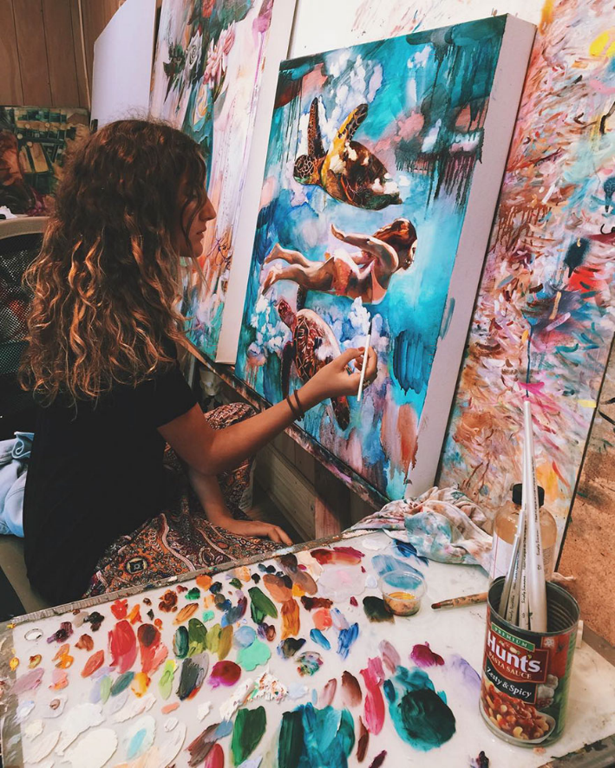
Texto adaptado de https://www.boredpanda.com/16-year-old-young-artist-surreal-painting-dimitra-milan/?utm_source=google&utm_medium=organic&utm_campaign=organic

READ EXAMPLE ABOVE _______________________________________________________________________________________________________________________________________________________________________________________________________________________________________________________________________________________.

