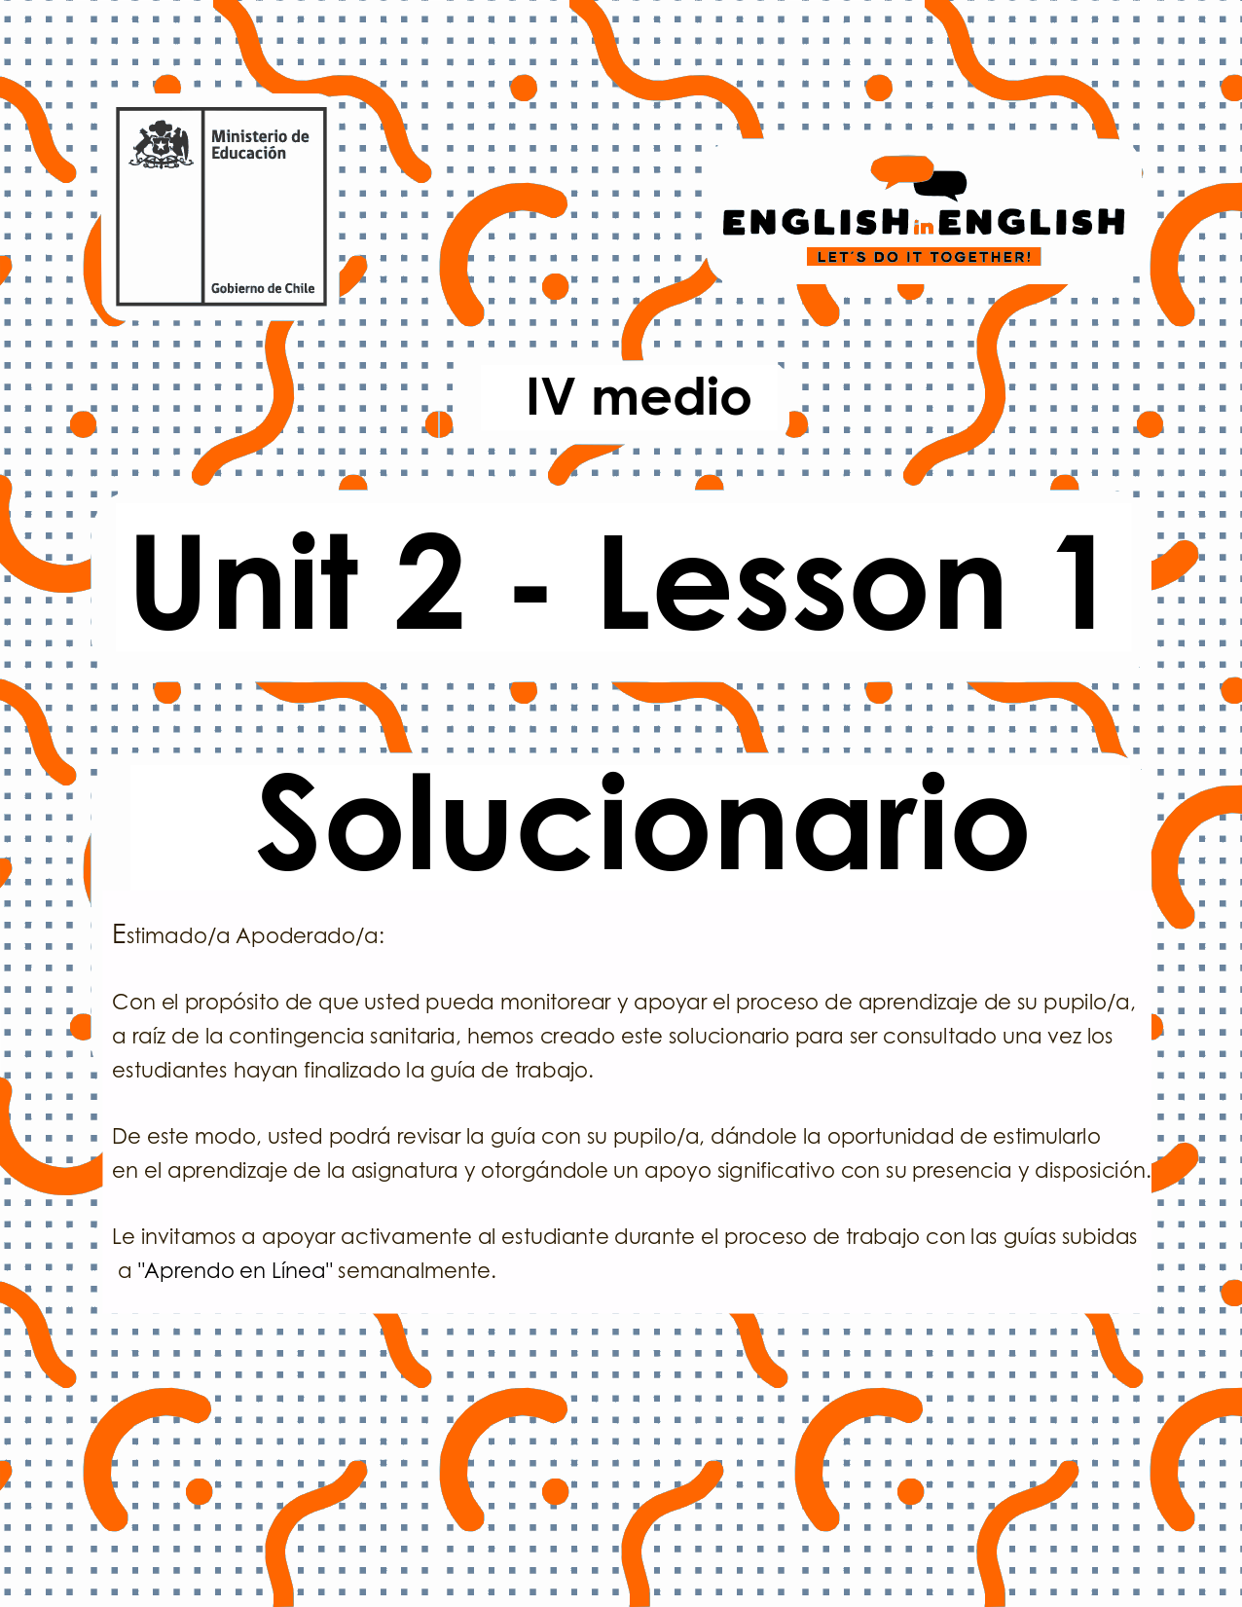

UNIT 2
LESSON 1

SECTION 1: SETTING THE CONTEXT

Vocabulary: Music and urban art

Hello students, welcome to unit 2!
- Do you like music? if your answer is yes, can you explain why?
- Use these words for reference: tone, music, feelings, and freedom.

Sample answer: Yes, I do. I love music because I feel free, and Iit helps me to express my feelings.

- Do you know any of these urban arts manifestations?

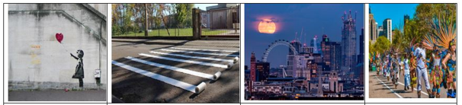
Graffiti | intervention | Urban landscape | Street festivals

If your answer is yes, which one do you prefer? and why?
Sample answer: I prefer street festivals because I love to see people happy and dancing.

- Can you label the music style under the corresponding image?
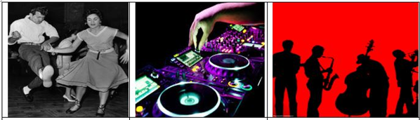
ROCK AND ROLL | ELECTRONIC | JAZZ
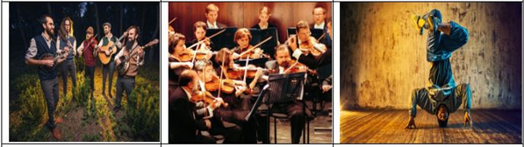
FOLK | INSTRUMENTAL -CLASSICAL | HIPHOP- BREAK DANCE
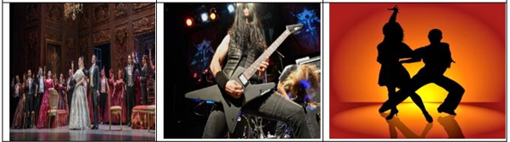
OPERA | HEAVY METTAL | SALSA

- Let's study the following vocabulary capsule about compound words.
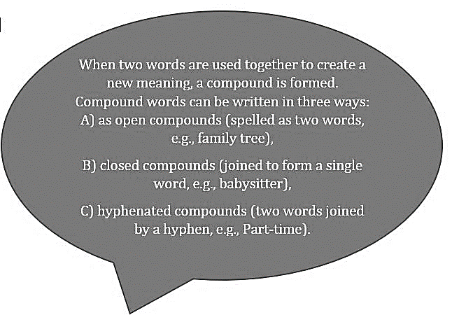
Now, can you classify and translate the words in the box into these three categories?

viral risk /social media/ workplace/ good-looking / homework / bright-coloured / wonderland
social network / well-known

as open compounds | SOCIAL NETWORK / VIRAL RISK / SOCIAL MEDIA
as closed compounds | WORKPLACE / WONDERLAND / HOMEWORK
as hyphenated compounds | GOOD-LOOKING / BRIGHT-COLOURED / WELL-KNOWN

For translation
RISGO VIRAL | MEDIOS SOCIALES | LUGAR DE TRABAJO | ATRACTIVO
TAREA PARA LA CASA | BRILLANTE | REFERENTE A TIERRA DE MARAVILLAS | RED SOCIAL
BIEN CONOCIDO

SECTION 2: LET’S PRACTICE!
- Once you have already started working on this Unit, what about unscrambling the following?
- FIAGRTIF GRAFFITI
- TAR ART
- SPEACANLD LANDSCAPE
- MNIAESFATOINT MANIFESTATION
- NABRU URBAN

- Odd man out: cross out the word that does not belong to the group:
- Risk - danger - poison - benefit
- Good-looking - beautiful - ugly - handsome
- Task - homework - assignment - option
- Workplace - workshop - worksheet – handiwork

- Have a look at the following sentences and underline according to the meaning of the statement in bold:

- Urban landscape refers to:

- Buildings, highways, skyscrapers,etc.
- Farms, harvest, barns, etc.
- Desert, Oasis, islands, etc.

- Instagram and Facebook are very well-known teens apps means:
- They are unknown apps for teens.
- They are bright-coloured apps.
- They are very popular among teens.

- “To complete our band project, we need two get some keyboards and drumsticks”. The underline words talk about:
- Musical careers
- Musical instruments
- Musical theatres

- It is probable that at least one viral risk will arise soon reflects that:
- A dangerous event will happen soon.
- A dangerous event will never happen.
- None of the above.

SECTION 3: LET´S CONSTRUCT AND APPLY OUR KNOWLEDGE

- Complete the following crossword with the vocabulary from the previous activities:
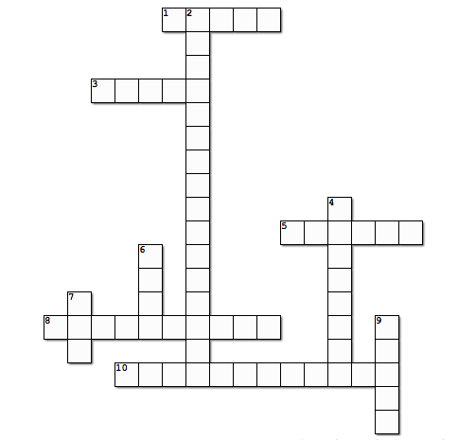

Down

- 2. A structure which is a result of the interaction between the human and the environment (URBAN LANDSCAPE)

- 4. A form of expression consisting of drawing and painting, usually made on walls and for public view (GRAFFITI)

- 6. A very popular music style born in the 40's, developed from 'Rock and Roll' (ROCK)

- 7. Cultural manifestation made in different ways, such as music, theatre, painting. (ART)

- 9. Performance art consisting of body movement (DANCE)

Across

- 1. A form of art made of musical instruments, rhythm, and other elements (MUSIC)

- 3. A mix of music and theater where the singers take the lead role (OPERA)

- 5. The words of a song (LYRICS)

- 8. An athletic style of street dancing, accompanied with break and hip hopmusic (BREAKDANCE)

- 10. An artistic interaction with a previously existing work, audience, or space (INTERVENTION)

- Let’s write and talk about you.
- What style of art do you like?
- What kind of music you don’t like?
- You can use the vocabulary from the previous activity if you want.
- For example:

- I like urban landscapes because they transform concrete and urban areas into beautiful architecture.

(sample answers)

- I like graffiti because it is a form of expression for youngsters.

- I like interventions because they are creative and original forms of art.

- I like classical music, because it is beautiful, and it makes me relax.

SECTION 4: EXTRA ACTIVITY

Talking about Music and urban art, read the following statements and cross out the incorrect alternative
- Rio de Janeiro Carnival is a street / religious festival.
- Graffiti are painted on the open spaces / walls.
- The person creating lyrics for a song is a singer / composer.
- How many of the most popular music styles / style do you know?

