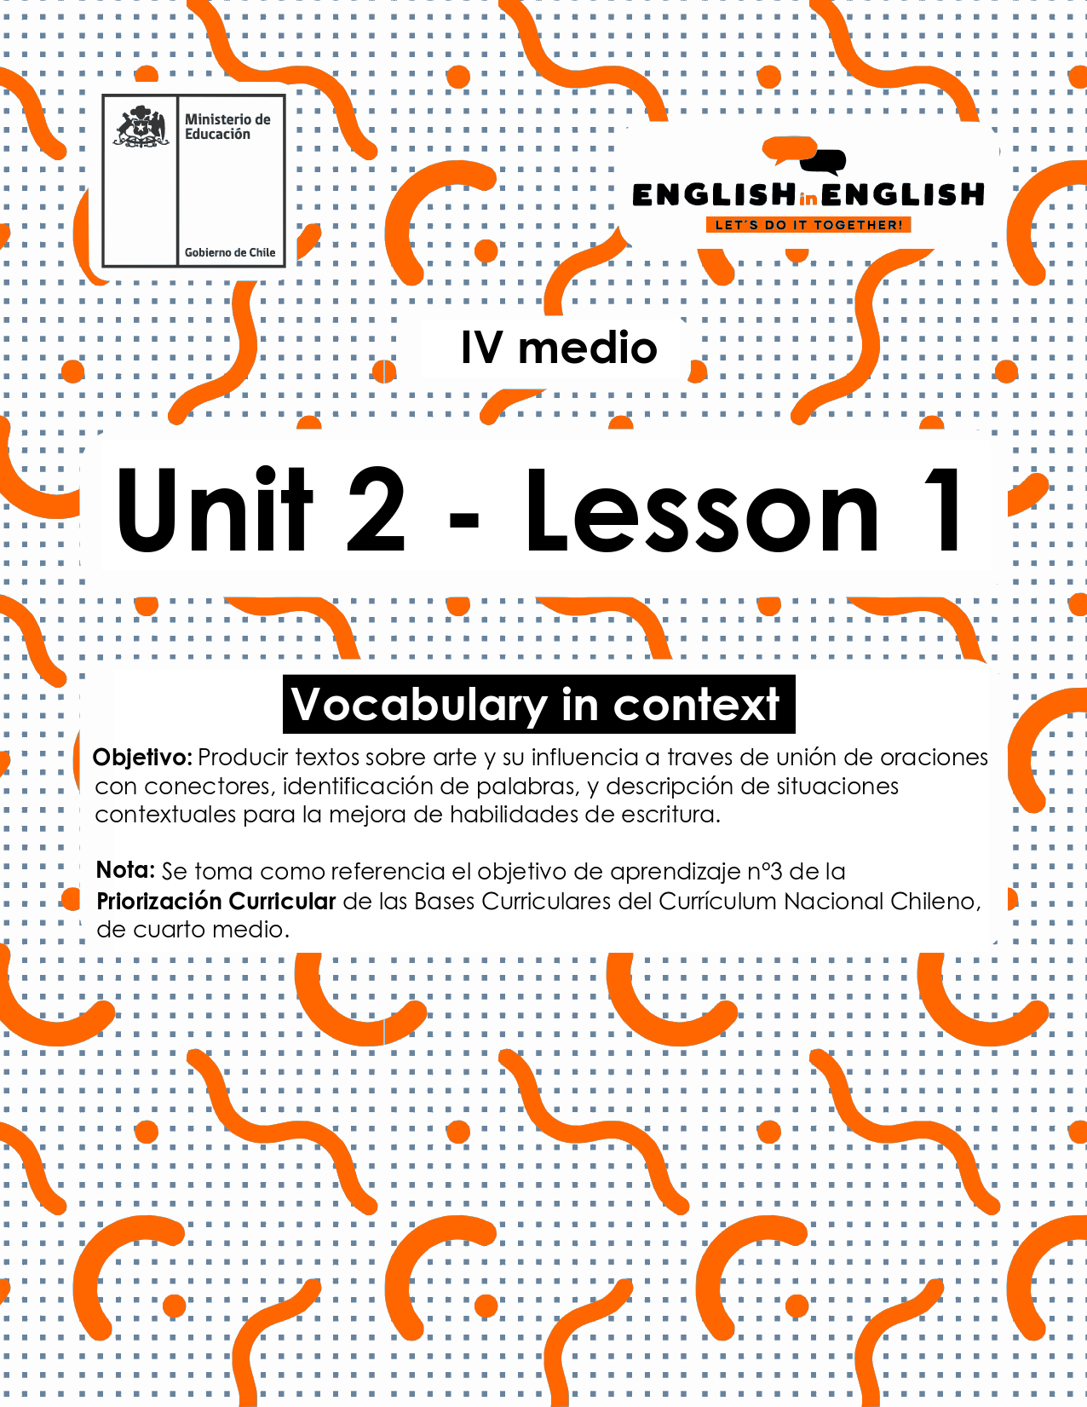

UNIT 2
LESSON 1

ÚTILES

- Texto del estudiante de 3° medio.
- Diccionario de inglés.
- Lápices.
- Cuaderno de asignatura.

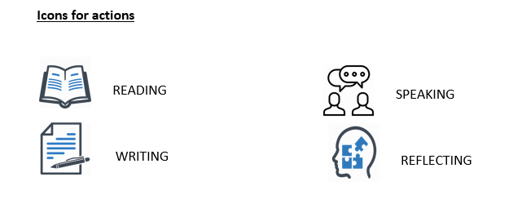

SECTION 1: SETTING THE CONTEXT

Vocabulary: Music and urban art

Hello students, welcome to unit 2!
- Do you like music? if your answer is yes, can you explain why?
- Use these words for reference: tone, music, feelings, and freedom.
_______________________________________________________

- Do you know any of these urban arts manifestations?

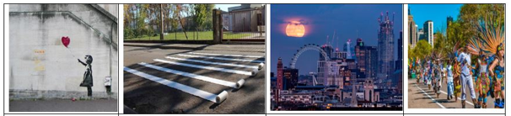
Graffiti | intervention | Urban landscape | Street festivals

If your answer is yes, which one do you prefer? and why?
_______________________________________________________

- Can you label the music style under the corresponding image?

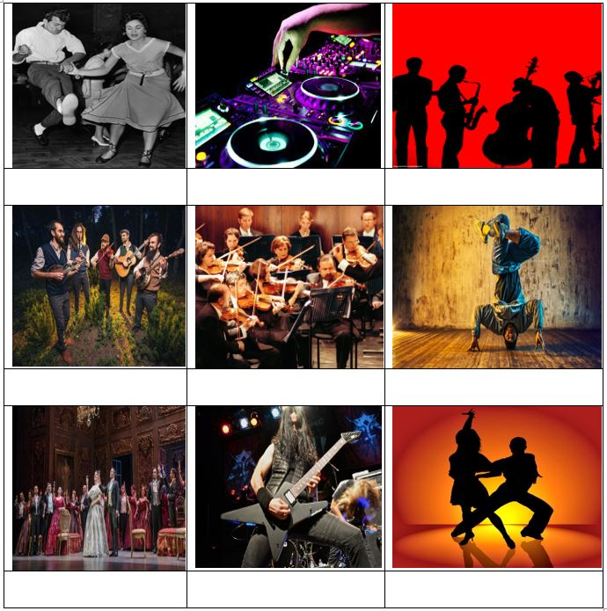

- Let's study the following vocabulary capsule about compound words.
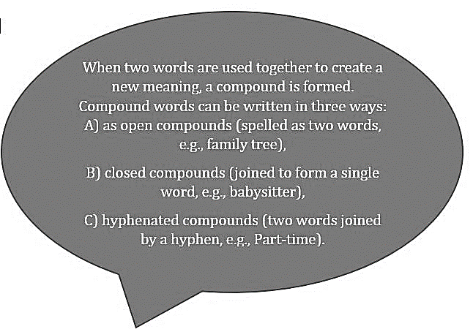
Now, can you classify and translate the words in the box into these three categories?

viral risk /social media/ workplace/ good-looking / homework / bright-coloured / wonderland

social network / well-known

as open compounds
as closed compounds
as hyphenated compounds

For translation

SECTION 2: LET’S PRACTICE!
- Once you have already started working on this Unit, what about unscrambling the following?

FIAGRTIF______

TAR_____

SPEACANLN________

MNIAESFATOINT________

NABRU_______

- Odd man out: cross out the word that does not belong to the group:
- Risk - danger - poison - benefit
- Good looking - beautiful - ugly - handsome
- Task - homework - assignment - option
- Workplace - workshop - worksheet – handiwork

- Have a look at the following sentences and underline according to the meaning of the statement in bold:

- Urban landscape refers to:

- Buildings, highways, skyscrapers,etc.
- Farms, harvest, barns, etc.
- Desert, Oasis, islands, etc.

- Instagram and Facebook are very well-known teens apps means:
- They are unknown apps for teens.
- They are bright-coloured apps.
- They are very popular among teens.

- “To complete our band project, we need two get some keyboards and drumsticks”. The underline words talk about:
- Musical careers
- Musical instruments
- Musical theatres

- It is probable that at least one viral risk will arise soon reflects that:
- A dangerous event will happen soon.
- A dangerous event will never happen.
- None of the above.

SECTION 3: LET´S CONSTRUCT AND APPLY OUR KNOWLEDGE

- Complete the following crossword with the vocabulary from the previous activities:
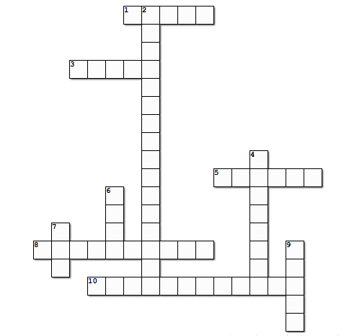

Down

2. A structure which is a result of the interaction between the human and the environment
4. A form of expression consisting of drawing and painting, usually made on walls and for public view
6. A very popular music style born in the 40's, developed from 'Rock and Roll'
7. Cultural manifestation made in different ways, such as music, theatre, painting.
9. Performance art consisting of body movement

Across

1. A form of art made of musical instruments, rhythm, and other elements
3. A mix of music and theater where the singers take the lead role
5. The words of a song
8. An athletic style of street dancing, accompanied with break and hip hopmusic
10. An artistic interaction with a previously existing work, audience or space

- Let’s write and talk about you.
- What style of art do you like?
- What kind of music you don’t like?
- You can use the vocabulary from the previous activity if you want.
- For example:

- I like urban landscapes because they transform concrete and urban areas into beautiful architecture.

- I like_________________, because_______________________________.

- I like_________________, because_______________________________.

- I like_________________, because_______________________________.

SECTION 4: EXTRA ACTIVITY

Talking about Music and urban art, read the following statements and cross out the incorrect alternative
- Rio de Janeiro Carnival is a street / religious festival.
- Graffiti are painted on the open spaces / walls.
- The person creating lyrics for a song is a singer / composer.
- How many of the most popular music styles / style do you know?

