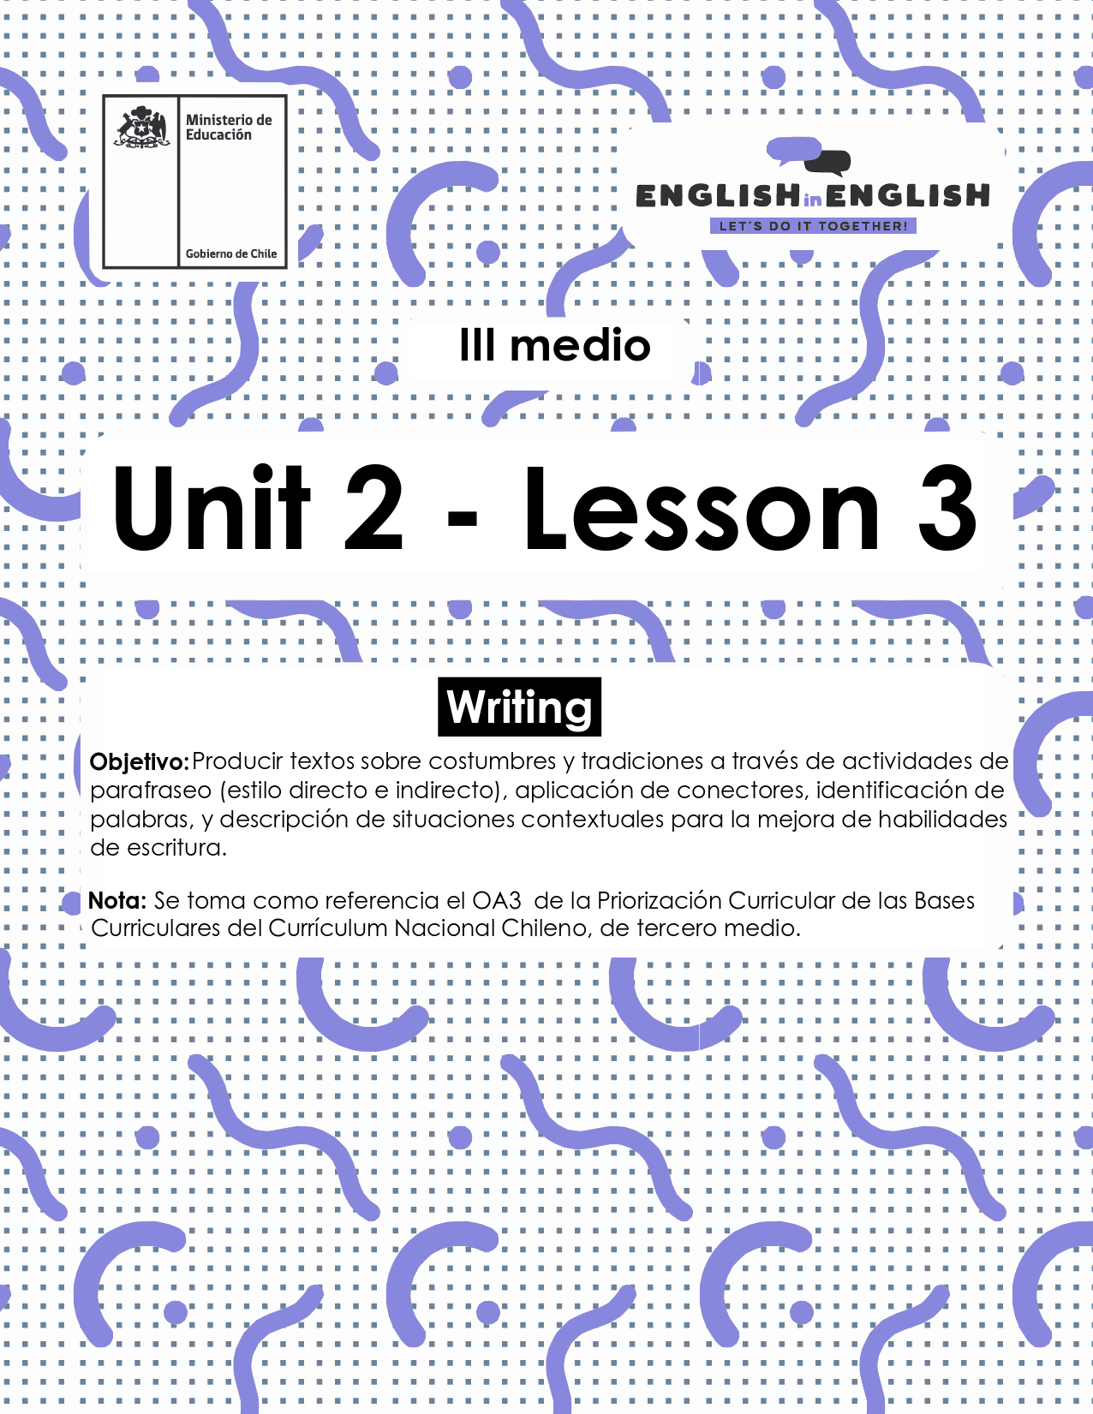

UNIT 2
LESSON 3

ÚTILES

- Texto del estudiante de 3° medio.
- Diccionario de inglés.
- Lápices.
- Cuaderno de asignatura.

ICONS FOR ACTIONS

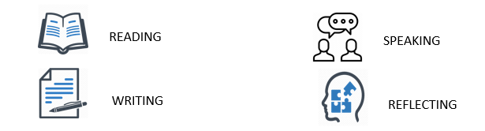

SECTION 1: SETTING THE CONTEXT 

Welcome to lesson number 3! Now it is time to practice Writing skills. So, let´s get started!

- Do you recall some opinions or facts from lesson number 2 about reading?
- We worked on customs and traditions all over the world.
- Write down some ideas:

Fact(s):

Opinion(s):

Sometimes it is not easy to discriminate what a fact or an opinion might be. How can you distinguish between them both? Remember! A fact is something that can be checked and backed up with evidence, while an opinion is based on a belief or view.

- Considering that, write down some facts and opinions you may know about the following topics:

Topic | Fact | Opinion
- For example: Europeans having Penpal friends. | It is commonly used by young people. | It can be hard for adults as it involves having certain TICs skills.
- Chilean teens backpacking across our country.  - Americans celebrating “sweet 16” and Mexicans “quinceañera”.  - Brazilians wearing white clothes during New Year´s Eve. | .

Traffic signs are part of our culture. We use them to regulate the traffic and for preventing accidents. Let´s check your knowledge about traffic signs.

- Look at the sign and underline the right alternative.
 | - You should stop  - You must stop  - You might stop

 | - You must enter  - You mustn't enter  - You should enter

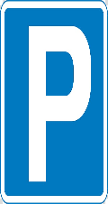 | - You should park  - You must park  - You can park

SECTION 2: LET´S PRACTICE 

- Read the following information about Ramon
Ramon is a Chilean teenager who has traveled all over the world with his parents. At the age of 16 Ramon has many friends in different countries including China, Haiti, Russia, Colombia, Venezuela, among others. Yesterday, Ramon was chatting with his friend Konico from China about the things he should and should not do in China if he ever visited. Konico told him that in China:
- You shouldn’t talk about uncomfortable sensitive topics with strangers.
- You shouldn't show up in a house empty handed if you are invited.
- You should travel in licensed transportation services only.
4.1 Using the information from Konico, write 5 sentences giving advice to foreigners who are visiting Chile:
- Foreigners should __________________________
- They shouldn't ____________________________
- Foreigners perhaps_________________________
- Maybe foreigners should ____________________
- They should never _________________________

- Look at the key words that match each definition below:
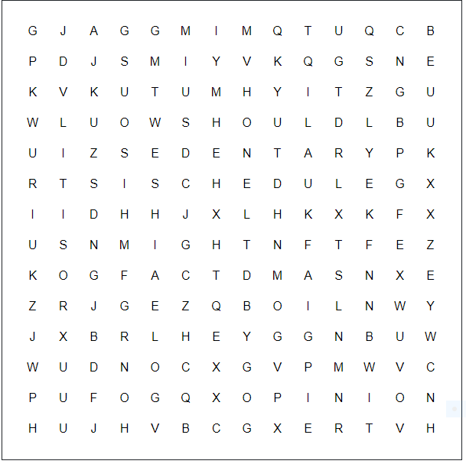
5.1 Now, write the words below
- ______is used for giving advice and recommendations.
- ______is used to express (un) certainty.
- ______is something that can be checked.
- ______is based on a belief.
- ___ __refers to someone who is not active.
- ______indicates times and days for organization purposes.

5.2 Finally, write original sentences with the words from the previous exercise:
- ____________________________________________________
- _______________________________________________
- _______________________________________________
- ______________________________________________
- _______________________________________________
- _______________________________________________

- Do you remember the text from last week? It was about Italian teenagers and how they are living the quarantine in Italia.

- The first teenager was Rami, and he said this:
“I consider myself a very sedentary person. Usually during the school holidays, I tend to stay at home most of the time. Quarantine is not affecting what I would normally do with all this extra free time, and I know I must stay at home. One of the things that changed is my schedule. Since I don’t have to wake up at 6 am, I started to wake up later and later, and as a result I ended up having lunch, dinner, and going to bed at least two hours after my usual time, although I should go back to my usual schedule”.
6.1 What do you think Rami must do about his schedule?

6.2 What do you think Rami should do about his sedentary life?

- The next teenager was Alice, and she said:
“Staying at home is difficult, more than anything else, because I can’t see my friends in person, but I understand that going out might be dangerous for me and my family. Apart from not going to school and participating in extra-curricular activity, the only different thing is not going out with my friends”.
6.3 What do you think might happen if you go outside during quarantine?

6.4 What do you think Alice should do with her friends when they meet again?

- The last teenager was Chiara, and she mentioned this:
“Obviously, I miss my friends and going out, but I get along well with my family and maybe I’ve always been a bit lazy, so adapting wasn’t difficult. Instead of going out with friends, on Saturday nights, I watch movies or series with my family, something nobody had time to do before. I spend most of my days studying, but I also have virtual meetings and chat with my friends, but physically it is different, and I miss that aspect.
At first it took me a while to know what was really happening, but I’m optimistic: if we all respect the rules and stay at home, we will be able to get out of this situation”.
6.5 What do you think may happen with “movie time” when Chiara’s family go back to their normal routine?

6.6 What rules you must follow during quarantine?

SECTION 3: LET´S CONSTRUCT AND APPLY OUR KNOWLEDGE

7. Imagine you are invited to post an article at a digital international travel magazine.
- The invitation involves including some pieces of advice when a foreigner may want to visit Chile.
- What would you suggest him or her doing?
- Use the following prompts:
- Time of the year and climate
- Travel documents like passport, visa, entry fee, parental ones, etc.
- Main tourist attractions
- Local traditions and Chilean culture

You may start with something like “To visit Eastern Island in February for the Tapati Rapa Nui celebration, first you must have a valid passport to get to Chile first. Second, you should bring summer clothes and diving equipment if you might practice some water sports. Also, you must not harm or destroy historical sites like the Moai at Rano Raraku...


SECTION 4: EXTRA ACTIVITY

8. Can you tell us about your quarantine life?
- Please write a short paragraph about you.
- Start by introducing some facts about you, and then continue with some opinions or predictions you may have.
- You can answer these questions to have an idea:
- What is your name?
- Where are you from?
- What is your favorite activity?
- How have you been feeling lately?
- What good advice can you give to other teenagers who are living in quarantine in this moment? Remember to use “should”
- What do you think may or might happen to you in this school year?

