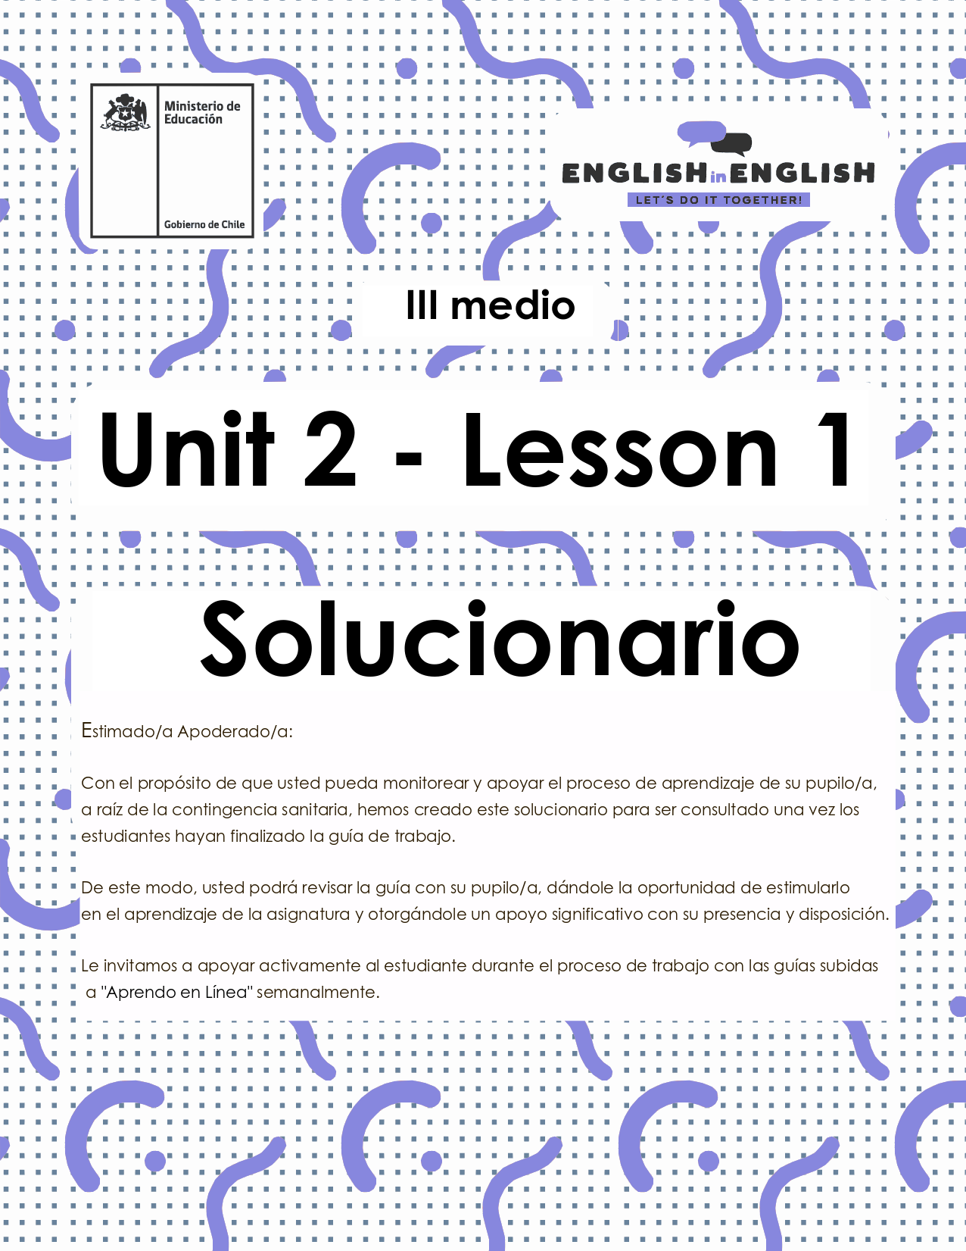

UNIT 2
LESSON 1

ÚTILES

- Libro de inglés de 3° medio.
- Diccionario de inglés.
- Lápices.
- Cuaderno de asignatura.

ICONS FOR ACTIONS

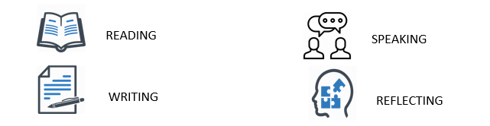

SECTION 1: SETTING THE CONTEXT: 

Vocabulary: Traditions and food

- Look at the following images and match the words with their corresponding definition.
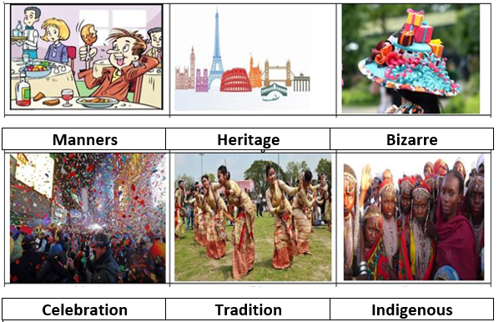
  - A _CELEBRATION_ refers to the action of celebrating an important day or event.
  - __MANNERS_______________ refers to the ways of behaving toward people, specifically to ways that are socially correct and show respect for others in social settings.
  - ___INDIGENOUS___ refers to something or someone naturally existing in a place or country rather than arriving from another place.
  - __BIZARRE___ is something or someone that is very strange or unusual.
  - ____TRADITON ______________ refers to features belonging to the culture of a particular society, such as traditions, languages, or buildings, that were created in the past and still have historical importance.
  - ____HERITAGE_____ is a belief, principle, or way of acting that people in a particular society or group have continued to follow for a long time.

- Let's classify some vocabulary! Can you classify these synonyms (or related words) in the chart below?
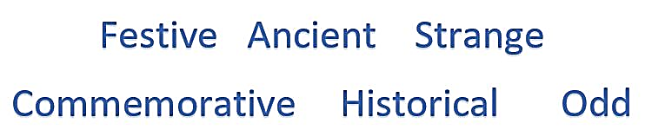
Celebration | Bizarre | Traditional
FESTIVE | ODD | HISTORICAL
COMMEMORATIVE | STRANGE | ANCIENT

- Do you like traditional food?
  - Can you write the list of ingredients for these Chilean traditional recipes?
  - If you don´t know you can ask your family.
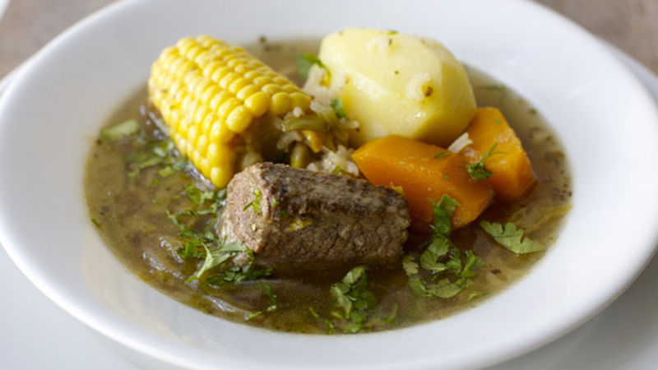 | 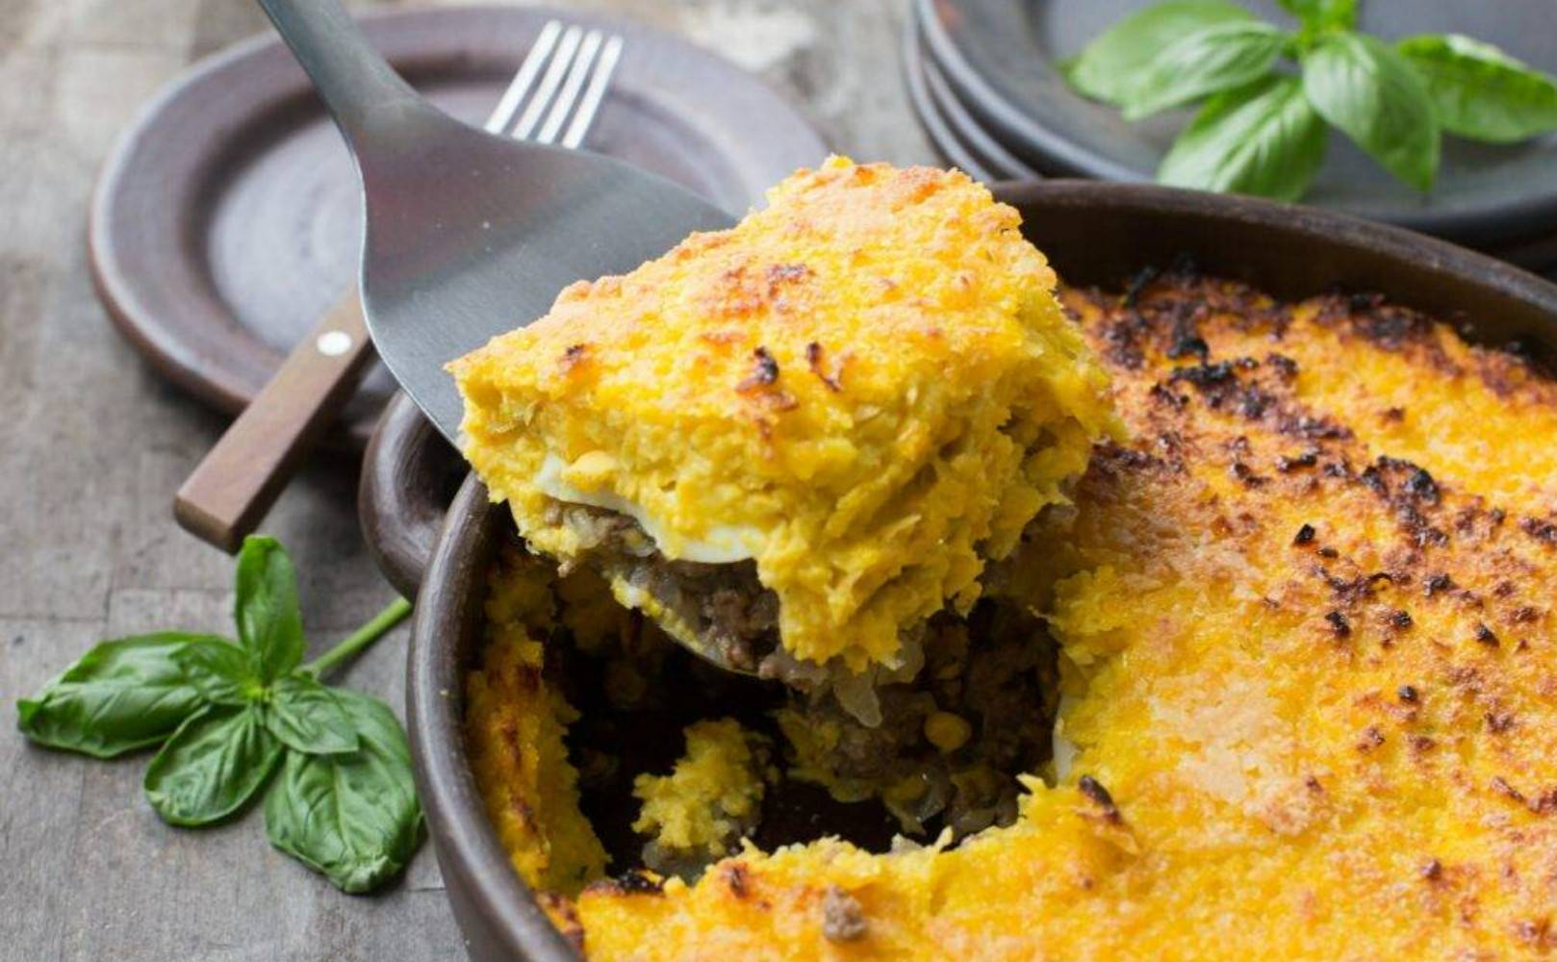
Ingredient for Chilean Cazuela  · beef  · vegetable oil  · onion, cut into quarters  · teaspoon oregano  · teaspoon ground cumin  · Salt and pepper  · CARROT  · PUMPKIN  · POTATOES | Ingredients for sweetcorn pie  · beef  · chicken  · vegetable oil  · CORN  · ONION  · OLIVES  · SALT  · EGGS  · SUGAR

SECTION 2: LET´S PRACTICE 

- Once you have already started working on this Unit, what about unscrambling the following words?
DOD | ODD
MNAENSR | MANNERS
TANICNE | ANCIENT
NDITEGERN | INDIGENOUS
ZBIEZAR | BIZARRE
ETEHIGR | HERITAGE

- Odd man out: cross out the word that does not belong to the group:
- Example: Have fun – celebrate - get bored - have a blast

- Food - poison - meal - snack
- New - historical - ancient - antique
- Misbehaviour - manners - habits - good attitudes

- Have a look at the following sentences and circle according to the meaning of the statement in bold:
- Observing local traditions and customs refers to:
- Looking at people celebrating their culture.
- Obeying local customs according to people's beliefs.
- Looking for certain local urban stories.
- Historical monuments should be kept safe means:
- They need to be taken care of by every person in any community.
- They do not have to be protected or maintained.
- They are made just to give cities a different look.

- Culture is whatever people do anytime and anywhere as they have grown up inside a specific community talks about:
- Festivals
- Celebrations
- Heritage

- Locals may come at midday to pick up their Chinese food portion reflects that “_______ are coming to get some Asian food by 12.00 PM.”
- People
- Shops
- One person

- Talking about traditions/customs and food, what do you think about the following?
- Do you think the sentences below are traditions or facts (things happening according to specific situations)?
- Fill in with T for tradition and F for fact.
- _T_ Chilean people go to fondas and parties at national festivities in September.
- _F__ Eating too much traditional Mexican food like tacos or enchiladas can be dangerous for your body.
- _F_ The more calories you eat daily, the more you will gain weight.
- _T__ People in Chiloe believe that Caleuche and el Trauco belong to their own history and heritage.

SECTION 3: LET´S CONSTRUCT AND APPLY OUR KNOWLEDGE

- Let’s use the vocabulary you learnt during this worksheet.
- Complete the text using the words from previous activities.
- There are many options you can use if you pay attention to activity 1-C:
People all over the world have different traditions and customs. They all celebrate their own important dates or events in the most varied ways. Some may appear bizarre or odd to you, but it is probably because your own culture is different. The important thing is to understand that differences make us unique, and cultural differences should open your eyes to other different realities.
In Chile, for example, we celebrate our national holidays with barbeques, empanadas, and different social gatherings. Some kids play typical games and fly kites. Usually, we meet with our family and sometimes with friends in a festive environment. However, in Venezuela, even though the national holidays are a historical event, they don’t celebrate in such a big way like Chileans do. | 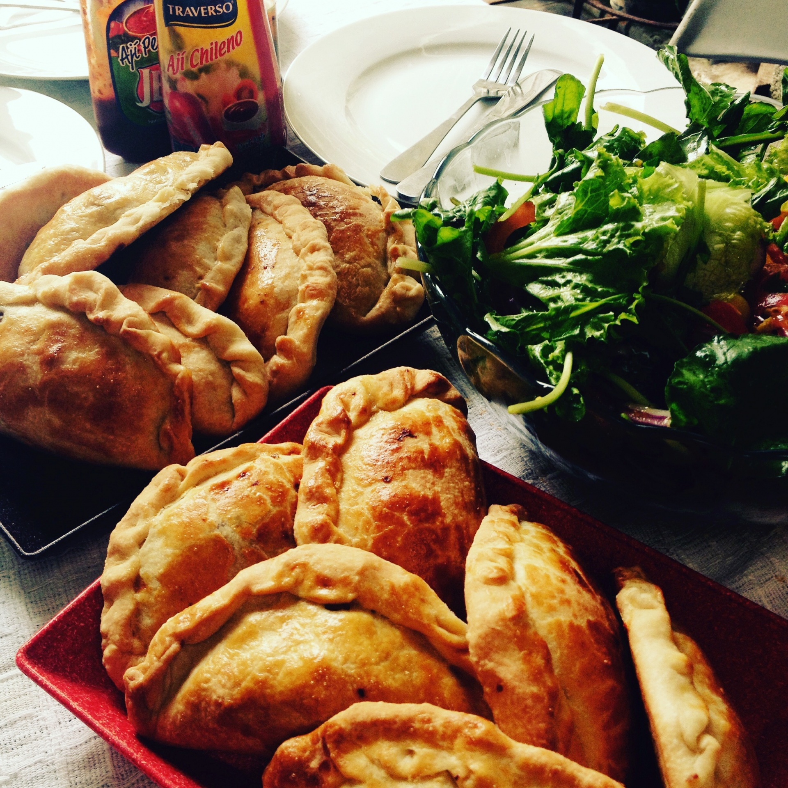
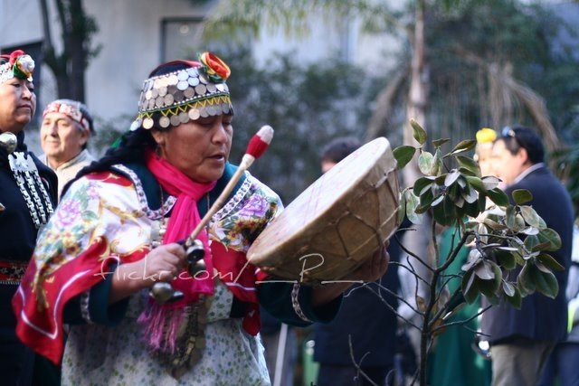 | There are indigenous celebrations that are also important and very festive. Mapuches, for example, celebrate “We Tripantu”, which is the Mapuche New Year celebration, and it is an ancient heritage that has survived until these days. “We Tripantu” is celebrated during June, unlike the common New Year’s Eve in December.
While in December people have dinner and gather with their family to receive the new year, Mapuches celebrate in June to welcome the new year with a social gathering where the elders teach the young the ancient manners and Mapuche traditions. Then, when the sun comes up, they bathe in a river or lake. Different, right? But that’s the great thing about traditions, we can all learn about different cultures and understand that these differences are the richness of our society”.

9.Now it’s your turn to write.
- Can you describe some traditions or celebrations in Chile or in other parts of the world?
- Maybe traditions from your own family?

Place | Celebration | Date | Family tradition
My house | Christmas | December 24th | Dad cooks Christmas dinner and we meet with my relatives at midnight to open presents and eat Christmas bread
Fonda | Independence Day | September 18th | With my family we go to fondas and eat traditional food
My house | My birthday | August 24th | My brothers, mom and dad wake me up with breakfast

SECTION 4: SPONGE ACTIVITY

- Now let’s put the description into sentences, you can follow this example:
- “In my family there is a tradition. For Christmas, on December 24th, my dad cooks the Christmas dinner, and we meet with my relatives to open presents and eat Christmas bread”.

Sample for reference:
In my family, there is a tradition. For Independence Day, on September 18^{th,} my family and I go to the Fondas in Parque O'Higgins and we eat a lot of traditional food. It is delicious and fun!

