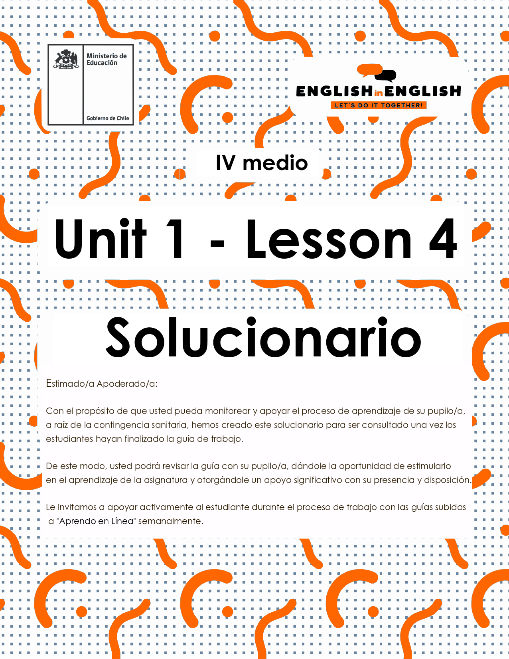

LESSON 4
REVIEW

ÚTILES

- Texto del estudiante de 3° medio.
- Diccionario de inglés.
- Lápices.
- Cuaderno de asignatura.

ICONS FOR ACTIONS

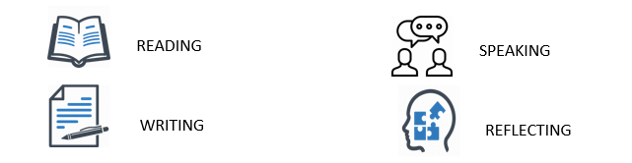

VOCABULARY SECTION 1: 
Hey there! Now it is time to check all you have learnt during the previous three worksheets. So, let us get started!

- Can you remember 8 words from past lessons? Look at the pictures for inspiration and Write them down:
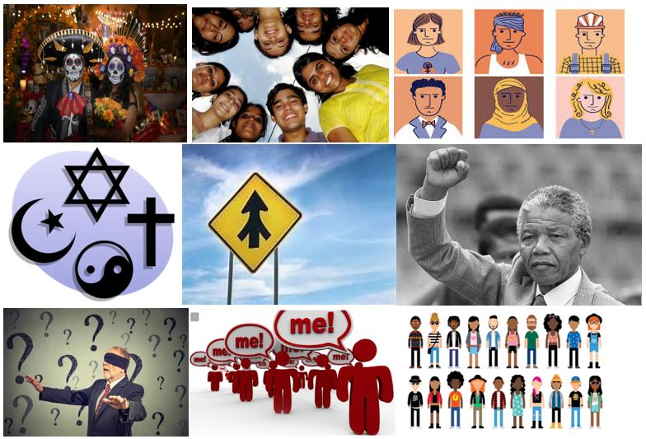
- TRADITION
- YOUNGSTERS
- STEREOTYPE
- BELIEF
- MERGE
- LEADER
- UNAWARE
- SELF-CENTERED OR GENERATION

- Unscramble the following key words:
- EGEMR: __MERGE
- ONTIRADTI: _TRADITION
- RATNEGEION: _GENERATION

- Have a look at the words in bold and fill in the definitions with them:

self-centered / unaware / youngsters / tradition / prejudice
- They are people between the ages of 10 and 16: youngsters
- The transmission of customs from generation to generation: tradition
- Someone only worried about their own needs: self-centered
- A preconceived opinion not based on opinion or experience: prejudice
- Not knowing something means to be unaware
- Choose and circle the correct option to complete the sentence:
- Ultimate science discoveries have kept/shifted to start new ways of living nowadays.
- Every people/generation has stories to tell.
- Last Saturday night's soccer match really came to life/come to life almost in the end!
- The teacher has challenged/challenge me to improve my English all the time!
- Come on! Do not support firsts impressions/first impressions...Just live and let die!

GRAMMAR SECTION 
To continue this review, we will work with some grammar!
Do you remember the “adverbs of sequence” from last week?
Well, in English and in Spanish, we use adverbs of sequence to describe the order in which things happen. We often use adverbs of sequence to tell a story, write a recipe, or give directions!

- Can you unscramble the words and form adverbs of sequence?
Example: SRIFT - FIRST
XETN __NEXT__ ETNH ____THEN__ TRAFE ___AFTER_
YFLINAL__FINALLY_ ATAS TA AT LAST _ ERLTA _LATER__

- Once you have unscrambled the words can you classify them in these three groups
Beginning | Middle | Ending
FIRST | THEN-NEXT | AT LAST
TO START | AFTER-LATER | FINALLY,

- Finally, look at the three-picture sequence, and write three sentences to create a coherent idea.
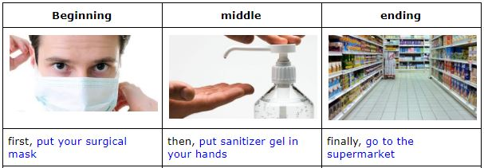
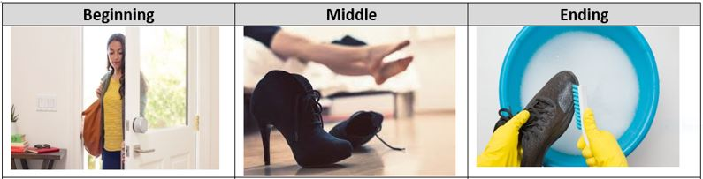
First, ARRIVE HOME
Then, REMOVE YOUR SHOES
Finally, CLEAN THEM WITH A SANITIZER SOLUTION

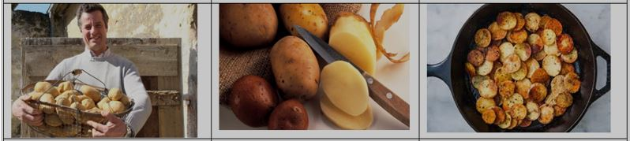
First, BUY 1 KILOGRAM OF POTATOES
Then, PEEL AND CUT THE POTATOES IN SLICES
Finally, FRY AND TOSS THEM BEFORE YOU EAT

SECTION 3: Practice Project activity: Down with stereotypes
Before finishing this review, we want to invite you to show us your impressions about your generation and your friends.
- First, write a stereotype you think that old people have about your generation, for example “young people are lazy”.
- Then, paste a picture that you like about you or your friends related to the stereotype.
- Finally, write a short paragraph (5 to 6 lines) explaining your picture and why the stereotype in the first part is false.
Step one | Step two | Step three  

You can use the previous worksheets as a template for the paragraph describing your picture, or you could answer the following questions:

- Why did you select that stereotype?
- where did you listen to it?
- How is it false?
- What is your belief about your generation?
- How is your picture representing your belief?
- What do you think about your generation in general?

Also, remember to include some of the keywords you have learnt in these past weeks.

Step one:
People think we don’t care about important aspects like politics or education, because they think we are mainly rioting. That is a wrong stereotype.

Step two:
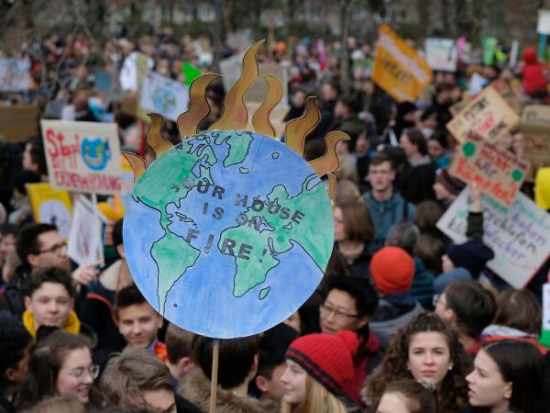

Step three:

Most people in my country believe that we do not care about important things, that is not right! We care A LOT about the environment, the animals, flora, and fauna. It is important for us to change that idea because we want to change the world. We are changing as the world is changing!

