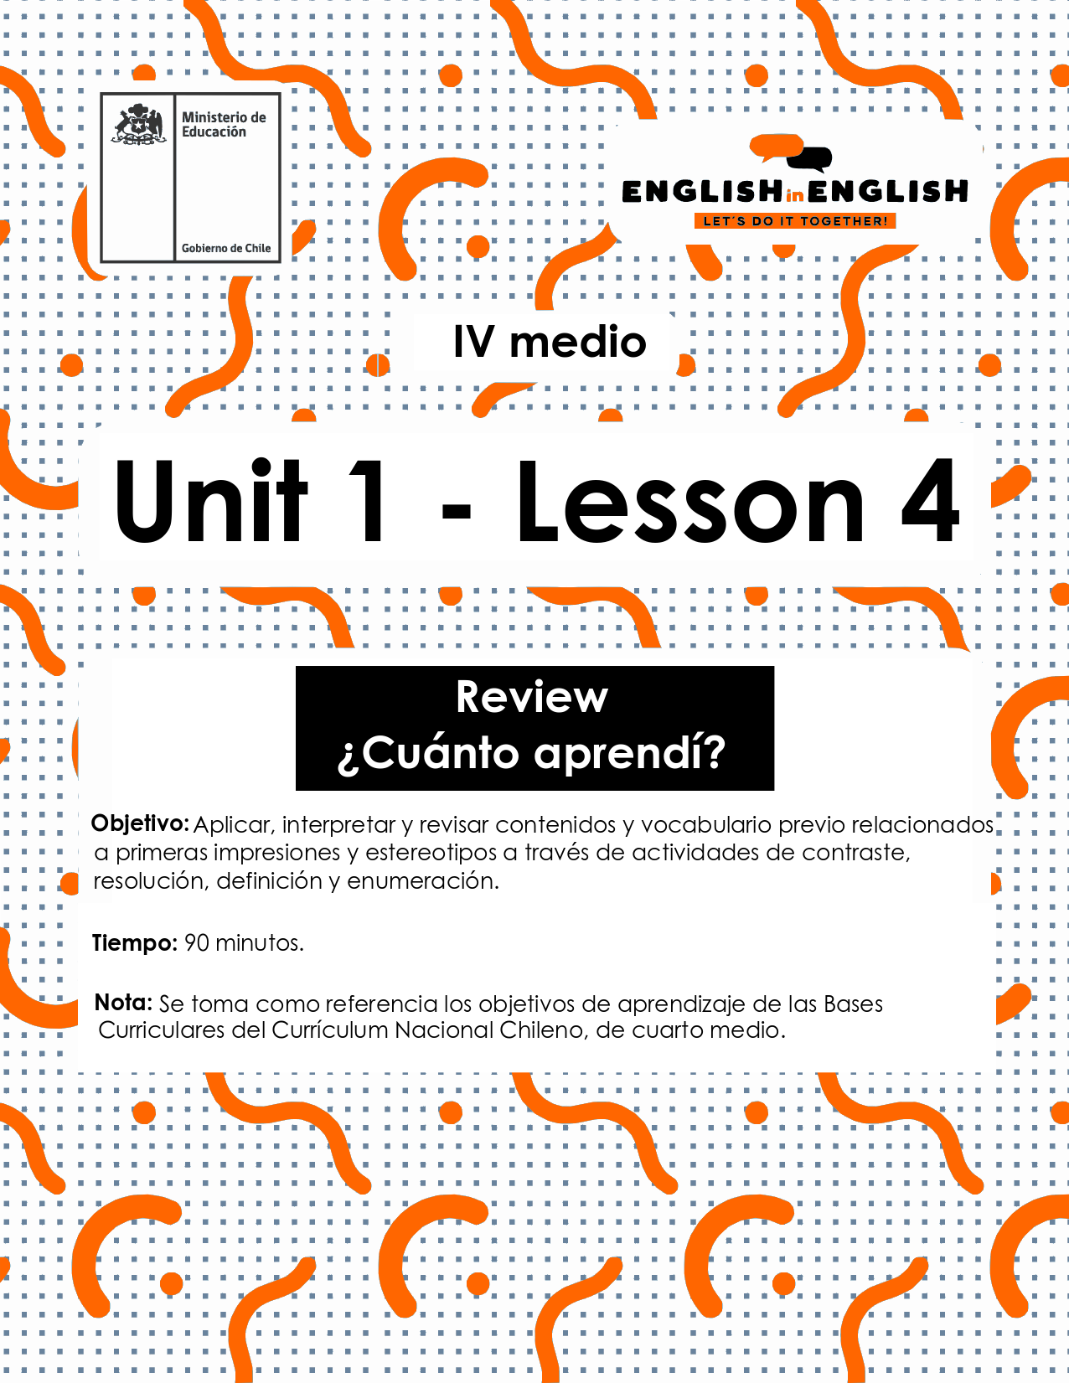

LESSON 4
REVIEW

ÚTILES

- Texto del estudiante de 3° medio.
- Diccionario de inglés.
- Lápices.
- Cuaderno de asignatura.

ICONS FOR ACTIONS

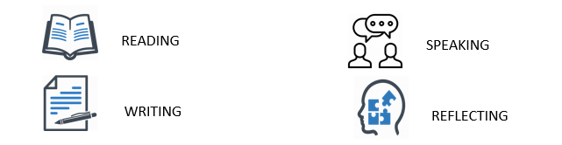

VOCABULARY SECTION 1: 
Hey there! Now it is time to check all you have learnt during the previous three worksheets. So, let us get started!

- Can you remember 8 words from past lessons? Look at the pictures for inspiration and Write them down:
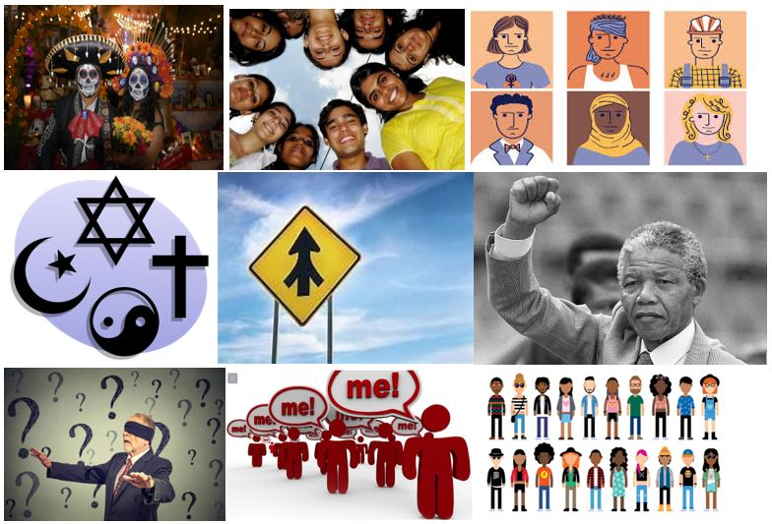
a_______________ b_____________ c_____________ d ________________
e ______________ f _____________ g _____________ h _______________

- Unscramble the following key words:

EGEMR: ___________
ONTIRADTI: ____________
RATNEGEION: ________
- Have a look at the words in bold and fill in the definitions with them:

self-centered / unaware / youngsters / tradition / prejudice

- They are people between the ages of 10 and 16: _________________________
- The transmission of customs from generation to generation: ________________
- Someone only worried about their own needs: __________________________
- A preconceived opinion not based on opinion or experience: _______________
- Not knowing something means to be: _________________________________

- Choose and circle the correct option to complete the sentence:
- Ultimate science discoveries have kept/shifted to start new ways of living nowadays.
- Every people/generation has stories to tell.
- Last Saturday night's soccer match really came to life/come to life almost in the end!
- The teacher has challenged/challenges me to improve my English all the time!
- Come on! Do not support firsts impressions/first impressions...Just live and let die!
GRAMMAR SECTION 
To continue this review, we will work with some grammar!
Do you remember the “adverbs of sequence” from last week?
Well, in English and in Spanish, we use adverbs of sequence to describe the order in which things happen. We often use adverbs of sequence to tell a story, write a recipe, or give directions!

- Can you unscramble the words and form adverbs of sequence?
Example: SRIFT - FIRST

XETN ____________ ETNH _____________ TRAFE _____________
YFLINAL__________ ATAS TA __ ________ ERLTA _____________
- Once you have unscrambled the words can you classify them in these three groups
Beginning | Middle | Ending
- Finally, look at the three-picture sequence, and write three sentences to create a coherent idea.
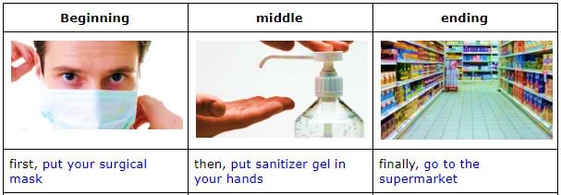

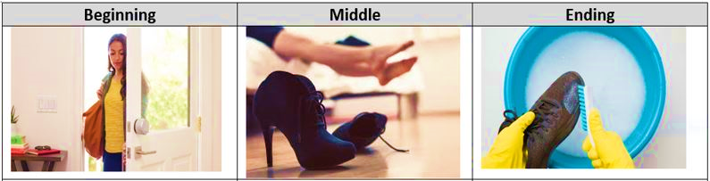
First, ……………………………………………………………………………….
Then, ………………………………………………………………………………
Finally, ……………………………………………………………………………
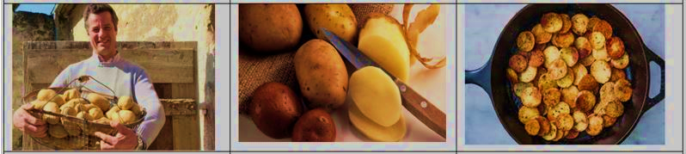
First, ……………………………………………………………………………….
Then, ………………………………………………………………………………
Finally, ……………………………………………………………………………
SECTION 3: Practice Project activity: Down with stereotypes
Before finishing this review, we want to invite you to show us your impressions about your generation and your friends.
- First, write a stereotype you think that old people have about your generation, for example “young people are lazy”.
- Then, paste a picture that you like about you or your friends related to the stereotype.
- Finally, write a short paragraph (5 to 6 lines) explaining your picture and why the stereotype in the first part is false.
Step one | Step two | Step three  

You can use the previous worksheets as a template for the paragraph describing your picture, or you could answer the following questions:

- Why did you select that stereotype?
- where did you listen to it?
- How is it false?
- What is your belief about your generation?
- How is your picture representing your belief?
- What do you think about your generation in general?

Also, remember to include some of the keywords you have learnt in these past weeks.

Step one:

Step two:

Step three:

