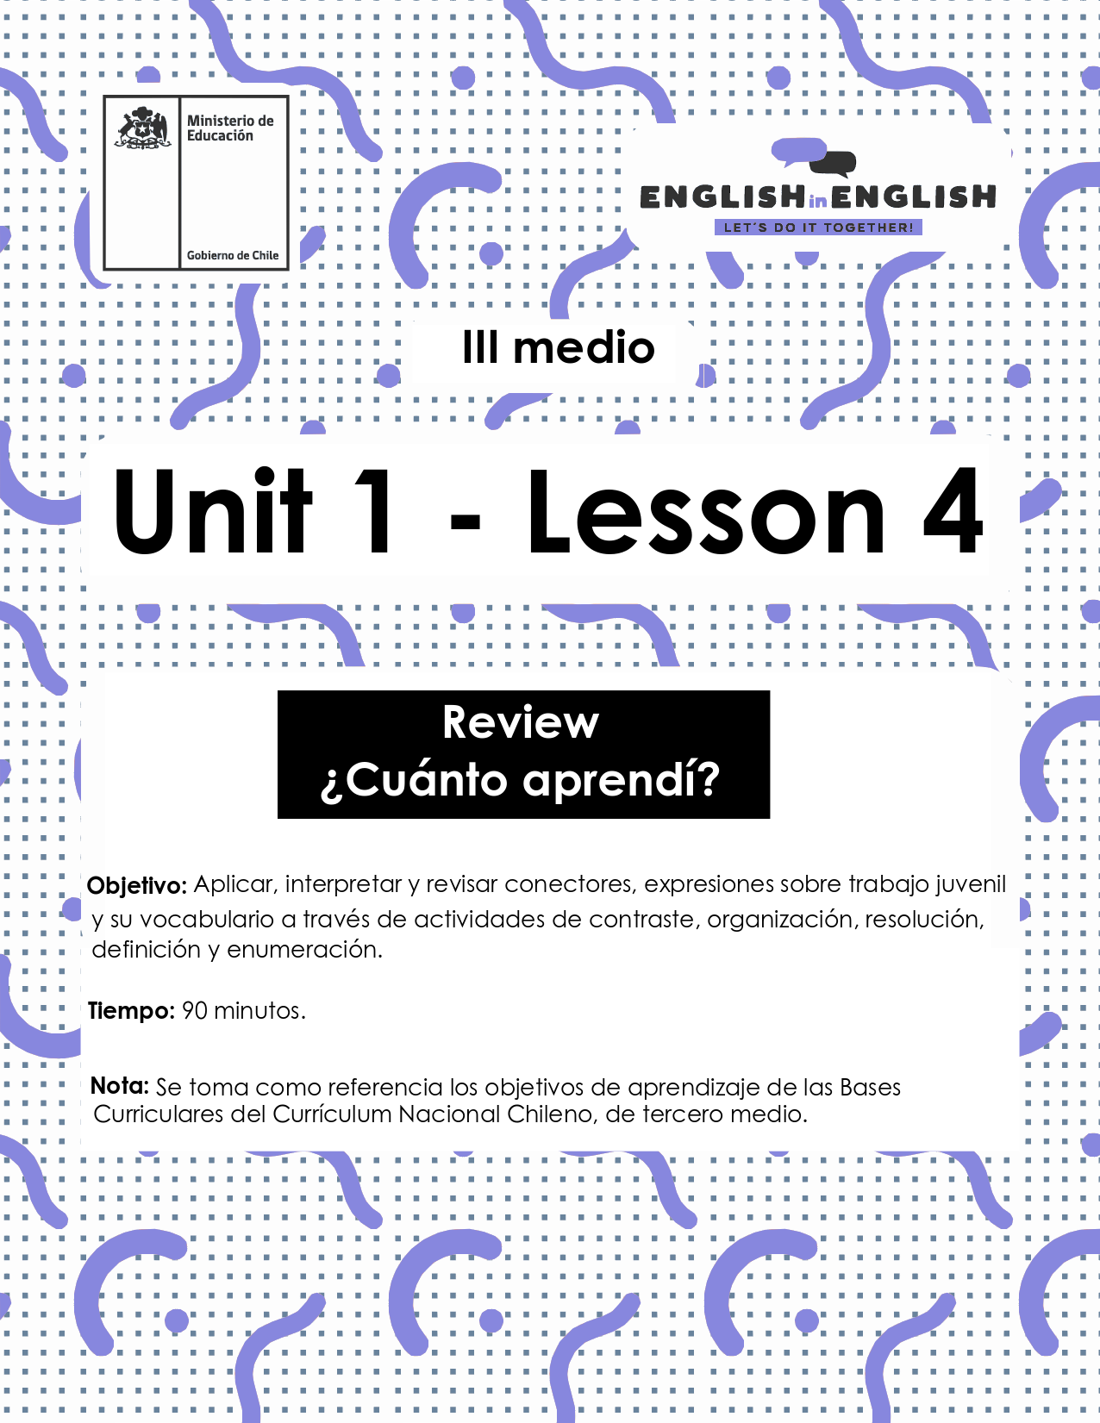

LESSON 4
REVIEW

ÚTILES

- Texto del estudiante de 3° medio.
- Diccionario de inglés.
- Lápices.
- Cuaderno de asignatura.

ICONS FOR ACTIONS

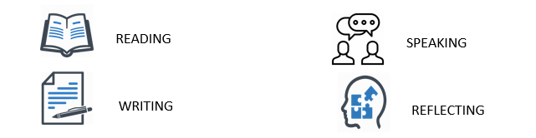

VOCABULARY SECTION: 
Hey there! Now it is time to check all you have learnt during the previous three worksheets. So, let us get started!

- Can you remember 8 words from past lessons? Look at the pictures for inspiration and Write them down:

a_______________ b_____________ c_____________ d ________________
e ______________ f _____________ g _____________ h _______________

- Unscramble the following key words:

- EHUDSCEL: S__________
- b. MEPLYEOR: E___________
- c. SYARAL: S__________

- Have a look at the words in bold and fill in the definitions with them:

salary / employee / skills / obstacles / resume / interview
- Fixed, regular payment:____________________________________________
- Thing that blocks one's way or prevents or hinders progress: _______________
- A meeting of people face to face:_____________________________________
- Any person who works part- time or full time:___________________________
- A written compilation of your education and work experience:_______________

- Choose and circle the correct option to complete the sentence:
- An example of being reliable/unreliable means someone you can trust.
- To attend a job interview, it is preferable to dress up/overdress.
- I need to know how to be confidence/confident at work!
- research/researches has shown teens prefer having part time jobs while they are in high school.
- Assisting head teachers in overseeing and educating 10 students for five months has been one of the most remarkable qualities/accomplishments of Ms. Brown.

GRAMMAR SECTION 
To continue this review, we will work on some grammar!
Do you remember the “connectors” from last week?
- Well, in English connectors are conjunctive words that help us to link two or more sentences together. We reviewed two kinds of connectors:
Connectors of addition | and | My boss is a reliable and honest person
Connectors of addition | also | For the job I held an interview and I also wrote a motivational letter
Connector of contrast | but | In my current job I got a good salary, but the supporting benefits are not good
Connector of contrast | However | I am a confident I will get the position in the company; however, I am not sure if the location is in Valparaiso or Rancagua
Keyword: conjunctive- to form a connection
- Read Marcela´s opinion about the benefits of part-time jobs for her, then complete with the connectors of addition and contrast (and, also, but, However)

 Keywords: counterpart- equal | What are the benefits of part-time jobs for students?  Speaking for myself, talking on a part-time job while studying may be hard work, _______ the benefits are typically greater than the amount of a paycheck. Students who work during their college careers may develop better time-management _____ organization skills that their counterparts, because they have to apply them to their daily lives. Students earn money that can be used for fun or tuition tuitions, _______, not all students can save money for tuitions fees. Most students have other obligations with their families. For example, I _____ have to buy food, pay for my bus ticket and clothes so I can't really save enough money.

We also reviewed reported speech to represent what other person or people have said before. For example,
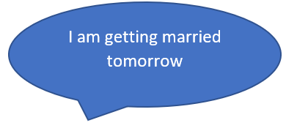 | 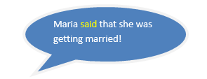
 | 

Here, we reviewed different verbs to report, such as mentioned, asked, said and told.

- Can you report what Patricia is saying? Use the given verbs.
Original sentence | Reported sentence
I am going on a trip to Sewell | Patricia mentioned…………………………..…….
I need help to pack my bag | Maria asked………………………….……
I am thrilled and excited about my trip | Patricia said………………………….……………...


Practice Project: Reporting your situation
- Before finishing this review, we want to invite you to practice your communication skills.
- Ask some members of your family or your friends (3 or 4 people) how they are doing in this quarantine.
- If any person you know is still going to their workplace, ask them about their situation too.

Here are some questions you can use (probably you will need to translate the questions into Spanish and the answers into English), but you can use your own too:
- How are you feeling today?
- What are the sanitary precautions you are taking in this quarantine?
- What are you doing to keep yourself busy?
- What is your daily routine?
- How are you getting to your workplace?
- What are the sanitary precautions in your workplace?
- What precautions do you take when you come back to your home?

Use reported speech, for example said, told, or informed, to write their answers and impressions here:
- Who did you interview? ____________________________________________________

- What did he/she say? My mom/dad said that___________________________________and_________________________________________________________________________________________but________________________.

- Who did you interview? ___________________________________________________.

- What did he/she say? ____________________________________________________________________________________________________________________________________________________________.

- Who did you interview?
____________________________________________________

- What did he/she say? ____________________________________________________________________________________________________________________________________________________________.

- Who did you interview? ___________________________________________________

- What did he/she say? ____________________________________________________________________________________________________________________________________________________________.

