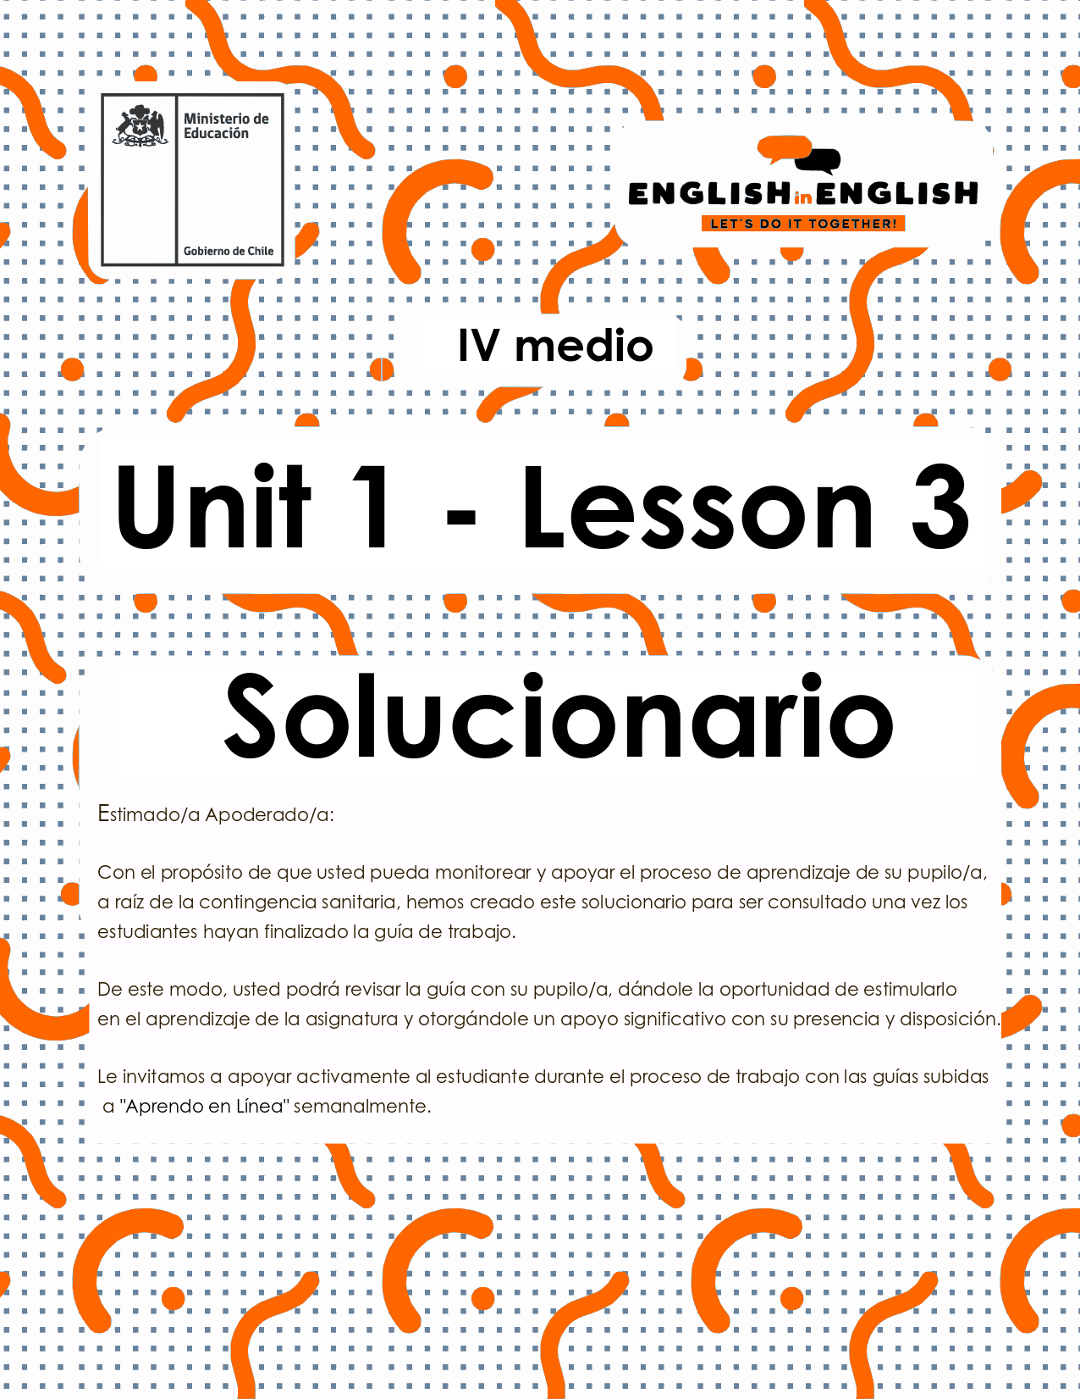

LESSONS 3
writing

ÚTILES

- Texto del estudiante de 4° medio.
- Diccionario de inglés.
- Lápices.
- Cuaderno de asignatura.

ICONS FOR ACTIONS

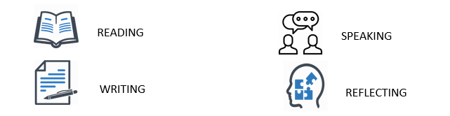

SECTION 1: SETTING THE CONTEXT 

1. Find in the word search game 20 words from class 1.
- Also, find 2 words about first impressions and stereotypes.

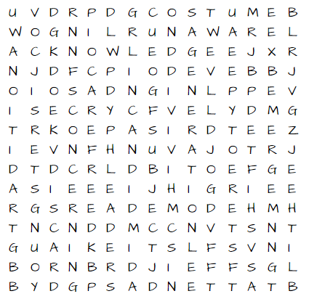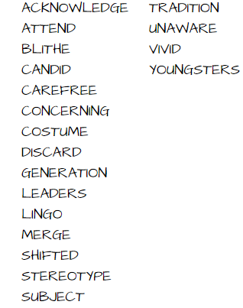

2. Read the study cloud
In English and in Spanish, we use adverbs of sequence to describe the order in which things happen. We often use adverbs of sequence to tell a story, write a recipe, or give directions. For example, to make a cup of tea…

First, you boil some water | 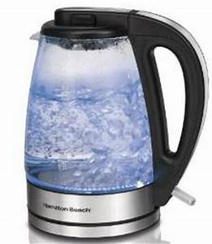
Next, you serve the water in the cup | 
Then, you put the teabag in the water | 
After, you add some milk and sugar (optional) | 
Finally, you add a biscuit and enjoy it | 

- Now, look at the following five images and circle the 2 sequences that are correct.
3
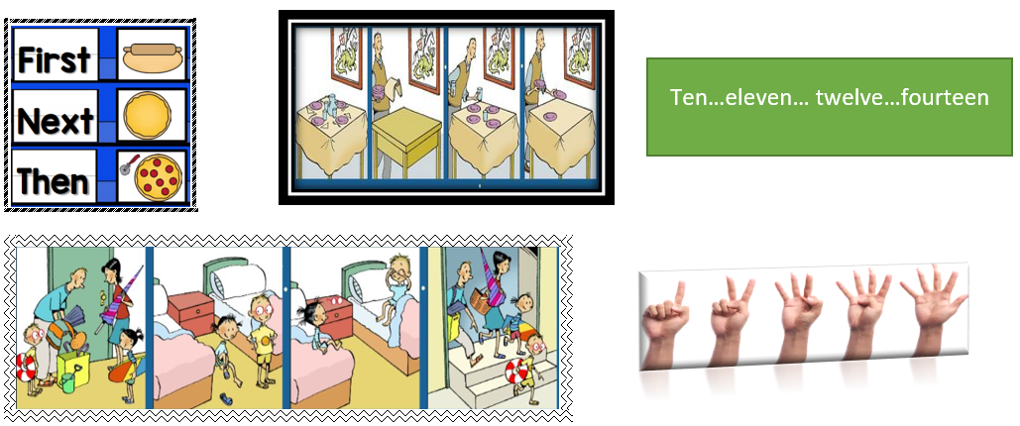
5
4
2
1
3. EXTRA adverbs of sequence.
- Complete the following table with the extra adverbs of sequence. These extra adverbs are synonyms!
BEGINNING | MIDDLE | ENDING
First | Then | Finally,
FIRST OF ALL | NEXT | AT LAST
TO START | LATER | BY THE END

SECTION 2: LET’S READ AND PRACTICE! 
4. Do you remember the photography contest we reviewed in the previous lessons?

- Let's put the sentences in a sequence, use numbers from 1 to 5.
(3) Later, the New York Times checked over 2.200 photographs, and selected the winners.

(1) First, the New York Times set up a photography contest

(2) Then, teenagers from around the world sent their photographs and their descriptions to enter the contest

(5) Finally, the New York Times published the winners on their webpage.

(4) Next, the photographs' descriptions were edited to fit the webpage’s standards
5. Now, read the following description about one of the photographs, and put the sentences in order.
- Use the key words in the box to help you.

Key words
Reliant: Someone who trusts/believes
Aid: Help
Willing: Someone who has disposition to do something

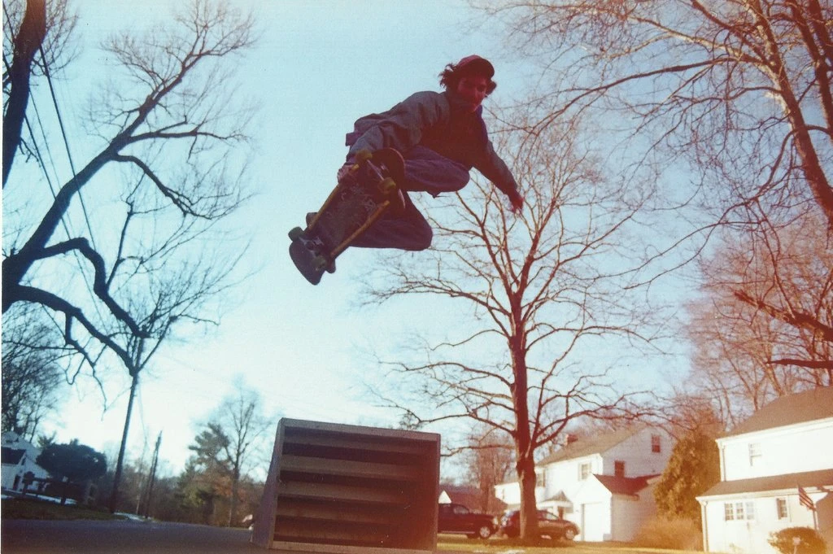 | Meet my friend Max, a 17-year-old kid from West Hartford, Conn. He’s not reliant on 21st Century technology. He uses it, sure, but as an aid. The internet, for Max, is a place to discover how to construct a traditional skate park, to build a skateboard ramp to launch off of, or to find a secret skate spot underneath a bridge. Max has more patience than most adults I know, being more willing to create than to take. He has shaped, cut and painted several of his own skateboards and ramps. It’s more fun and personal to make something with your own hands than to just buy it with an app on your phone.  Contrary to the stereotypes about my generation, we love to play outside and use our imaginations, we love to create, and we love to explore. Everything is a process, just like taking and developing these photographs on 35mm film. I get more satisfaction from being patient and persistent than I do from instantaneous rewards. —Jack Wisialowski, 17
Texto obtenido y modificado de https://www.nytimes.com/2018/10/30/learning/36-teenagers-show-us-their-generation.html

(1) First, Jack introduces his friend Max, a 17-year-old kid from West Hartford, Connecticut.
(7) Next, he names some characteristics of his own generation.
(5) and jack also tells us about his impressions about creating something on your own.
(3) and he mentions the different uses that Max gives to technology.
(8) Finally, Jack tells about what he thinks about rewards and finished processes.
(6) Then, he speaks about the stereotypes that older generations have about young people.
(2) Then, Jack states that his friend does not rely on technology.
(4) Later, we read about many of the projects that Max has worked on.

SECTION 3: FURTHER PRACTICE 

Playing devil's advocate!

Is there something you feel passionate about? For example, that you believe every person should have social media like Instagram. Take this belief and write about it from the opposite point of view. In this case, you would write about why everyone should not have social media. (When you start writing, pick up any first impression or stereotype you may know).
Have a look at the following example:

“I think people should not have social media for many reasons. First, it means giving up your private life. Oversharing is just childish behaviour and…”

ACTIVITY 4: SPONGE ACTIVITY 
- Finally, write a short description of the following activities.
- Use adverbs of sequence to describe actions for going to the supermarket, baking cookies and sending a text message.
BEGINNING | MIDDLE | ENDING
 |  | 
first, PUT YOUR SURGICAL MASK | then, PUT SANITIZER GET ON YOUR HANDS | finally, GO TO THE SUPERMARKER
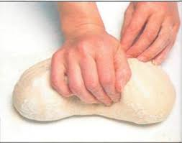 |  | 
first of all, KNEAD THE DOUGH | next, CUT CIRCLES IN THE DOUGH | by the end, PUT THE DOUGH IN THE OVEN
 |  | 
FIRST UNLOCK YOUR PHONE | THEN, WRITE A TEXT MESSAGE | FINALLY, SEND THE TEXT MESSAGE

