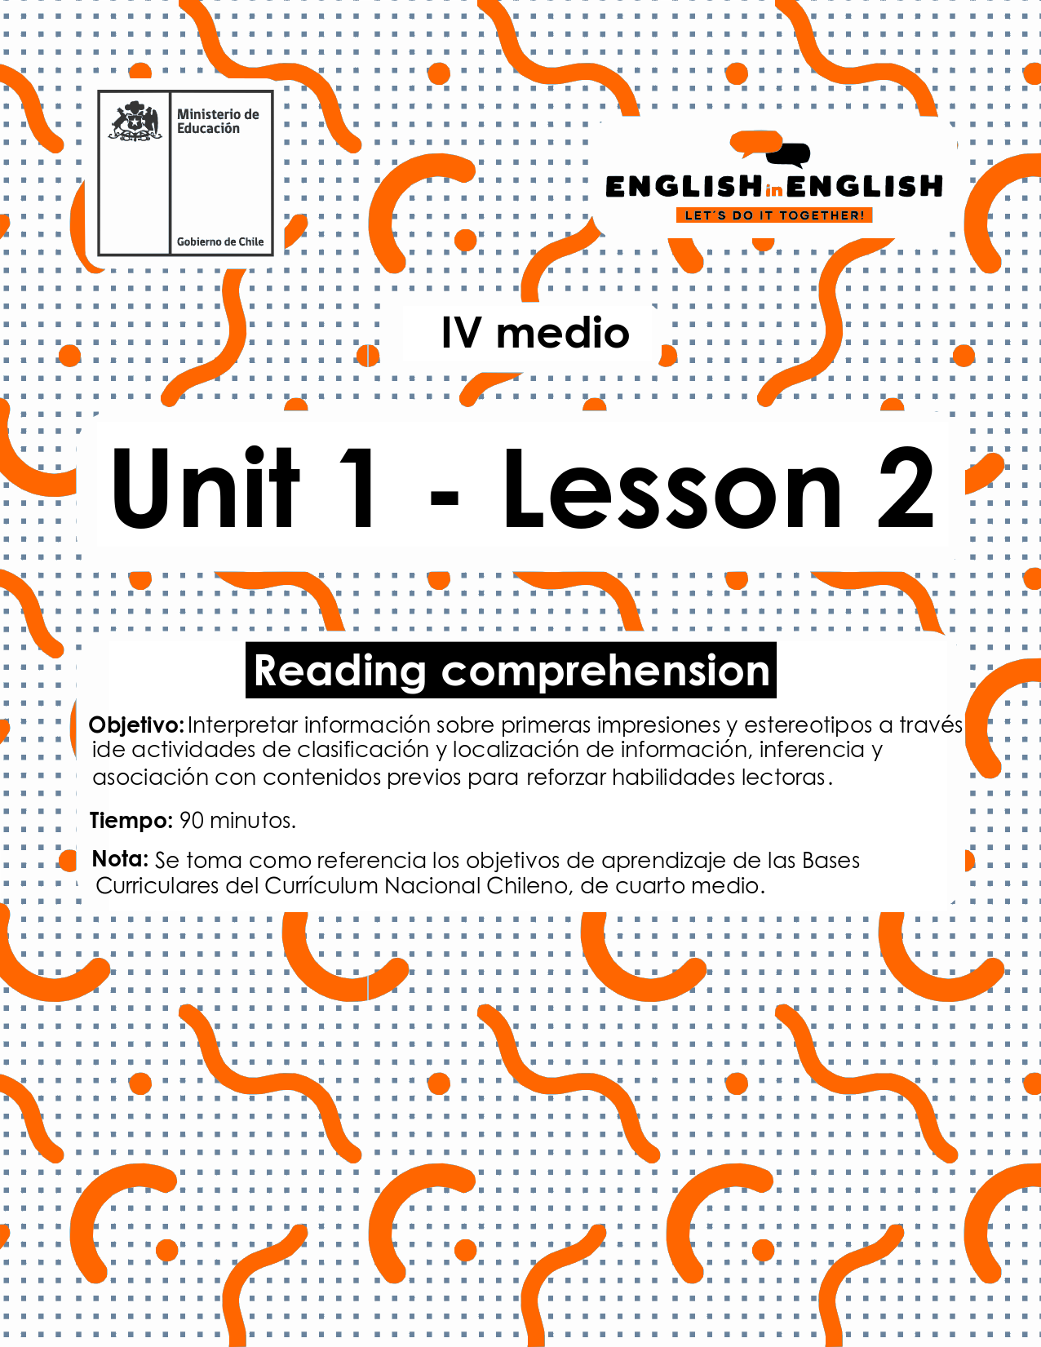

WEEK 2
READING COMPREHENSION
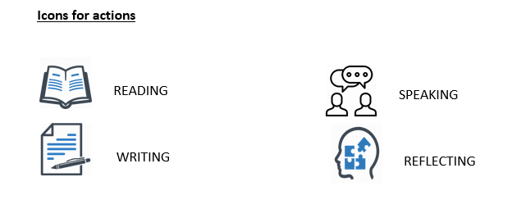

ACTIVITY 1

Setting the context 

- Let’s start. Read the questions and answer in your notebook.
- What are " first impressions and stereotypes"? Use your own words.
- Are first impressions always right? Explain.
- Do you agree with stereotyping people? Why/why not?

- Read the following statements and complete with "S" for stereotypes and "FI" for first impressions.
- Young people do not care about global issues ____
- Women are bad at maths ____
- Teens do not want to get involved in social or charity movements ____
- The more expensive the product, the better quality it will be ____

- What is your opinion about the four previous statements? Are they true? False? Explain in your own words.
_____________________________________________________________________________________________________________________.

ACTIVITY 2
Now, let’s read and practice!

- Read these keywords for 2 minutes and memorize as many as you can.
Then in your notebook write as many words as you can in one minute.

First impressions and stereotypes: Keywords
- Shifted: changed.
- Discard: throw away, not to take into consideration.
- Subject: person.
- Attend: go.
- Merge the gap: close the space, narrow the space.
- Look up to: admire.
- Acknowledge: recognize.
- Lingo: language, slang.
- Carefree: unworried.
- Candid: open hearted, sincere.
- Blithe: sincere.
- Unaware: ignorant, unworried.
- Own up to: be responsible for.
- Bottom line: “the reality is”.
- Vivid: clear.

Now, if you could write and memorized from...
- 10 to 15 words- You have a great memory!
- 5 to 9 words- you are good at memorizing words!
- 0 to 4 words- you can improve your memorization skills!

- Read the following text about a photography contest.
New York Times Photography contest
Teenagers around the world are often called technology addicted, self-centered, and indifferent. All of these may be stereotypes or first impressions that older generations have for the young people. Are these stereotypes true? Are all teenagers like that? In 2018, the New York Times challenged teenagers around the world to demonstrate through photographs what teenagers really are. They received over 2.200 photos from different people between 15 and 19 years old, from all around the world.
Here are some of the winning photographs, with a little description from their original photographer:

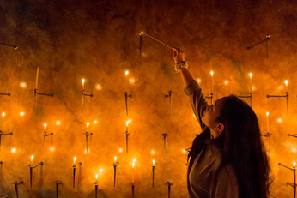 | My generation is believed to have abandoned the old ways. We are the first to grow up on Snapchat and Instagram, but while increased technology has shifted many aspects of our lives, it has not caused us to discard the traditions of our ancestors. In my photograph, a teenage girl is lighting a votive candle in a church.  Tradition is tremendously important to Maxine, the subject of my photograph. Every Sunday, she attends church service with her family, something that her parents also did when they were teenagers. My generation lives in a different world than past generations, however participating in traditions helps merge this gap and bring us together. —Eleanor Kinsel, 16.
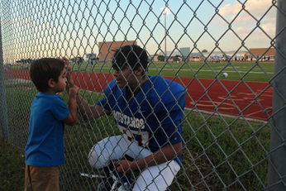 | These two boys are my little brothers. Andres is 14 and Angel is 3, and Angel looks up to Andres so much. This was taken on the football field after my brother’s game. You can see the connection between the two clearly, Angel looking up to Andres and Andres acknowledging it proudly because he knows he became a good role model for him to follow.  Adults get the wrong impression that we don’t care about anyone else but ourselves and that we don’t care about how we’re seen, but they couldn’t be more wrong. We know younger ones look up to us and try to do better for them. —Alexis Ceniceros, 16
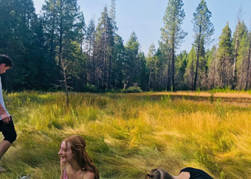 | My photo is a representation of the carefree explorative parts of teenagehood that incorporate emotional connection, personality development, life experience, and adventure. Some of which, adults rarely get to be a part of. Our own social groups, beliefs, lingo, form of communication, becoming who we are as individuals; this is the part that is hidden or sometimes unreachable for adults about their children. I wanted to capture a candid, jovial, blithe moment shared between teenagers when no one is caring or worried about who’s watching. —Maya Pachman, 15
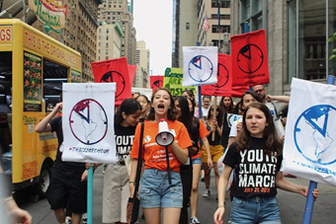 | We are not lazy but tired. Tired of how we are portrayed and treated by others. Like self-absorbed children who don’t understand how the world works. Older generations, including our parents and grandparents, are unaware of what goes on behind the scenes of teenage life and only see the moments of rest. If anything, they want to believe we are lazy so they are not required to own up to their inactions concerning the world’s problems.  We are leaders, circus masters balancing the rest of our childhood while fighting to improve the world. —Lydia Valentine, 16
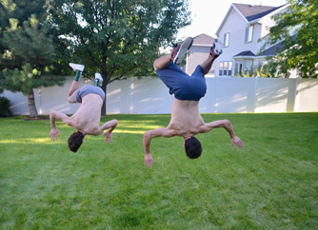 | These are my two best friends, Ben and Jordan. They love to work out and love to wrestle; they play football for their high school varsity teams. From the eye of a parent their kids look like lazy people who sit on their phones all day Snapchatting, or scrolling through their Instagram feed, and things like that, but in reality when they’re with their friends they are extremely active. Bottom line is that teenagers are underestimated. —Chanakya Duggineni, 17
 | She’s just a girl, and she’s on fire.  Adults do not understand why teenagers dye their hair in bright colors, because they, of course, prefer natural beauty to unnatural. But it’s not childish, as they often think, it’s a form of self-expression. This is a vivid manifestation of the teenagers’ personality, individuality, which is trying to get out. Modern teenagers want to be bright and memorable. They want to attract attention, a lot of attention. —Sabina Sarsenova, 19

Información obtenida de https://www.nytimes.com/2018/10/30/learning/36-teenagers-show-us-their-generation.html

ACTIVITY 3: AFTER YOU READ

- Look at the words in bold from the text:
- Tradition, Role Model, Social Groups, Leaders, Self-Expression.
- Complete the sentences with the correct word:

- I really admire my older sister, she is my ____________________.
- Tattoos and piercings are also a way of _____________________.
- Different cultures have different ______________ that impact in people’s lives, beliefs and stereotypes.
- Teenagers are the new _______________ of the future generations.
- ___________________ are different groups of people who interact to create unity and traditions.

- Look again at the words in bold from the text:
- Tradition, Role Model, Social Groups, Leaders, Self-Expression.
- Use the words to create an original or new sentence:
- __________________________________________________________.
- __________________________________________________________.
- __________________________________________________________.
- __________________________________________________________.

ACTIVITY 4: SPONGE ACTIVITY 

- Do you remember the first impression/stereotype you created in Unit 1, right?
- Now it is time you use that to make up a poster/flyer mentioning why first impressions/ stereotypes are not always right or true.

- Think about your community.

- What are two things/actions/beliefs you would like your neighbours could change? Why?

- How can people make them real?

- If possible, read and record your statements. Share them with your classmates if possible, through social media.
________________________________________________________________________________________________________________________________________________________________________________________________________________________________________________________________________________________________________________________________________________________________________________________________________________________________________________________________________________________________________________________________.

