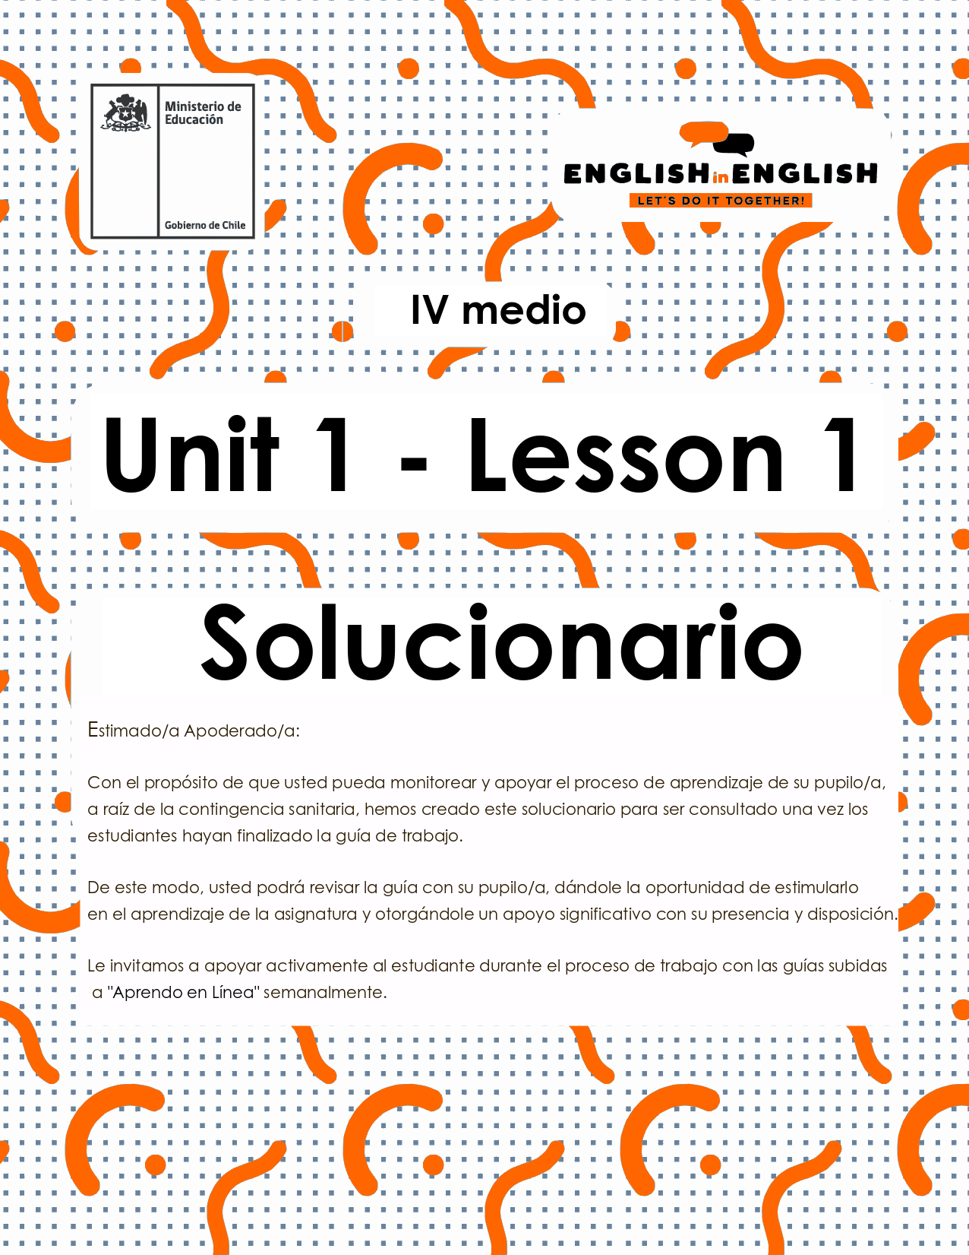

WEEK 1
VOCABULARY IN CONTEXT

ÚTILES

- Libro de inglés de 3° medio.
- Diccionario de inglés.
- Lápices.
- Cuaderno de asignatura.

ICONS FOR ACTIONS

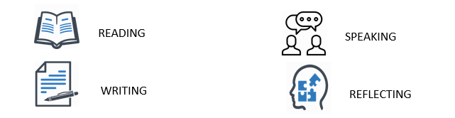

ACTIVITY 1: SETTING THE CONTEXT 

1. Let's talk about "first impressions and stereotypes". What do you know about those? Explain.
I think first impressions and stereotypes refer to the first image/picture we get about someone or something.
2. About first impressions, where do you think they come from? Explain.
I think they come from what people say/believe or even prejudices and traditions they have heard or have been taught to.
3. Related to stereotypes, are they positive or negative? Why?
I believe it depends on everybody' s perceptions. If someone thinks they are positive, they might help to make decisions. If others believe they are negative, that can help to stop making wrong judgements.
4. Can you list 2 beliefs related to "first impressions" and/or "stereotypes" related to your community?
- Example: Young people only care about parties and fun.
- Young people are lazy.
- People in my community are posh.
- Men are very good at Maths but very bad at Literature.
- Every girl in the world wants to get married before they are 25
5. Look at the words in bold in the text.
- Can you guess their meaning?
- If not, select 3 words and use a dictionary to look them up.

WORD | MEANING/SIGNIFICADO
- self-centered | egocéntrico
- stereotype | estereotipo
- shifted | cambiar
- tradition | tradición
- merge | unir
- unaware | no ser consciente de algo
- own up to | organizar
- concerning | concerniente a
- leaders | líderes
- youngsters | jóvenes

ACTIVITY 2: LET’S READ AND PRACTICE! 

Teenagers around the world are often called technology addicted, self-centered, and indifferent. All of these may be stereotypes or first impressions that older generations have for young people. Are these stereotypes true? Are all teenagers like that? In 2018, the New York Times challenged teenagers around the world to demonstrate through photographs how teenagers really are. They received over 2.200 photos from different people between 15 and 19 years old, from all around the world.

One of the winners of the contest, Eleanor Kinsel, said that her generation is believed to have abandoned the old ways, that they are the first to grow up on Snapchat and Instagram, but while increased technology has shifted many aspects of their lives, it has not caused them to discard the traditions of our ancestors. In her photograph, a teenage girl is lighting a votive candle in a church. Tradition is tremendously important to Maxine, the subject of her photograph. Every Sunday, she attends church service with her family, something that her parents also did when they were teenagers. Eleanor’s generation lives in a different world than past generations, however participating in traditions helps merge this gap and bring them together.

Another contestant, 16-year-old Lydia Valentine says that youngsters are not lazy but tired. Tired of how they are portrayed and treated by others. Like self-absorbed children who don’t understand how the world works. Older generations, including their parents and grandparents, are unaware of what goes on behind the scenes of teenage life and only see the moments of rest. If anything, they want to believe teenagers are lazy, so they are not required to own up to their inactions concerning the world’s problems. “We are leaders, circus masters balancing the rest of our childhood while fighting to improve the world”, concludes Lydia.

Being unconcerned, self-centered, or lazy, are stereotypes that teenagers face everyday… but is this entirely true? Are all teenagers from all over the world like that? How was that these stereotypes came to life? It is unknown if all youngsters are the same, but one thing is for certain: Teenagers are changing the world, and they will grow up to show their true face.
Información obtenida de https://www.nytimes.com/2018/10/30/learning/36-teenagers-show-us-their-generation.html

ACTIVITY 3: AFTER READING THE ABOVE TEXT, CIRCLE THE CORRECT ALTERNATIVE… 
6. In the sentence “The New York Times challenged teenagers around the world to demonstrate through photographs how teenagers really are”:
- The part “how teenagers really are” refers to…
A. Photographs should demonstrate that teenagers don’t care about anything.
B. Photographs should demonstrate the reality about teenagers.
C. Photographs should demonstrate what teenagers like and don’t like.

7. In the sentence “increased technology has shifted many aspects of their lives”:
- Shifted means:
A. Changed.
B. Interfered.
C. Proven.

8. In the sentence “How was that these stereotypes came to life?”:
- “Came to life” means:
A. Appeared
B. Disappeared
C. Changed

ACTIVITY 4: INDEPENDENT PRACTICE 
9. Complete the crossword with the key words from the text.

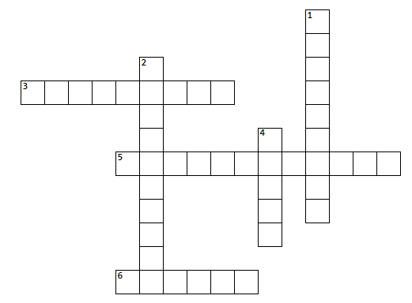
Across
3. It is a belief, principle, or way of acting that people in a particular society or group have (tradition)
5. It relates to someone who is only concerned with own needs and interests (self-centered)
6. It is a person in control of a group, country, or situation (leader)
Down
1. It is a young person, usually an older child (youngster)
2. It is a fixed general image or set of characteristics that a lot of people believe represent a particular type of person or thing (stereotype)
4. It is to combine or join together (merge)
10. Look at the key words in the picture.
- Select 3 key words.
- Create one original sentence for each of them. 
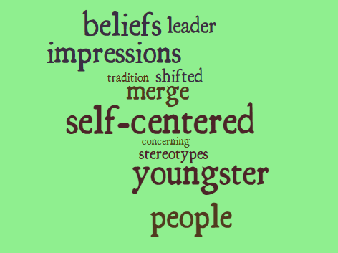

WRITE SELECTED WORD | CREATE 1 ORIGINAL SENTENCE
1. LEADER | A leader makes good decisions for the people
2. SELF-CENTERED | Peter is self-centered. He does not think much about other´s feelings
3.TRADITION | One tradition in our country is to dance Cueca in independence day

11. Label these pictures by considering the words in bold from the text. 
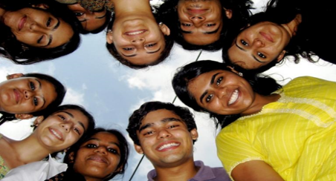  YOUNGSTERS | 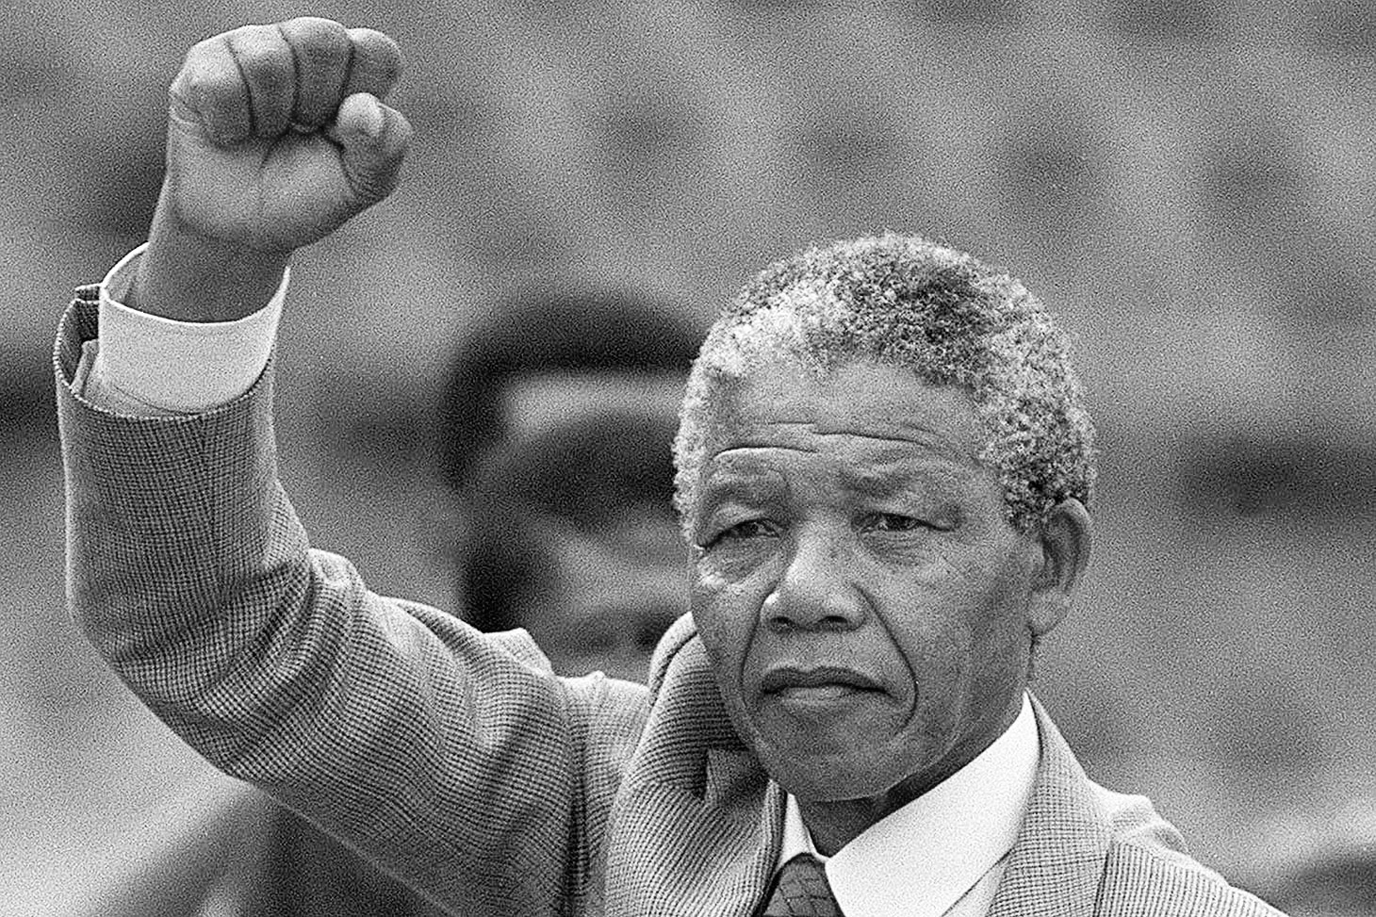  _LEADER_ | 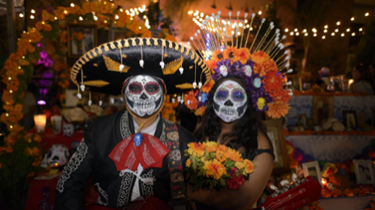  _COSTUME___
  _MERGE_ | 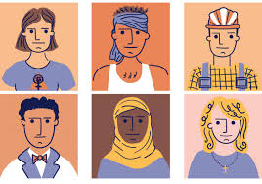  STEREOTYPE_ |   UNAWARE

12. Word Pairs.
- For each word write one (or more) word related
- For example, synonym or an antonym:
ORIGINAL WORD | WORDPAIR
1. Tradition | Custom, typical dance, history, legacy
2. Teenagers | young people, adolescent, teen
3. Leaders | presidents, organization, power
4. Self-absorbed | self-centered, egocentric,
5. Generation | age group, epoch,
6. Stereotype | pattern, convention,

ACTIVITY 5: SPONGE ACTIVITIES 

13. Finally, by considering all you have learnt in this first lesson, make up your own quote related to first impressions or stereotypes following the example given:
"I do not want to be fake. I'm just being me. And I have the power to break stereotypes and whatever useless rules that society puts on us.”
(Bad Bunny, www.brainyquote.com)
- Note: Do not forget to make your statement including the belief, what you commit to do and how you will make it real.
- Now, create your own quote:
"I am a teenager who believes in being true to myself and respecting other people' beliefs. So, I will fight against prejudices and precipitated judgements by showing generosity and promoting respect and tolerance inside my community."

