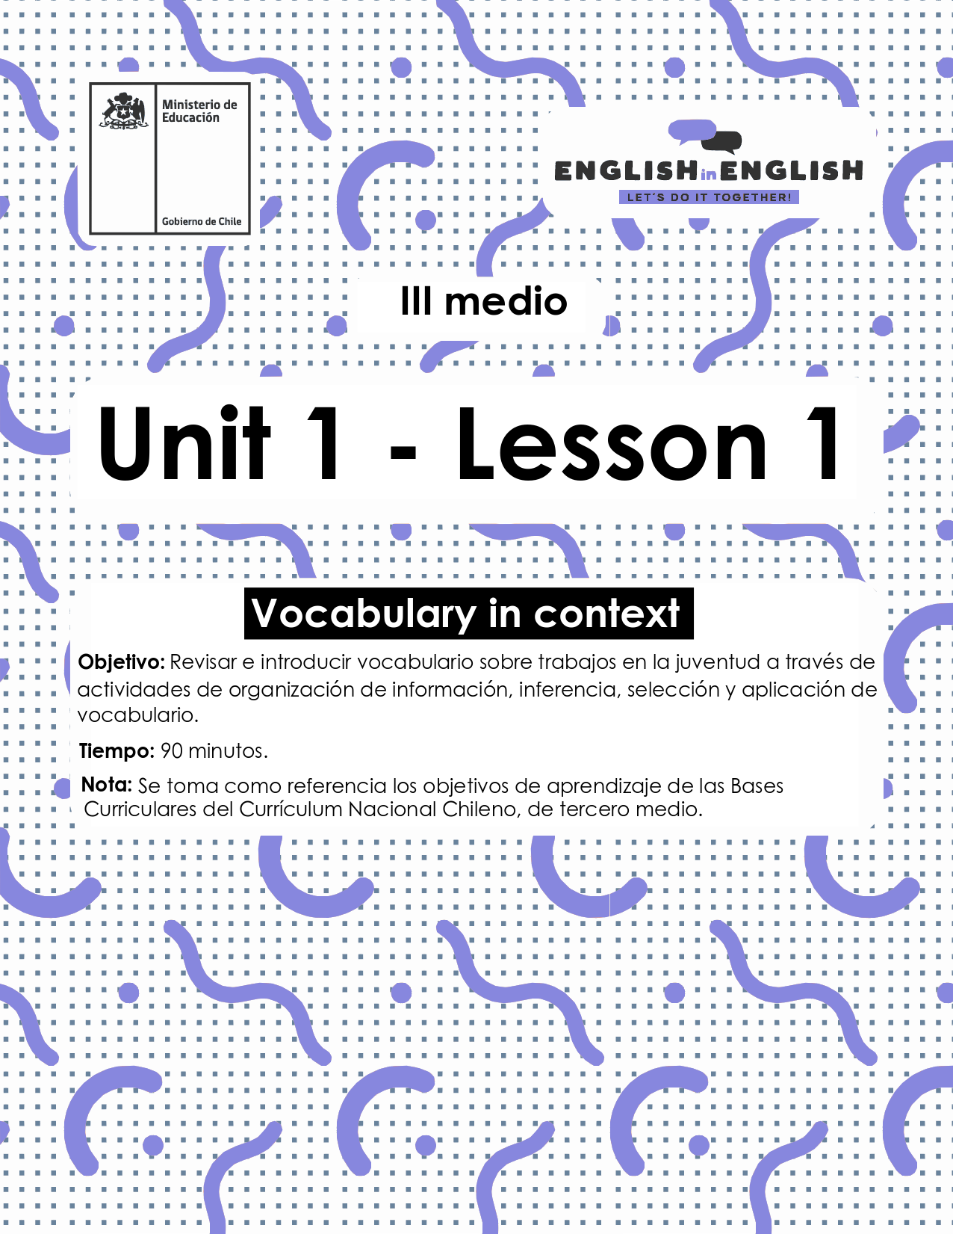

WEEK 1
VOCABULARY IN CONTEXT

ÚTILES

- Libro de inglés de 3° medio.
- Diccionario de inglés.
- Lápices.
- Cuaderno de asignatura.

ICONS FOR ACTIONS



ACTIVITY 1: SETTING THE CONTEXT 

- For setting the context read and answer the following questions:

1. Let’s talk about work. Where do the members of your family work?
_________________________________________________________

2. Would your parents allow you to work part-time?
_________________________________________________________

3. Can you list 10 words related to work? Example: Salary.
1. | 2.
3. | 4.
5. | 6.
7. | 8.
9 | 10.

4. Look at the words in bold in the text.
- Can you guess their meaning?
- If not, select 3 words and use a dictionary to look them up.
WORD | MEANING/SIGNIFICADO

ACTIVITY 2: LET’S READ AND PRACTICE! 

Adolescence is that difficult period of time when children transition to responsible adults. One method for assisting this transition is obtaining part-time employment. A job can help teenagers better develop their identities, obtain increased autonomy, achieve new accomplishments, develop work experience, and become more independent from their parents.

There are many obstacles to teens finding a job. For example, finding reliable transportation is critical. Also, fighting stereotypes that employers have about adolescents, such as poor attitudes or lack of skills, can be challenging. Especially when teenagers need to have an environment that supports them and will boost their confidence. And sometimes, free time is also an obstacle, especially if teenagers are studying. Here, part-time jobs are the best option, so students can attend their regular classes, and use some of their free time to work for a few hours, without much interruption on their regular schedule. Usually, part-time jobs only take 20 hours a week, and they are mostly directed to teens.
When applying for a job, first you have to send your resume, and then go to an interview. Here are some job interview tips you should keep in mind when meeting with a potential employer. First, be sure to dress up appropriately for the situation. However, you don’t want to overdress for the interview either. Next, be sure to do some research on the company for which you are interviewing. This will help you know if you have the needed skills or experience to work for that company. Finally, show enthusiasm and be confident to tell them your accomplishments and why you would be the best choice for the position; you can tell them why you can help their company better than other applicants. And most importantly, don’t be late for the interview!

Regarding salary, teens want to work for a variety of reasons, but more than half express that they work because they want to buy things. Typically, teens spend their money on games, entertainment, or clothing. However, there are others who work for their education, saving for university, and helping their families with living expenses, for example, buying groceries. This is a sign that a lot of teenagers who work weigh their priorities.
Texto modificado de https://middleearthnj.wordpress.com/2010/04/02/teenagers-and-part-time-jobs-benefits-drawbacks-and-tips/
http://www.dailyesl.com/education/job-interview-tips
5. Let’s do some spider maps. According to the text and your own knowledge: 
- Write words related to the themes.
- One theme is free for you to add your own ideas.

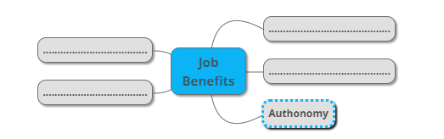
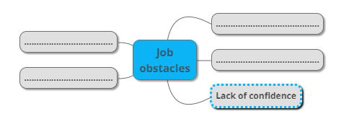


ACTIVITY 3: NOW, CIRCLE THE RIGHT ANSWER… 

6. The sentence "one method for assisting this transition" reflects that…
A. It’s not easy to help teens when becoming adults.
B. It’s easy for children to become adults.
C. There is not any option to help them with.

7. The sentence “finding reliable transportation is critical” means that…
A. Transportation is not reliable.
B. Reliable transportation is very important.
C. Workers should walk to their workplace.

8. Something that “boosts your confidence” is something that…
A. Will make you feel important and better about yourself.
B. Will not help you in your life.
C. Does not matter.

9. “Living expenses” refers to…
A. Money you receive for your work.
B. Money you spend to go to work.
C. Money you spend on food, transportation, clothing, and others.

ACTIVITY 4: INDEPENDENT PRACTICE 

10. Read the explanation and complete the following chart with the words from the text.
- Use the words in purple.

APPLICANTS - DRESS UP- SKILLS - OVERDRESS- EMPLOYMENT -RESUME

EXPLANATION | WORD
- This refers to a relationship between two parties based on a contract that is paid.
- This is an ability based on your knowledge, experience, aptitude, etc.
- This word is a synonym of curriculum vitae (CV)
- This refers to dressing with too much display, finery, or formality
- This refers to a person who applies for or requests something
- This refers to putting on special clothes for an occasion.

11. Label these pictures by considering the information from the text. 

  OBSTACLE |   ____________ | 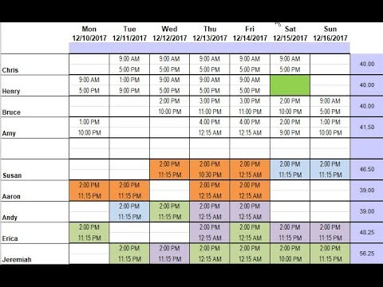  ____________ |   ____________
  ____________ |   ____________ |   ____________ |   ____________

ACTIVITY 5: SPONGE ACTIVITIES 

12. Finally, by considering all you have learnt in this first lesson, make up a job advertisement following the example given:
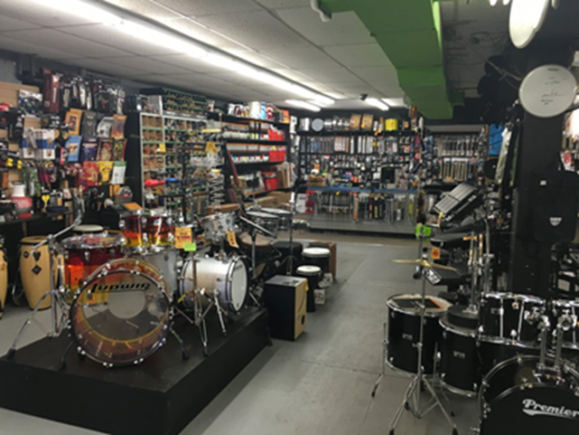

"A MUSIC STORE NEEDS TWO EMPLOYEES…
to work part-time from 6.00 to 9.00 PM. Candidates must be confident, responsible, and punctual. Salary according to grade pay. Bonuses also included."
- Note: Do not forget to mention workplace, type of job, schedule, candidate's profile, salary and/or bonuses.
- Now, create your own advertisement:

