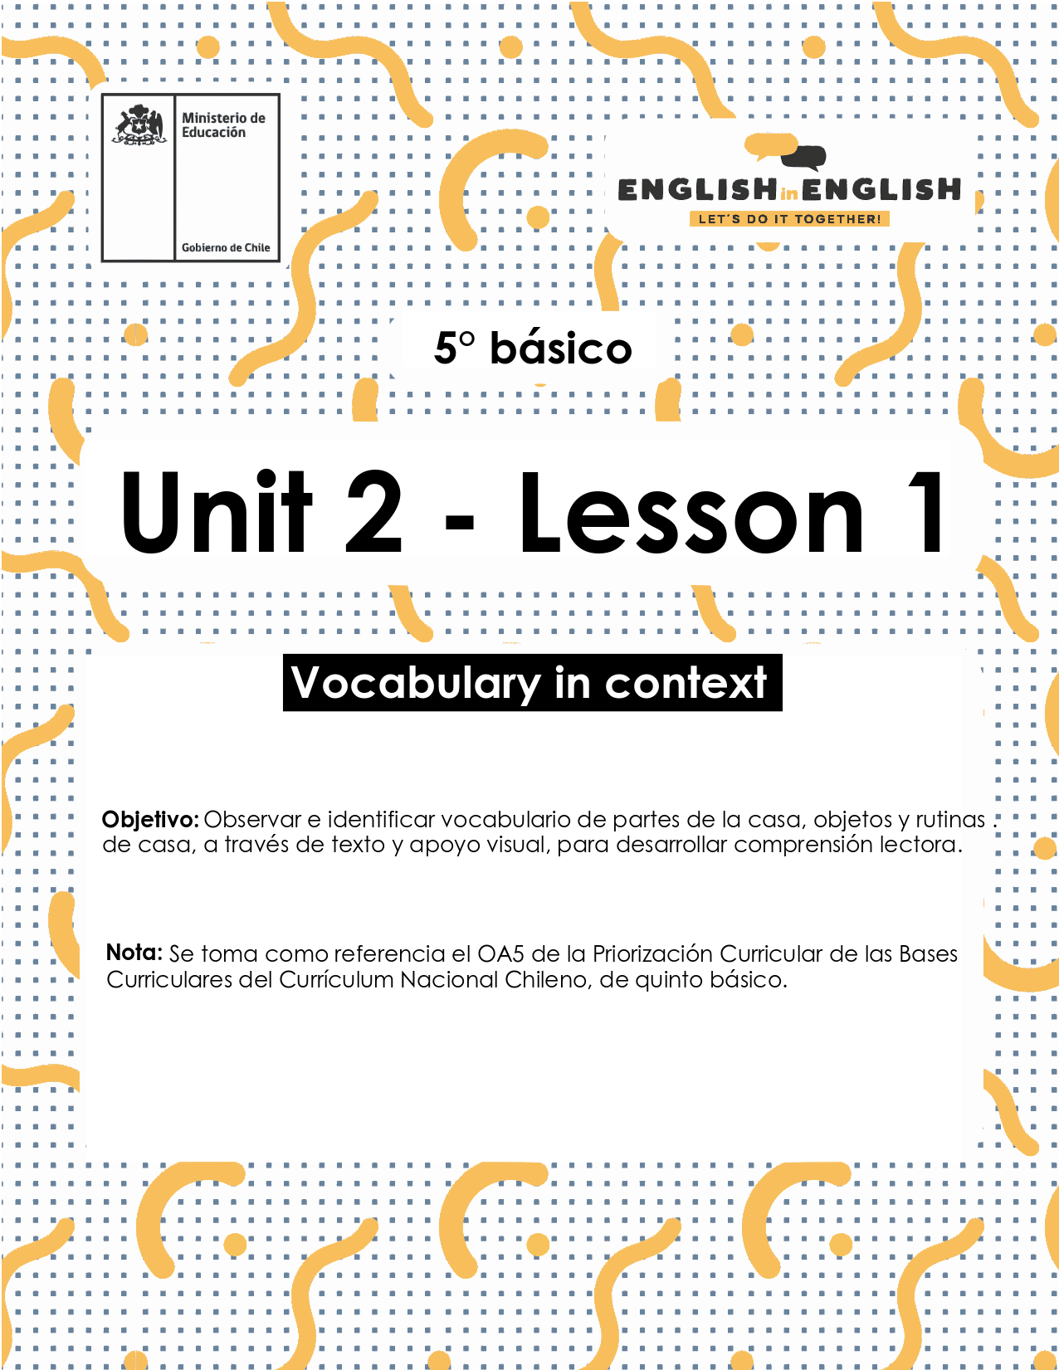

UNIT 2
LESSON 1

ÚTILES RECOMENDADOS:
- Texto del Estudiante 5° Básico
- Diccionario de Inglés físico / online https://dictionary.cambridge.org/es/diccionario/espanol-ingles/
- Cuaderno de inglés o 2 hojas en blanco.
- Lápiz grafito y goma.

SECTION 1: SETTING THE CONTEXT

“House vocabulary”
1. Observe the image and answer the questions.
- Observa la imagen con atención y responde las preguntas.
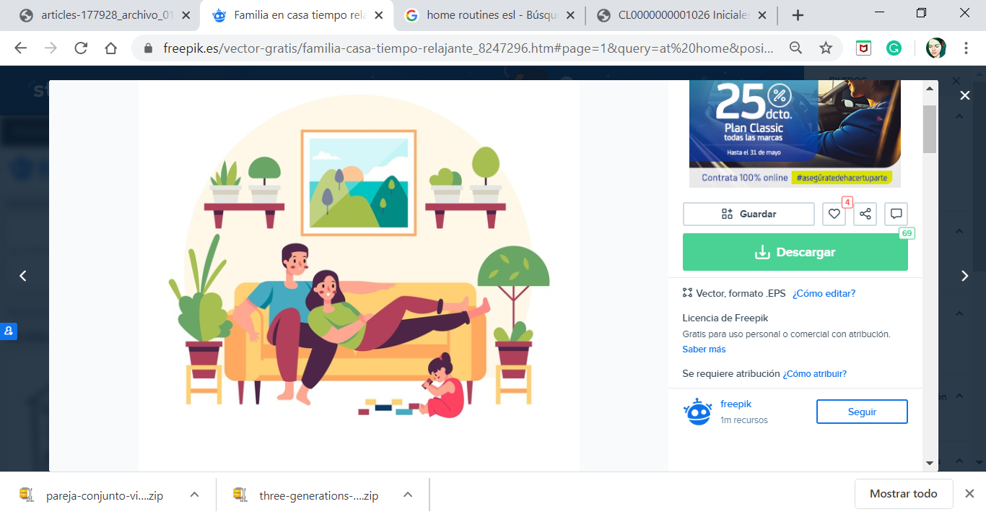

Where are they?
- ¿Dónde están ellos?
___________________________________________________

Think about some activities you do at home.
- Piensa en algunas actividades que haces en casa.
___________________________________________________

2. Observe the images and the vocabulary.
- Observa las imágenes y el vocabulario.
Parts of the house.
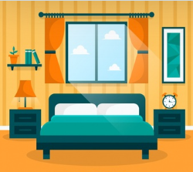  Bedroom | 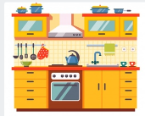  Kitchen | 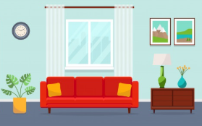  Living Room
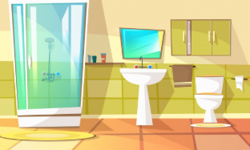  Bathroom | 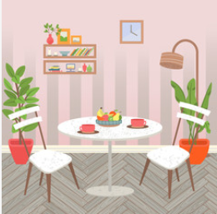  Dining Room |   Garden

Home Routines.
  Tidy my bedroom |   Do my homework |   Do the dishes
  Work on the computer |   Watch TV |   Chat with friends

House Objects.
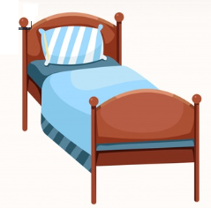  Bed |   Shower | 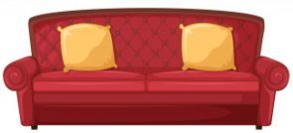  Couch
  Table and chairs | 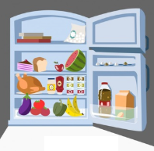  Fridge |   Plants

SECTION 2: LET'S PRACTICE

“Reading a text”

1. Read the text. What is it about?
- Lee el texto. ¿De qué se trata?
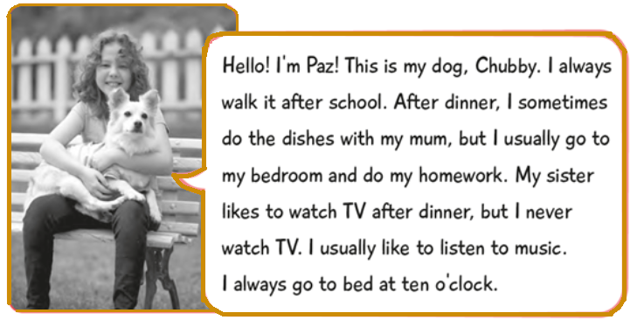

2. Find the words from the vocabulary in the text and classify it.
- Encuentra las palabras del vocabulario en el texto y clasifícalas.
Parts of the house | Objects of the house | Home routines

SECTION 3: LET’S CONSTRUCT AND APPLY OUR KNOWLEDGE

“Using the house vocabulary”

1. Write the sentence from the box that corresponds to each image.
- Escribe la oración del recuadro que corresponde a cada imagen.
I do the dishes in the kitchen. - I work on my computer in the dining room. - I do my homework in the bedroom. - I watch TV in the living room.
  1.______________  _______________ |   2.______________  _______________ |   3.______________  _______________ |   4.______________  _______________

2. Choose the correct alternative about the objects and the parts of the house.
- Elige la alternativa correcta sobre objetos y partes de la casa.
1. The shower is in the…  - bedroom  - bathroom  - living room | 2. The plants are in the…  - garden  - bathroom  - bedroom | 3. The couch is in the…  - kitchen  - living room  - garden
4. The table and chairs are in the…  - bedroom  - dining room  - bathroom | 5. The fridge is in the…  - garden  - kitchen  - bedroom | 6. The bed is in the…  - living room  - dining room  - bedroom

3. Observe this house and draw at least 2 objects that correspond to each room.
Write the home routines that you do. Use the boxes.
- Observa esta casa y dibuja al menos 2 objetos que correspondan a cada habitación.
- Escribe las rutinas del hogar que tú haces. Usa los recuadros.
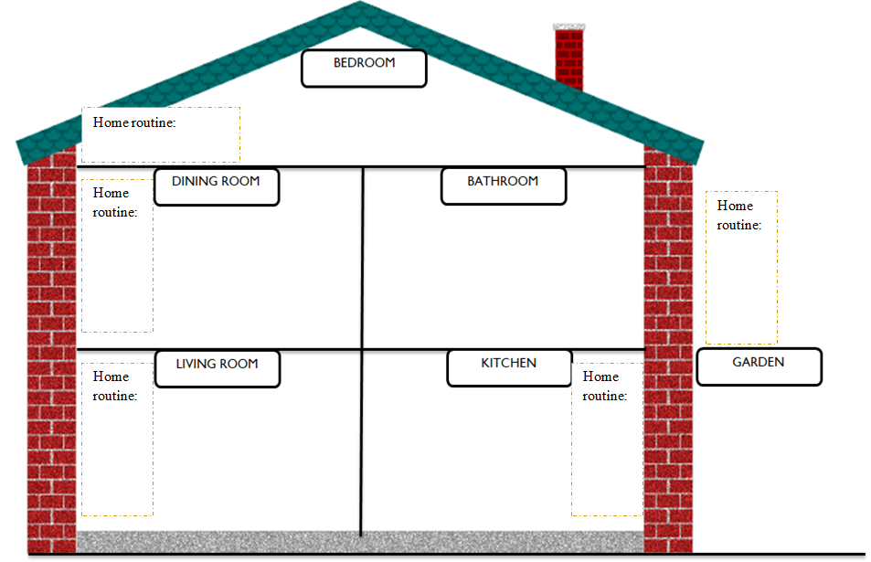

4. Create a timetable of your home routines for the weekdays.
Use the vocabulary from “Home routine”
- Crea un horario de tus rutinas del hogar para los días de la semana.
- Utiliza el vocabulario de “Home routine”
- Sigue el ejemplo.
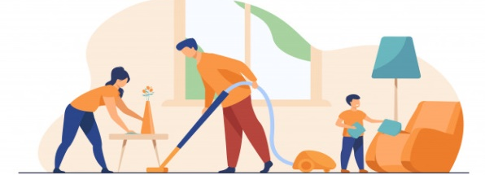
HOME ROUTINE
Timetable | MONDAY | TUESDAY | WEDNESDAY | THURSDAY | FRIDAY
MORNING | Do my homework
AFTERNOON | Do the dishes
EVENING | Chat with friends

SECTION 4: SPONGE ACTIVITY

Complete this chart about you!
- ¡Completa este cuadro sobre ti!
Name
Age
Grade
School
Family
Favorite part of the house
Most used object in the house
Favorite home routine
Home routine that you do with your family

NO OLVIDAR REPASAR EL CONTENIDO CON UN ADULTO

