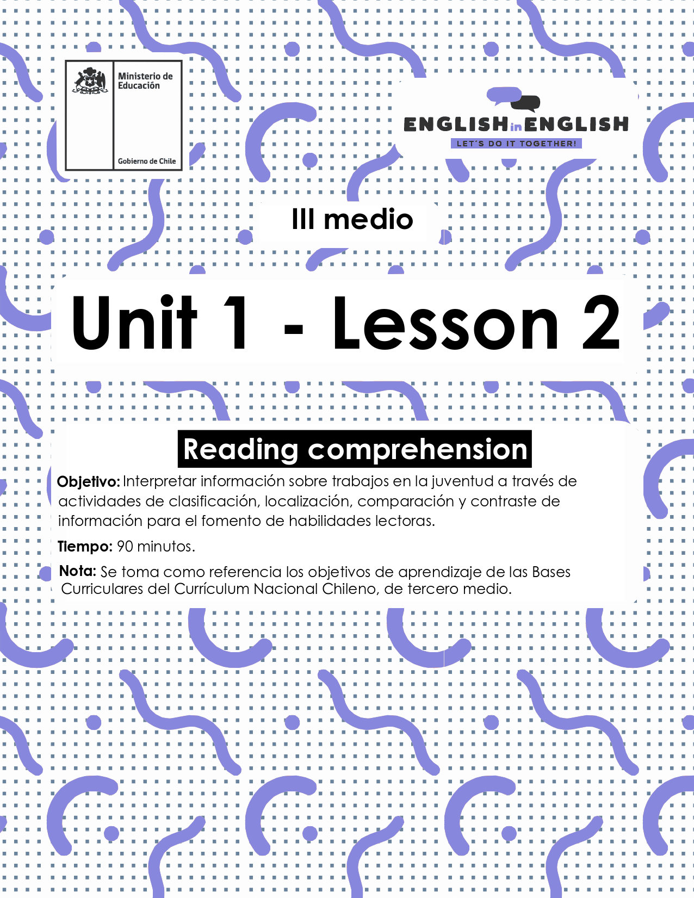

WEEK 2
READING COMPREHENSION
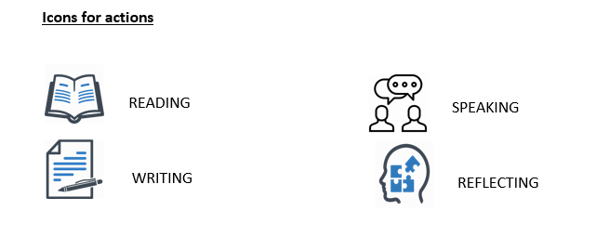

ACTIVITY 1: SETTING THE CONTEXT 

First, think and answer the following questions in your notebook:
- Do you know what a part-time job is? Explain.
- Have you or any of your friends ever had a part-time job? If so, what did you/they do?
- Would you prefer having a part-time or full-time job? Explain.

Now think for 2 minutes and complete the chart with part-time and full-time jobs.

Full-time job | Part-time job
Police officer | Dog walker

ACTIVITY 2: LET´S READ AND PRACTICE 

For this, follow the 4 instructions below:
- Read the keywords for 2 minutes and memorize as many as you can.

- Benefit: something good.
- Obstacles: difficulties, problems.
- Employment: work, job.
- Reliable: something or someone that will not fail.
- Lack: absence, not present.
- Skills: abilities and attitudes.
- Groceries: food such as vegetables.
- Drawbacks: problems.
- Praise: congratulate.
- Youth: teenage people.
- Adulthood: adult people.
- Over: more than.
- Manage: control.
- Useful: of good use, positive.
- Absenteeism: absent, not present.

- Find the key words in the article and colour them.
- Now, think about the main idea of the text, and write a sentence.
- The main idea of the text is: ___________________________________________________________

- Read the text again and find repeated words or sentences

Youth at work 

According to the U.S. Department of Labor, 50% of American teenagers have an introductory working experience with informal jobs, such as babysitting by age 12, and during high school, 80% of the students have a part time job outside their school hours. The average high school student works 20 hours per week, and about 10% work full time (35 hours or more).
There are many obstacles to teens finding a job. For example, finding reliable transportation is critical. Also, fighting stereotypes that employers have about adolescents, such as poor attitudes or lack of skills, can be challenging. Especially when teenagers need to have an environment that supports them and will boost their confidence. And sometimes, free time is also an obstacle, especially if teenagers are studying. Here, part-time jobs are the best option, so students can attend their regular classes, and use some of their free time to work for a few hours, without much interruption on their regular schedule. Usually, part-time jobs only take 20 hours a week, and they are mostly directed to teens.
When applying for a job, first you have to send your resume, and then go to an interview. Here are some job interview tips you should keep in mind when meeting with a potential employer. First, be sure to dress up appropriately for the situation. However, you don’t want to overdress for the interview either. Next, be sure to do some research on the company for which you are interviewing. This will help you know if you have the needed skills or experience to work for that company. Finally, show enthusiasm and be confident to tell them your accomplishments and why you would be the best choice for the position; you can tell them why you can help their company better than other applicants. And most importantly, don’t be late for the interview!

Regarding salary, teens want to work for a variety of reasons, but more than half express that they work because they want to buy things. Typically, teens spend their money on games, entertainment or clothing. However, there are others who work for their education, saving for university, and helping their families with living expenses, for example, buying groceries. This is a sign that a lot of teengers who work weigh their priorities.
Researchers have studied and debated the benefits and drawbacks of teens and part-time jobs for more than 2 decades. Many researchers praise part-time work and say it contributes to the transition from youth to adulthood. Other studies have found significant negative consequences to students working over 20 hours a week. We will take a close look at both.
Texto modificado de https://middleearthnj.wordpress.com/2010/04/02/teenagers-and-part-time-jobs-benefits-drawbacks-and-tips/

Benefits of having a part-time job | Problems of having a part-time job
- Obtaining valuable work experiences, which are excellent for a resume.  - Learning how to effectively manage finances.  - Providing constructive use of free time. Employment gives teens less time to engage in risky behaviors.  - Learning time management skills.  - Forming good work habits.  - Gaining useful skills such as improving their communication, learning how to handle people, developing interview skills and filling out job applications.  - Providing a sense of responsibility and independence. | - Less time for homework. Working students may not have or make the time to complete their work.  - Higher rates of absenteeism and less school involvement.  - Lower grades in school.  - Increased stress. Balancing work and school can prove to be too much for any student.

ACTIVITY 3: AFTER YOU READ 

- Answer these questions:
Which is the best description for the text?
- Reasons why you should get a job.
- The story of students and their part-time jobs.
- Good and bad sides of a part-time job.

What kind of text is it? ________________________________

- Let’s complete: Using the information from the green box, complete the following chart:

20 hours per week / 80% / 2 decades / 50%

Item | Explanation
 | This percentage represents the number of students having a job outside the school
 | This information represents the number or years research has studied teenagers’ working habits
 | This information represents the hours a high school student works.
 | This percentage represents the number of American teenagers having experience with informal jobs

- Now it is time to show what you have learned! Answer the following questions using your own words. You can answer in your notebook if you want:

- What do you think about the list of benefits and problems of a part time job?
________________________________________________________________
________________________________________________________________

- Add one more benefit and one more problem to the list:

Benefit: ________________________________________________________________
Problem: _______________________________________________________________

- As you know more about part-time jobs:
- imagine you are an employer who needs to hire some employees to work part time in a music store.
- What are the requirements to get the position?
- Make up a flyer/poster to tell about responsibilities and roles.



ACTIVITY 4: SPONGE ACTIVITY 

Finally, do you remember the job advertisement you made up in Unit 1, right? Now is time you do the following:
By using your ad and smartphone:
- Imagine you work for a Music Company looking for new employees: a part time disc jockey and a full-time sound engineer.
- Write a message to look for applicants mentioning the salary, schedule, candidate' s profile and two advantages for working with your Music Company.
- Once you have finished reading and recording your voice, share it with your classmates if possible, through social media.

_______________________________________________________________________________________________________________________________________________________________________________________________________________

