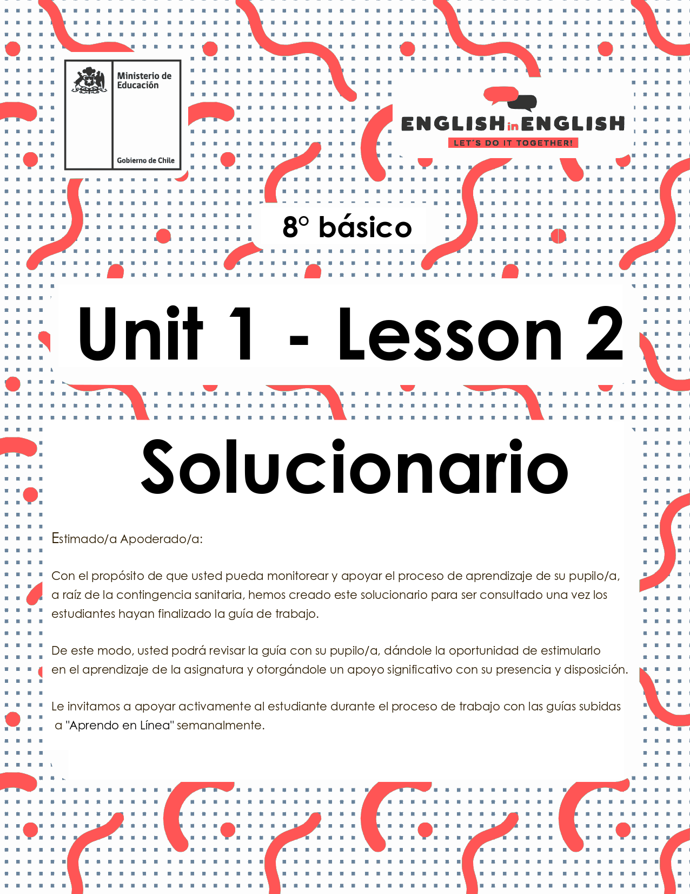

WEEK 2
READING COMPREHENSION

ÚTILES

- Tu cuaderno de inglés o hojas en blanco.
- Lápiz grafito, goma, regla.
- Marcadores de colores y/o lápices de colores.

ACTIVITY 1: BEFORE READING
(Tiempo estimado: 20 minutos)

- Answer the following questions.
Responde las siguientes preguntas.

Do you know what an ode is? | YES / NO  *La respuesta puede ser Yes o No
What type of text is an ode? | Lyric
What type of text is an ode? | Descriptive
What type of text is an ode? | Narrative
What type of text is an ode? | Instructive

*Dependerá de los conocimientos previos del estudiante.

- Read the following quotation and answer the questions below.
Lee la siguiente cita y responde las preguntas a continuación.
“TECHNOLOGY IS A USEFUL SERVANT BUT A DANGEROUS MASTER”

What does it mean? According to your interpretation. | ** LAS RESPUESTAS PUEDEN SER VARIAS, ALGUNOS EJEMPLOS: **  1. Technology is useful in our daily life.  It can have a negative impact in our lifestyle.
Do you agree with the quotation? | Yes, I do.  No, I don’t

- Match the word with the corresponding image.
Relaciona la palabra con la imagen correspondiente.
1.- Laptop  2.- Notebook  3.- Fingernails  4.- Denim jackets  5.- Stand out  6.- Weird | 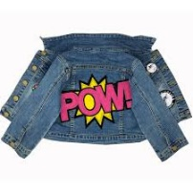 |  | 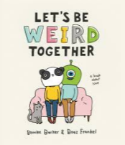
 | 4 | 1 | 6
 |  |  | 
 | 3 | 5 | 2

ACTIVITY 2: WHILE READING
(Tiempo estimado: 20 minutos)

- Read the following Ode carefully.
Lee cuidadosamente la Oda.

Ode to...
This is an ode to
bone earrings,
rock music,
tattoos and inappropriate laptop stickers,

To the un-conventionalists,
multi colored tape,
the red notebook,
and long painted fingernails.

To round glasses,
thrift stores,
denim jackets
and angels,

To the inclusionists
and real-world conversations ripe
with humor
and light,

To the quiet ones
and the loud

To the ones who are meek
and the ones who stand out

To jolly ranchers
and weird games.
taken from:https://powerpoetry.org/poems/ode-army-pens-keypads
ODE: An ode is a poem that gives praise to an object.

- Read the ode and then answer the following questions.
Lee la Oda y luego responde las siguientes preguntas.

- What is the topic of the ode?

Creative people that stand out for their interests and personalities

- The ode is written to a/an:

- Animal
- Object
- Person
- Nature (ocean, forest, etc.)

- Create a title for the ode.

* LAS RESPUESTAS PUEDEN SER VARIAS. EJEMPLOS:
- Ode to Cool People
- Ode to stickers
- Creating a style
- Ode to the writers
- Ode to computers

- Read the verse and write what it means for you in one sentence.
Lee el verso y escribe lo que significa para ti, en una oración.

This is an ode to
bone earrings,
rock music,
tattoos and inappropriate laptop stickers,
** LAS RESPUESTAS PUEDEN SER VARIAS, EJEMPLO:
1 refers to adopt a new life style
Se refiere a adoptar nuevos estilos de vida

To the un-conventionalists,
multi colored tape,
the red notebook,
and long painted fingernails
** LAS RESPUESTAS PUEDEN SER VARIAS, EJEMPLOS:
People create art and new fashion styles.
/. La gente crea arte y nuevos estilos de moda.

ACTIVITY 3: AFTER READING
(Tiempo estimado: 30 minutos)

- Read the following example.
Lee el siguiente ejemplo.

An Ode to Blueberries
Oh blueberries,
I see you wearing your purple crown,
sprinkled over my waffle.
Oh blueberries,
thank you for swimming
in sweet butter
and
maple syrup.
Oh blueberries, you are simply delicious.

2.- Use these instructions when working on your odes.
Usa las instrucciones cuando prepares tu oda.

  - Pick an ordinary place or thing
  - Give your place or thing praise or thanks. (Oh, _____________!)
  - Speak directly to the object.
  - Use adjectives to describe it.
  - Use verbs to bring that object to life. (Personification)
3.- Choose any technological object and write your own ode following the given example above.
Elige algún objeto tecnológico y escribe tu propia oda siguiendo el ejemplo de arriba.
** LAS RESPUESTAS PUEDEN SER VARIAS, ALGUNOS EJEMPLOS:**

Oh Dear Smart TV
Thanks to you I can watch Netflix
You're so lit, I can't sleep
Thinking about your HD screen.

EXTRA CURRICULAR ACTIVITY
(Tiempo estimado: 20 minutos)

- Challenge.
Desafío

Step 1 Send the ode you created to 10 friends on Instagram or any
social media.

Step 2 Ask your friends to give a title to the ode.

Step 3 Choose your 3 favorite titles and write them down:

1.-Depends on the student’s selection.
2.-Depends on the student’s selection.
3.-Depends on the student’s selection.



