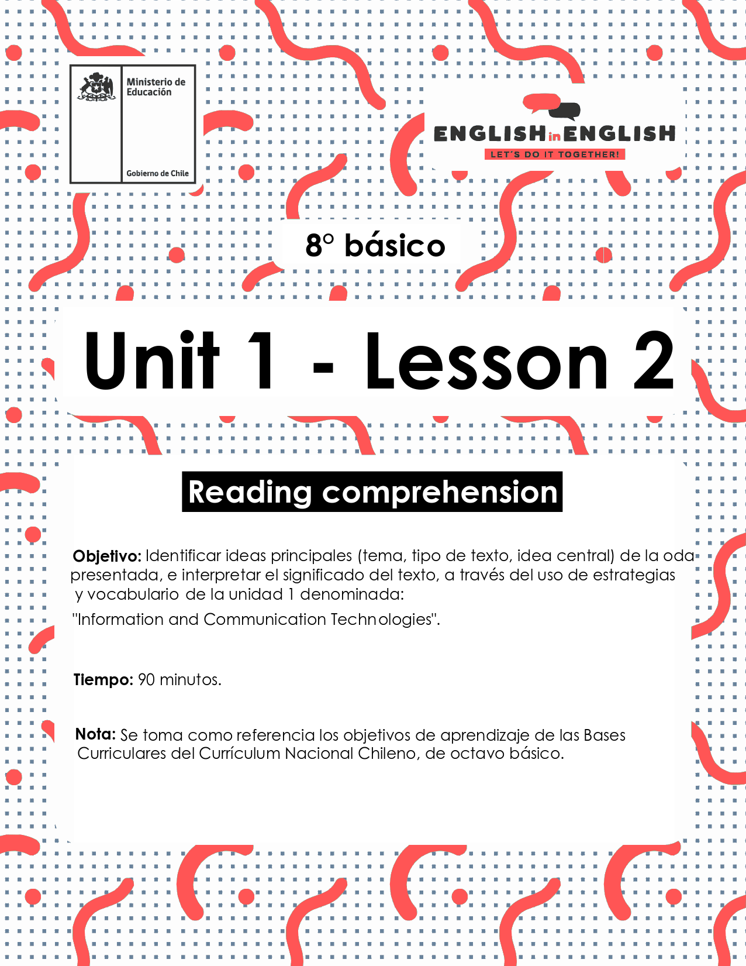

WEEK 2
READING COMPREHENSION

ÚTILES

- Tu cuaderno de inglés o hojas en blanco.
- Lápiz grafito, goma, regla.
- Marcadores de colores y/o lápices de colores.

ACTIVITY 1: BEFORE READING
(Tiempo estimado: 20 minutos)

- Answer the following questions.
Responde las siguientes preguntas.

Do you know what an ode is? | YES / NO
What type of text is an ode? | Lyric
What type of text is an ode? | Descriptive
What type of text is an ode? | Narrative
What type of text is an ode? | Instructive

- Read the following quotation and answer the questions below.
Lee la siguiente cita y responde las preguntas a continuación.

“TECHNOLOGY IS A USEFUL SERVANT BUT A DANGEROUS MASTER”

What does it mean? According to your interpretation.
Do you agree with the quotation?

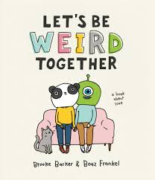
- Match the word with the corresponding image.
Relaciona la palabra con la imagen correspondiente.
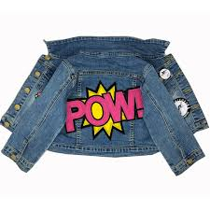

1.- Laptop
2.- Notebook


3.- Fingernails

4.- Denim jackets
5.- Stand out
6.- Weird

ACTIVITY 2: WHILE READING
(Tiempo estimado: 20 minutos)

- Read the following Ode carefully.
Lee cuidadosamente la Oda.

Ode to...
This is an ode to
bone earrings,
rock music,
tattoos and inappropriate laptop stickers,

To the un-conventionalists,
multi colored tape,
the red notebook,
and long painted fingernails.

To round glasses,
thrift stores,
denim jackets
and angels,

To the inclusionists
and real-world conversations ripe
with humor
and light,

To the quiet ones
and the loud

To the ones who are meek
and the ones who stand out

To jolly ranchers
and weird games.
taken from:https://powerpoetry.org/poems/ode-army-pens-keypads
ODE: An ode is a poem that gives praise to an object

- Read the ode and then answer the following questions.
Lee la Oda y luego responde las siguientes preguntas.

- What is the topic of the ode?

- The ode is written to a/an:

- Animal
- Object
- Person
- Nature (ocean, forest, etc.)

- Create a title for the ode.

- Read the verse and write what it means for you in one sentence.
Lee el verso y escribe lo que significa para ti, en una oración.

This is an ode to
bone earrings,
rock music,
tattoos and inappropriate laptop stickers,
__________________________________________________________________________________________________________________

To the un-conventionalists,
multi colored tape,
the red notebook,
and long painted fingernails
__________________________________________________________________________________________________________________

ACTIVITY 3: AFTER READING

(Tiempo estimado: 30 minutos)

- Read the following example.
Lee el siguiente ejemplo.

An Ode to Blueberries
Oh blueberries,
I see you wearing your purple crown,
sprinkled over my waffle.
Oh blueberries,
thank you for swimming
in sweet butter
and
maple syrup.
Oh blueberries, you are simply delicious.

2.- Use these instructions when working on your odes.
Usa las instrucciones cuando prepares tu oda.

  - Pick an ordinary place or thing
  - Give your place or thing praise or thanks. (Oh, _____________!)
  - Speak directly to the object.
  - Use adjectives to describe it.
  - Use verbs to bring that object to life. (Personification)
3.- Choose any technological object and write your own ode following the given example above.
Elige algún objeto tecnológico y escribe tu propia oda siguiendo el ejemplo de arriba.

___________________________
___________________________
______________________________
________________________________
______________________________

EXTRACURRICULAR ACTIVITY
(Tiempo estimado: 20 minutos)

- Challenge.
Desafío

Step 1 Send the ode you created to 10 friends on Instagram or any
social media...

Step 2 Ask your friends to give a title to the ode…

Step 3 Choose your 3 favorite titles and write them down:

1.- __________________
2.- __________________
3.- __________________



