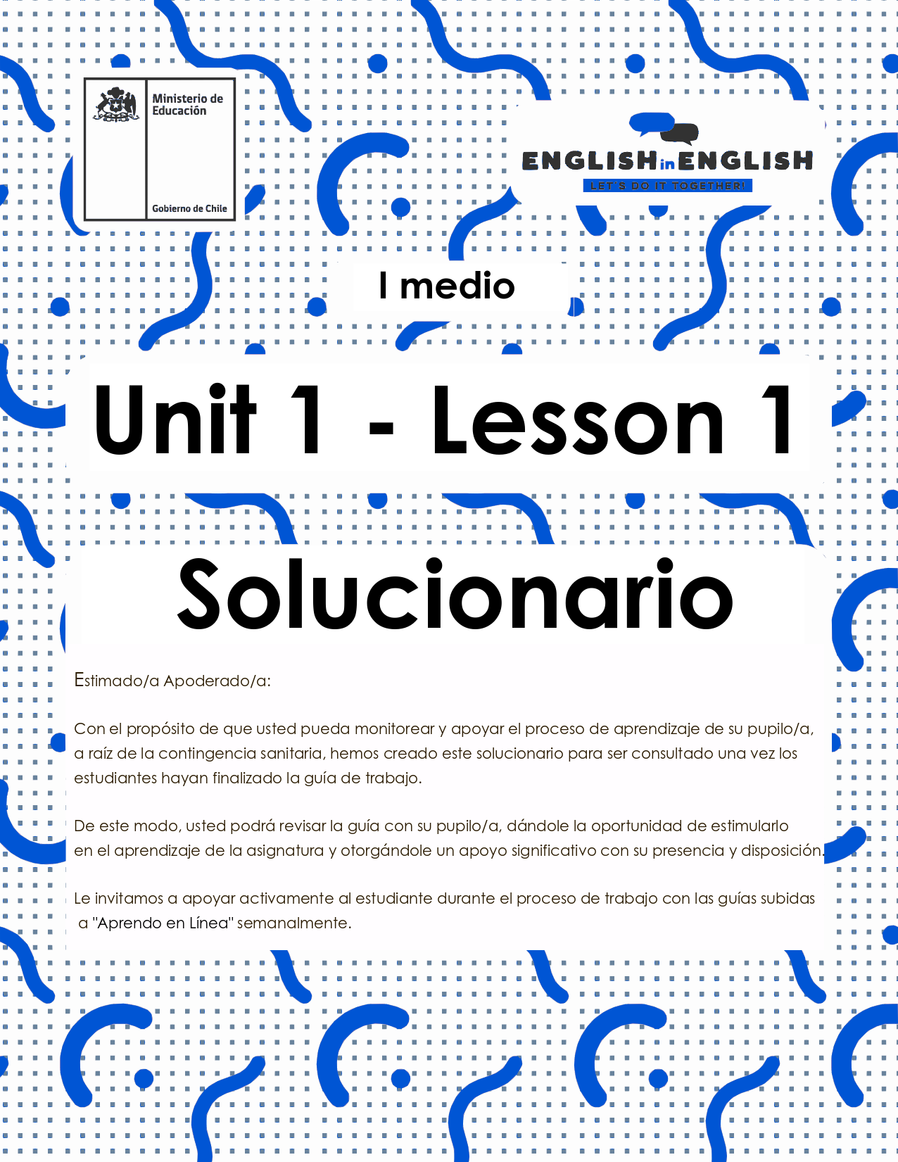

WEEK 1
VOCABULARY IN CONTEXT

ACTIVITY 1: GETTING READY

1. Look at the picture below, which jobs can you recognize?


1) Nurse
2) Doctor
3) Receptionist /secretary
4) Chef
5) Engineer/ Construction worker
2. Do you know what things can be asked in a job interview?
The following concepts can help you a little bit more.
- Link concepts from column A to their meanings in column B, as in the example:

A B
SKILLS AND ABILITIES
FULL-TIME JOB
PART-TIME JOB
GRADUATED FROM
JOB STABILITY
CHEERFUL
PUNCTUAL
RESPONSIBLE
SALARY EXPECTATIONS
JOB INTERVIEW
A form of employment that involves less hours per week than a full-time job. Sometimes you must work only in weekends.
Happy and positive.
Someone who is always on time.
The knowledge to do something well.
What you expect to earn as a salary for your job.
A formal meeting in which an applicant is asked questions to determine their suitability for a particular job.
Work a number of hours defined by their employer. 45 hours is the maximum in Chile.
Related to the place where you finished your studies.
Having an obligation to do something, or having control over or care for someone, as part of one's job or role.
Continuance at a job without change;
permanence.

ACTIVITY 2: LET’S PRACTICE
3. Complete the interview with the information in the box.
- You can use them more than once.

EXCELLENT WORKER WHAT SKILLS AND ABILITIES A FULL-TIME JOB

WHAT ARE YOUR PERSONAL TRAINER I GRADUATED FROM QUITE CHEERFUL


Personal trainer
Interviewer: So, Kylie, you are a qualified __________________________, aren’t you?
I graduated from
Kylie: Yes, I am. _______________________ the Fitness Academy last year.
Personal trainer
Interviewer: Why did you decide to become a _____________________________?
Kylie: Well, I have loved exercising and sports since I was a small kid.
a full-time job
Interviewer: Really? I understand that you are not interested in ___________________, are you?
a full-time job
Kylie: Ideally, I’d like a part-time job, but a _______________________ would be great, too.
Interviewer: Tell me Kylie, what is the most important thing you are looking for in a job?
Kylie: Above all, job stability.
What skills and abilities
Interviewer: _________________________ can you contribute to this company?
quite cheerful
Kylie: Skills and abilities? I think I’m responsible, I’m ________________________ and I’m a hard worker willing to help people get healthier.
What are your
Interviewer: That’s interesting. ______________________ salary expectations?
Kylie: I know I’m just starting so my salary expectations are not excessive.
Interviewer: And is there anything else you would like to add?
excellent worker
Kylie: I’m an honest person and if you hire me, you’ll get an _______________________.
4. Read the jobs descriptions and complete the crossword.
- You can use the Pictionary at the end for extra help.
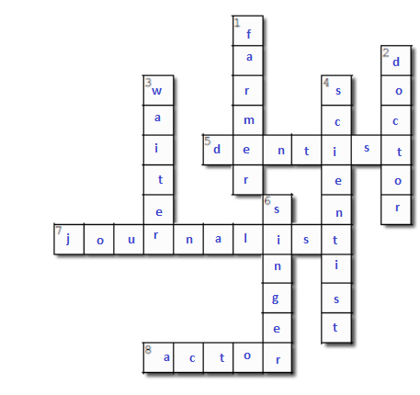
HORIZONTAL | VERTICAL
5. A person who removes and repairs teeth.  7. A person who gathers information, writes news pieces, and presents the news.  8. A person who acts a character in a performance (movie, play). | 1. A person who manages farms, ranches, and greenhouses.  2. A person who is qualified in medicine and treats people who are ill.  3. A person who takes orders and serve food and beverages in a restaurant.  4. A person who carries out experiments and investigations.  6. A person who vocalizes musical sounds and uses his or her own voice to produce music.
5. Complete the mind map with the professions in the box.
- You can use the Pictionary at the end for extra help.

TEACHER NURSE DOCTOR MANAGER CHEF

BUILDER VET BUS DRIVER

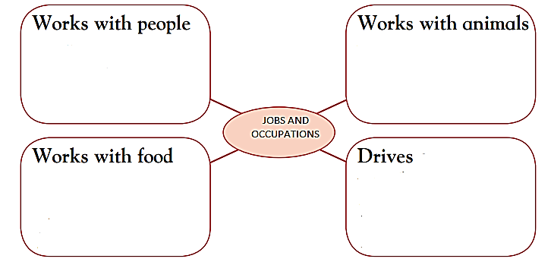
Chef

Bus driver
Vet

Teacher, Nurse
Doctor, manager
Builder

ACTIVITY 3: THINK AND REVIEW

6. Think about yourself ten years in the future.
- Choose an occupation you would like to work at and an occupation you would never do (and indicate why).
- Think about your own skills and interests.
- Follow the structure given in the example.
Example:
- I would like to be a translator because I like languages.
- I would never be a police officer because I don’t like uniforms.
a teacher because I like helping students.
- I would like to be _______________________________________________________.
a chef because I don’t like cooking.
- I would never be _______________________________________________________.

UNIT 1 PICTIONARY
