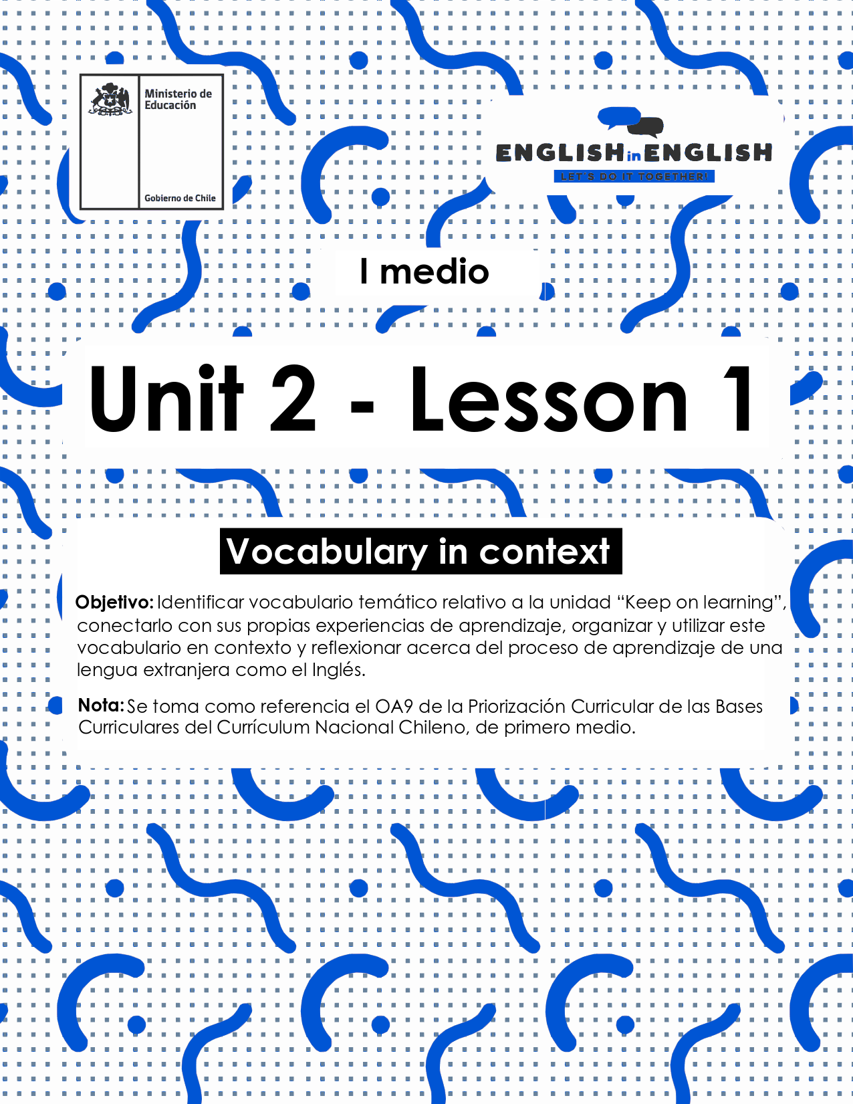
LESSON 1
VOCABULARY IN CONTEXT

ÚTILES RECOMENDADOS:
- Texto del estudiante 1° Medio
- Cuaderno de inglés o 2 hojas en blanco.
- Lápiz grafito y goma.
- Pictionary (Incorporado al final de esta guía)

SECTION 1: SETTING THE CONTEXT

- Look at the pictures and examine each one carefully.

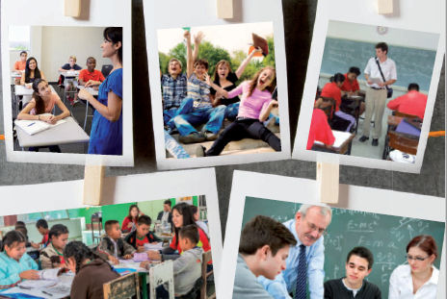

- Reflect about what you saw in the pictures.
- Think about people, places, materials, and actions performed.
- For example: Students, school, and study.
- Use the chart below to write your ideas.

Place(s) | People | Materials | Actions performed
(Source: Adapted from students’ book)

- Do you know the meaning of these words and phrasal verbs?
- Read the words and phrasal verbs with their definitions and match them to the corresponding picture like the example.
- You can use the Pictionary at the end for extra help.

Stress out:  To make someone feel nervous about something. |  | 
Bully:  To harm, laugh at, bother, or intimidate someone else. |  | 
Afford:  To have enough money to pay for. |  | 
Laugh at:  To make the noise with your voice that shows you think something is funny. |  | 
Learning:  The process of gaining knowledge and experience, for example by studying. |  | 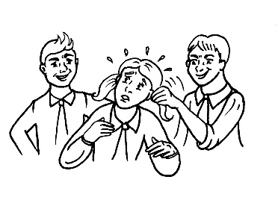
Message:  A piece of written or spoken information that you send to someone. |  | 
(Source: Original Material)
- Expand your vocabulary! Match the words and phrases related to Education with their definitions.

(Source: Taken from 1st Graders Student’s Book)

SECTION 2: LET’S PRACTICE

- Think about your school days.
- Do you remember your friends, teachers, and favourite activities you performed there?
- Read the following story about school days and use the words from the word bank to coherently complete it.

stressed out laugh at bullied

cruel messages cannot afford it learning

When I was at primary school, I never felt _________or unhappy. I have the best memories of my old school and classmates! We could always have a _________anything, we were never ________and we were __________ interesting things in most of the classes.
I am about to finish high school now and I have been studying very hard to complete all my online assignments. I have lots to print every week, but I____________, so I write down the answers in my copybook and send a picture to my teachers.
As we are not attending school, we have had to participate in forums as well. All opinions are accepted, but ___________are not allowed.

(Source: original material)

- Put the sentences into the correct order.
- The following sentences contain some words from activity 4 in the previous item.

- a real/ My summer job/ it was/ learning experience for me. / wasn’t fun but

______________________________________________________

- to attend/ Sophie/ a scholarship/ was awarded/ Boston University.

______________________________________________________
- through a series of/ The course/ lectures and seminars. / will be taught

______________________________________________________

(Source: Original Material-Sentences taken from MacMillan Dictionary)

SECTION 3: LET’S CONSTRUCT AND APPLY OUR KNOWLEDGE

- Reflect about your own experience learning English and define difficult and easy things about it.
- Use the graphic organizer bellow to organize your ideas.
(Source: Taken from 1st Graders Student’s Book)

SECTION 4: SPONGE ACTIVITY

- Select four new words from the ones you learned from this guide.
- Then, write a short sentence based on your school experience.
- Ex: I feel stressed out with my online assignments.
- You can use the Pictionary at the end for extra help.



SECTION 5: PICTIONARY
