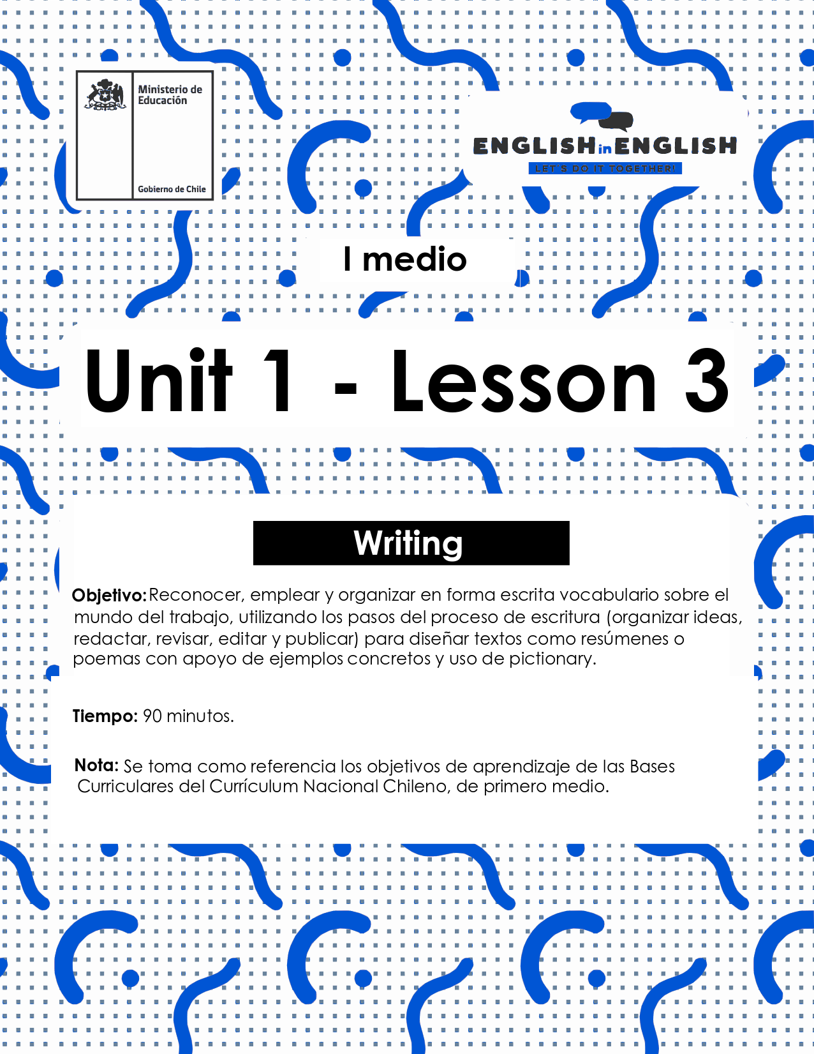

LESSON 3
WRITING SKILLS
ACTIVITY 1: GETTING READY
- Before you start, analyze the job advertisements below.
- Identify and underline what each applicant must do and the skills he / she must have.



- Think about a job or an occupation (usual or unusual) you would like to have.
- Use the prompts below to collect information about it.

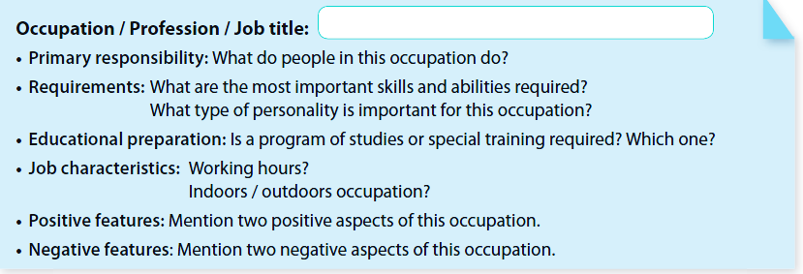
(Source: Adapted from 1st Graders’ Student’s Book)

Let’s Write!
DRAFTING
- Use the previous information to write some sentences about the job you would like to have. Follow the example below.
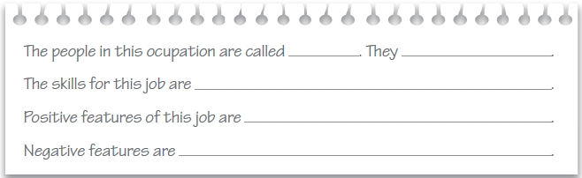

REVISING

- Put the sentences together into a paragraph.
- Use connectors to link your ideas and add words to make the paragraph more attractive to read.
- Look at the example and key words.

Example: The People in this occupation are called farmers and they are well organized and hard workers. The most important skills that people need for this job are interpersonal skills, but they also need to be efficient, productive and committed because farmers are an important part of the survival of our society by providing food. It is an important job but there is no 8-5 on the farm, they work long hours.

Key words: but – and – because – most important – that people need

The people in this occupation are called…

EDITING
- Read what you wrote and check for upper/lower case use, punctuation, and spelling.
- Evaluate your writing using the prompts in the box.

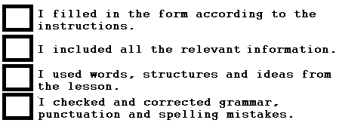

(Source: Adapted from 1st Graders’ Student’s Book)

ACTIVITY 2: GETTING READY
- Read these two poems and write as many characteristics of the jobs mentioned as you can find.

For example: Give less and expect more.

POEM
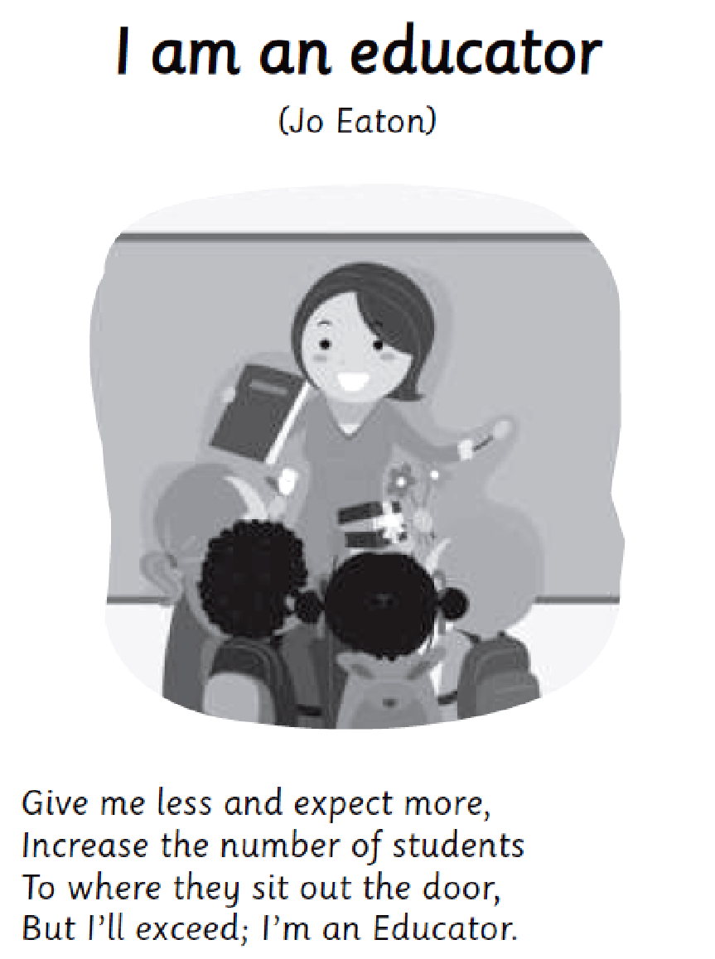 | 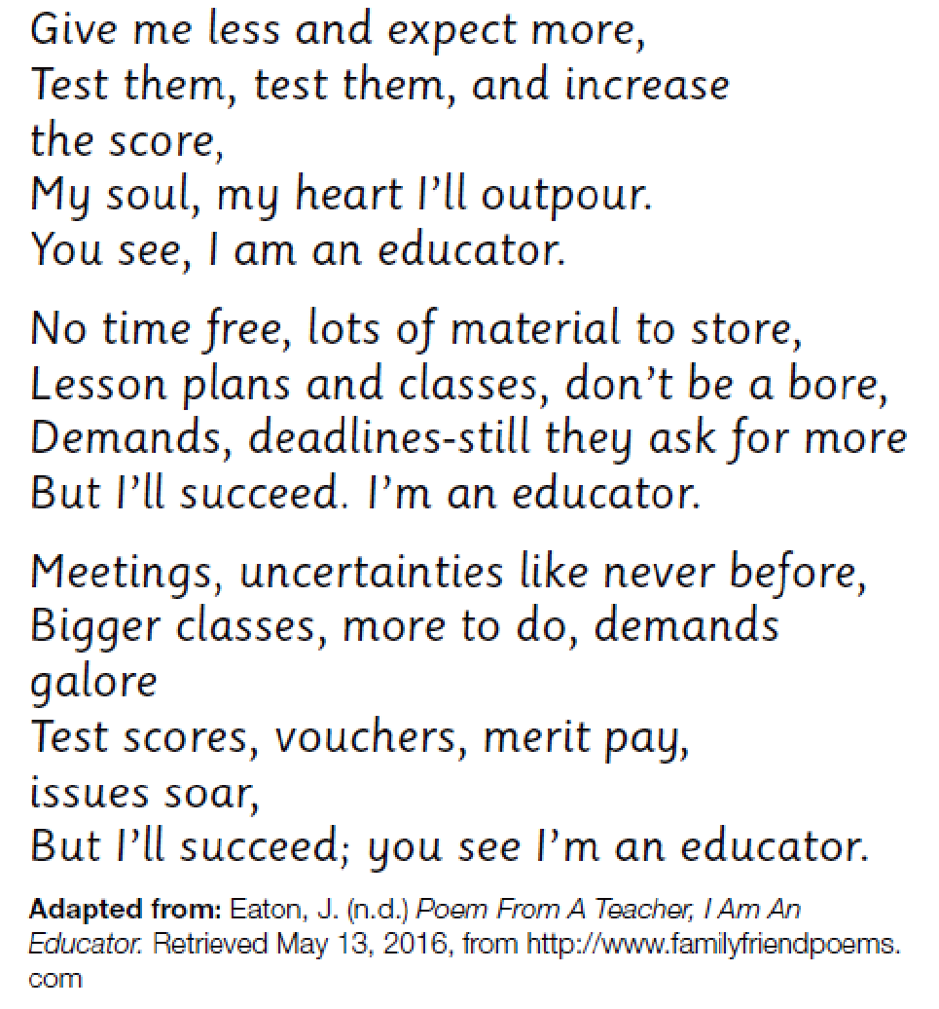

(Source: Taken from 1st Graders Teacher’s Book)
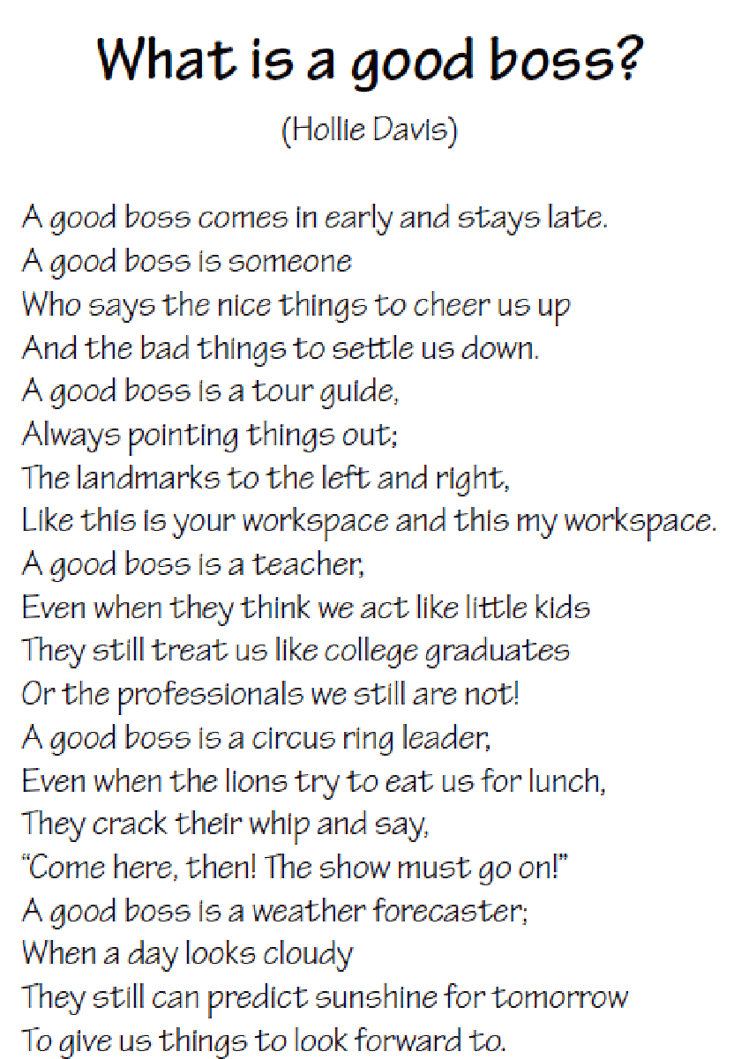 | 

Jobs’ characteristics
1.
2.
3.
4.
5.
6.
7.
(Source: Taken from 1st Graders Teacher’s Book)

- Now, list good and bad things about these two jobs in the poems.
- You can ask your parents or discuss with a friend to add extra information.

Good things | Bad things
(Source: Adapted from 1st Graders Teacher’s Book)

DRAFTING: WRITE YOUR OWN ACROSTIC POEM
- You can easily write an acrostic poem!
- Select a topic for your poem.
- You can think about any job, profession, or occupation.
- For example: teacher, journalist, doctor or any other you like.
- Use the pictionary provided in the first worksheet!

- Use this word map to identify important characteristics of the selected job.
Characteristics of this job
Ex. Well organized

JOB

Good things about this job
Ex. Visit different places.

Bad things about this job
Ex. No free time.

(Source: Adapted from 1st Graders National Syllabus)
REVISING
- Write the topic word vertically in the box. Be sure to capitalize each letter of the word.
- Start each line of the poem with the capital letters you wrote.
- Each line of the poem should consist of a word or phrase related to the topic. See the example below using the word poem.

Play with words
Open your mind
Everything is possible
My, what a great poem I wrote!

Try your own acrostic poem!
(Source: Adapted from 1st Graders National Syllabus www.readwritethink.org/files/resources/printouts/Acrostic%20Poem.pdf)
EDITING
- Read what you wrote and check for upper/lower case use, punctuation, and spelling.
- Evaluate your writing using the prompts in the box.

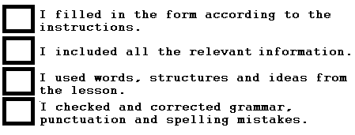

(Source: Adapted from 1st Graders’ Student’s Book)
SPONGE ACTIVITY

- Read these two emails, one is formal and the other informal.
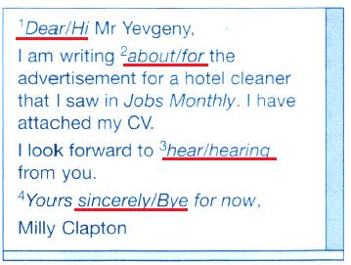
- Circle the correct answer.
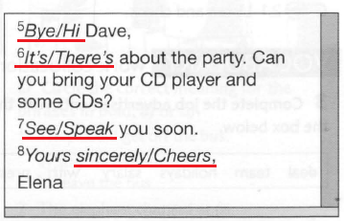
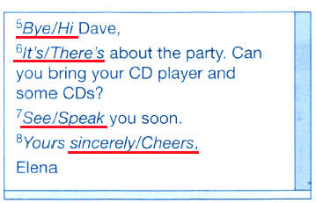
(Source: Adapted from Speakout pre-intermediate workbook by Antonia Clare & JJ Wilson)

