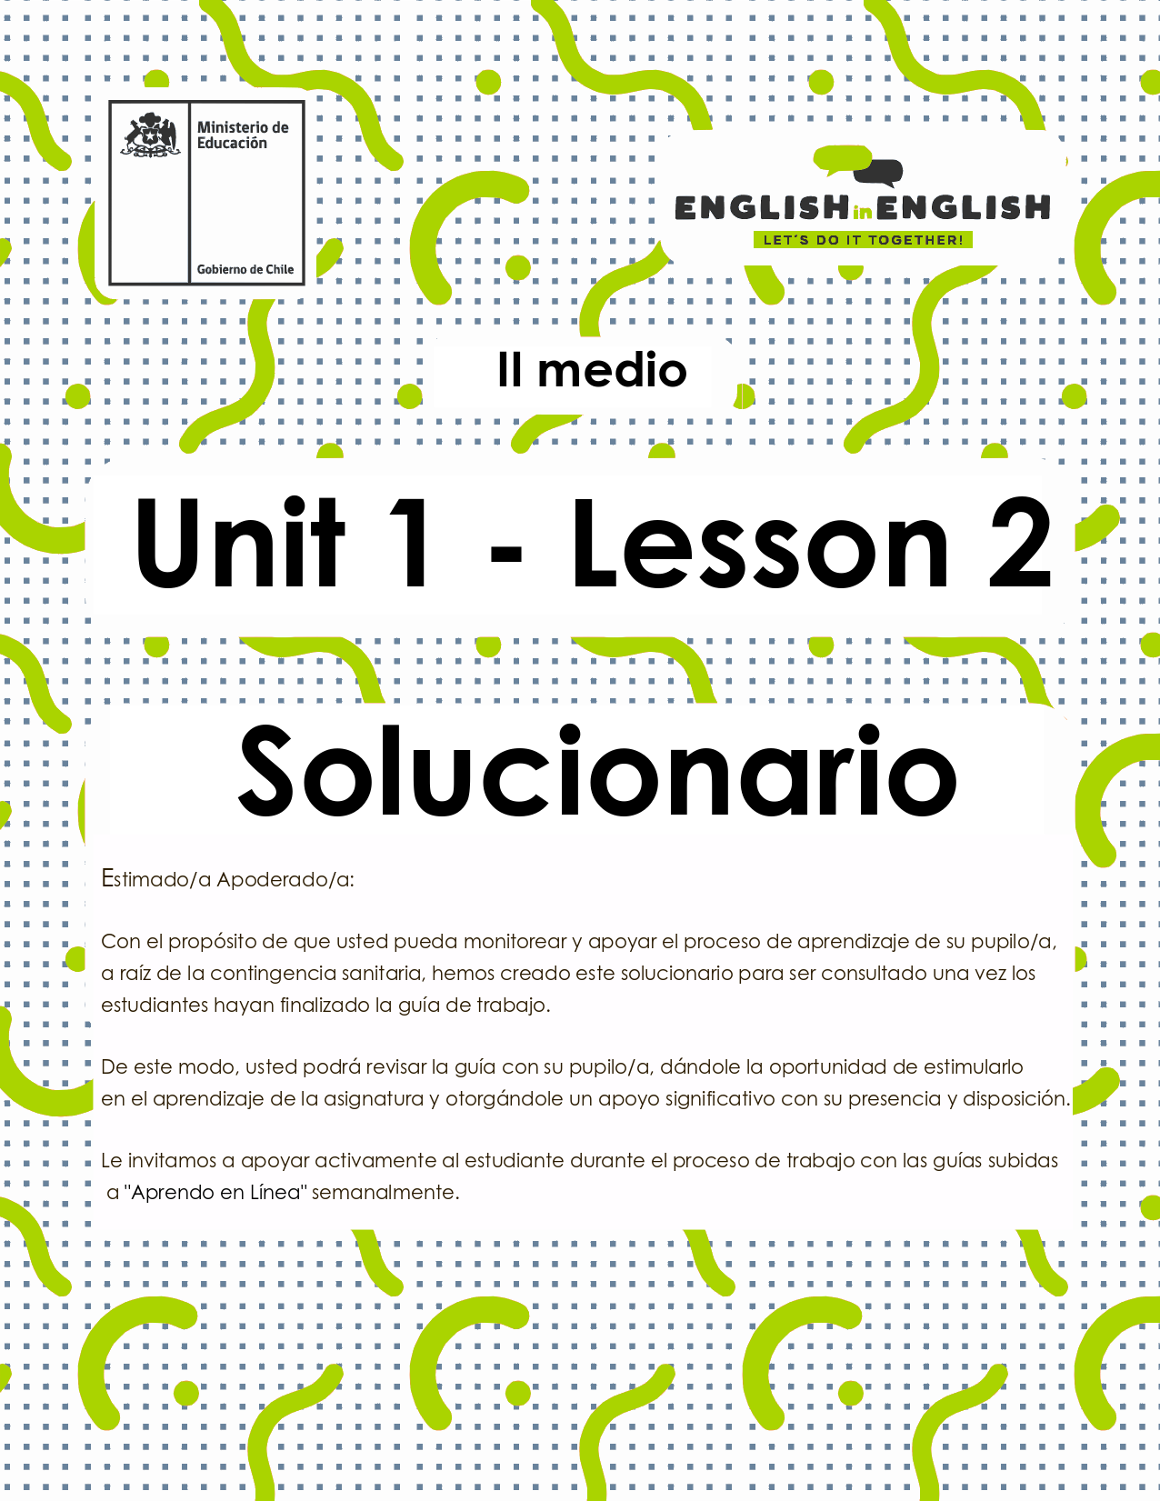

WEEK 2
READING COMPREHENSION

ACTIVITY 1: BEFORE READING

We all live globally! Think about all the TV programs you watch, the music you listen to and the food you eat or prepare at home… have you ever realised they come from different countries! Let’s see:
- At home, look around and find out the countries of origin of 10 different products you eat or use in your daily life. Follow the example.
Answers may vary
Product | Country of origin | Manufacturing origin
1. Smartphone | Korea | China
2.
3.
4.
5.
6.
7.
8.
9.
10.
(Source: Original material)

- Read this short story and answer questions a – e.

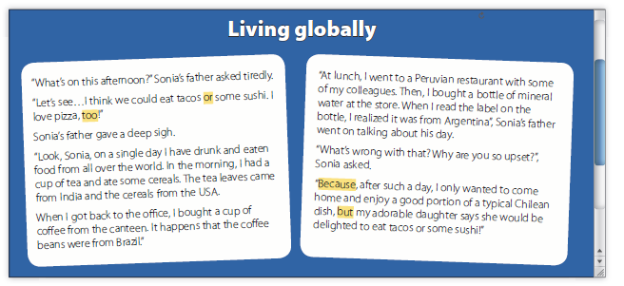
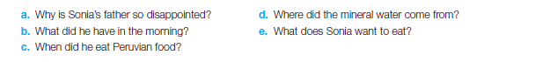

Answers
- Because he’s tired of eating foreign food every day and wants to eat some local food for dinner.
- A cup of tea and some cereals.
- At lunch.
- From Argentina.
- Tacos and some sushi.

- Read the text again and respond. Which of the highlighted words (because – but) introduce:
- Two alternatives : or _______________
- A reason: because_________________
- An additional idea: too_____________
- A contrast but____________________

ACTIVITY 2: READING
- Read the article carefully.
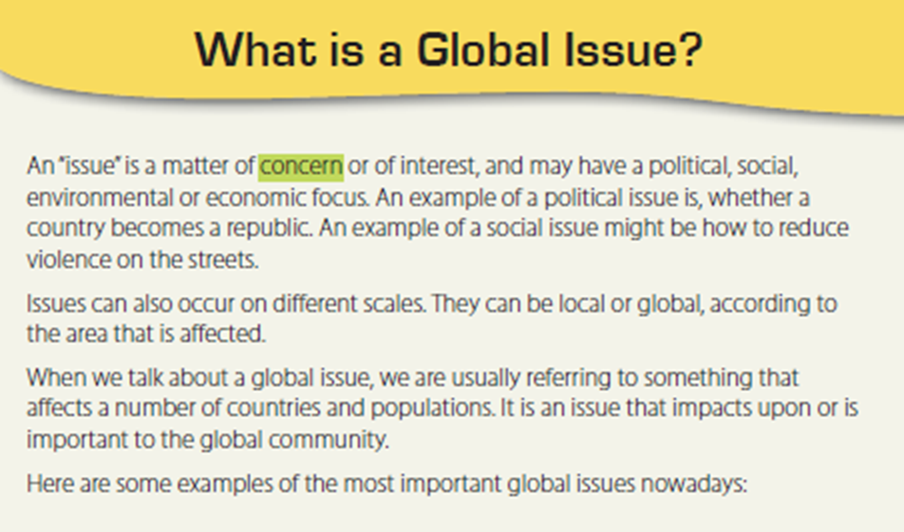
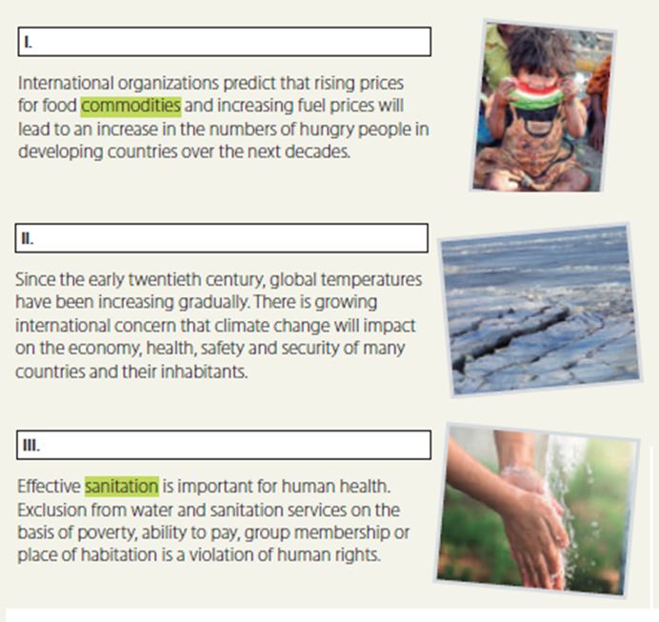

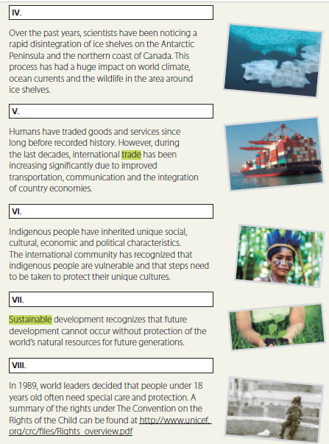

- Read the article again and identify the subtitle (a – h) for each paragraph (I- VIII)

c. Global food production.
b. Climate change.
h. Water shortage.
e. Ice shelf boundaries

d. Globalization.
f. Cultural diversity.
g. Sustainability of the planet.
a. Children’s rights

- Write T (true) or false (F) next to each statement.
a | When we talk about a global issue we are usually referring to something that affects a number of countries and populations. | T
b | Over the past years, scientists have been noticing a rapid disintegration of ice shelves. | T
c | Since the early twentieth century, global temperatures have been increasing gradually. | T
d | The international community has recognized that indigenous people are vulnerable and that steps need to be taken to protect their unique cultures. | T
e | It is impossible to find “The Convention on the  Rights of the Child” online. | F

ACTIVITY 3: AFTER YOU READ

Have another look at the reading text, reflect about it and answer the following questions: (Answers may vary)
- Which of these specific issues are affecting your town / city / area? Why?
- Are you personally concerned about any of these issues? Why? / Why not?
- What can you do in order to face the issues you identified?

ACTIVITY 4: SPONGE ACTIVITY
Write one word related with globalization from this worksheet or from the previous one, for each letter of the alphabet. You can use the Pictionary from last week for extra help.
Example: Communication for C. (answers may vary)
A | B | C | D
Agreement | Bank | Community | Diversity

E | F | G | H
Economy | Fuel | Global | Hungry

I | J | K | L
Issues | Justice | King | Local

M | N | O | P
membership | Needs | Ocean | Poverty

Q | R | S | T
Quality | Rights | Sustainable | Trade

U | V | W | X
Unique | Violence | Wildlife | Xenophobic

 | Y | Z
 | Yahoo | Zoom

(Source: Original material)

