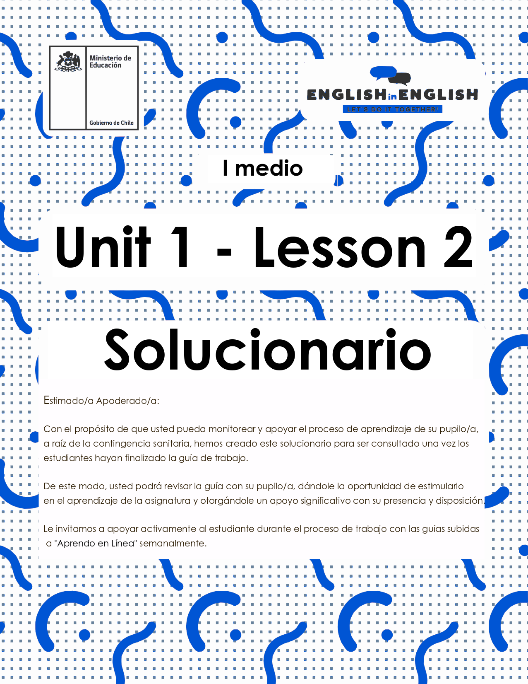

WEEK 2
READING COMPREHENSION

ACTIVITY 1: GETTING READY

- Read the following questions and reflect on them. Then, text two friends and ask them the questions to complete the chart.

 | What job would you love to have? Why? | Which skills or characteristics you need to develop this job?
Friend 1 | Answers may vary | Answers may vary
Friend 2 | Answers may vary | Answers may vary

- Read these business cards (1-3) carefully. In your own words, write a job description for each person.
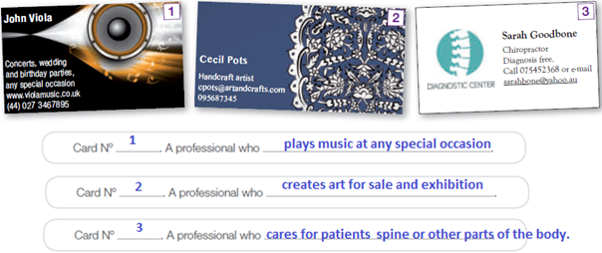

- After reading the previous business cards, answer the following questions.
(Answers may vary)
- Where can you find printed job advertisements?
I can find printed job advertisements in newspapers.

- What information do you usually find in business cards?
You usually find information about the salary, location, contact e-mail or phone.

- In what section of the newspaper would you look for job advertisements?
I would look for one in the Job advertisements section.

- What do you need to know before applying to a job?
First, I would look for the job description. Then I would look for the background of the company, how many people they would employ, what kind of work experience they require and the qualifications needed and the salary.

- What do you think is the best way to get a job?
A good way to find a job is talking to people who are already working in companies.

ACTIVITY 2: READING

- Read the advertisements below.
- likes traveling and getting to know the country.
Answer: picture III
- loves working indoors using IT skills.
Answer: picture IV
- doesn’t want to work nights and weekends.
Answer: picture II
- would love to do something that will let him / her meet people.
Answer: picture I
- doesn’t have any experience.
Answer: picture I
- wants some flexibility to keep on studying.
Answer: picture III

ACTIVITY 3: AFTER YOU READ

Based on the examples from activity 2, design your own job advertisement. Make sure you include the same categories but adding new information.

Think you are looking for a job. What would you expect from it in order to apply?

ACTIVITY 4: SPONGE ACTIVITY

Imagine you are looking for a job, list the personal characteristics or abilities you have, using the letters of your name. You can use the Pictionary for extra help.
- Example: SUE → S: sociable, U: unique, E: empathic
(Answers may vary)
LETTERS OF YOUR NAME | CHARACTERISTIC

(Source: Original material)

EXTRA: PICTIONARY


