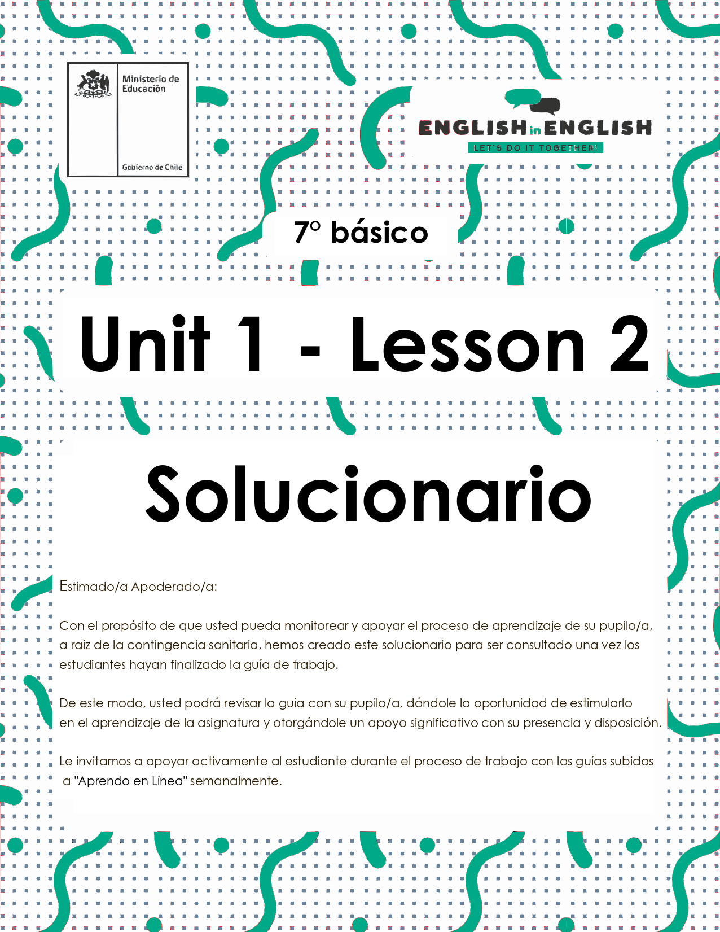

WEEK 2
READING COMPREHENSION

ÚTILES
- Tu cuaderno de inglés y/u hojas en blanco
- Lápiz grafito, goma, regla.
- Marcadores de colores y/o lápices de colores

ACTIVITY 1: BEFORE READING,

(TIEMPO ESTIMADO: 20 MINUTOS)

- Answer the following questions.
Responde las siguientes preguntas.
*RESPUESTAS ABIERTAS

Do you like reading poems? | YES | NO
What is your favorite poem? | example: Poem XX
Which is the last poem you read? | example: Be like a bird

2.- Read the following poem.
Lee el siguiente poema.
(Tiempo estimado: 10 minutos)

"Hope" is the thing with feathers
By Emily Dickinson

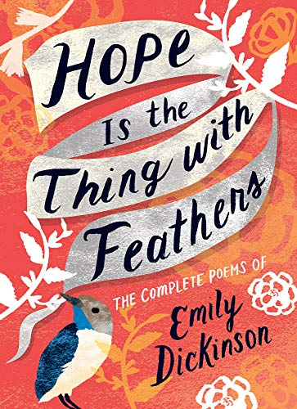

"Hope" is the thing with feathers—
That perches in the soul—
And sings the tune without the words—
And never stops—at all—

And sweetest—in the Gale—is heard—
And sore must be the storm—
That could abash the little Bird
That kept so many warm—

I've heard it in the chillest land—
And on the strangest Sea—
Yet, never, in Extremity,
It asked a crumb—of Me.

GALE = very strong wind PERCHES = sits ABASH = embarras
CRUMB = a small piece of bread Chillest = coldness

ACTIVITY 2: WHILE READING
(Tiempo estimado: 20 minutos)

1.- Look at the title and image of the poem. What is the topic of the poem? .
Observa el título y la imagen del poema. ¿Cuál es el tema del poema?

HOPE

2.- Mark with an X the correct answer. Marca con una X la respuesta correcta.

What type of text is it?
Narrative
Descriptive
Informative
Lyric | X

3.- What is the central idea of the poem?
- Hope is everywhere.
- Hope is only in God.
- Hope asks for many things.
- Birds take your hope away.

4.- Which line suggests that hope can be found everywhere?
- 3 : and sings the tune without the words
- 7 : that could abash the little bird
- 9 : I´ve heard it in the chillest land
- 11: yet,never, in Extremity

ACTIVITY 3: AFTER READING
(Tiempo estimado: 30 minutos)

1.- Draw an image that represents the poem.
Dibuja una imagen que represente al poema.
- SE ACEPTAN TODAS LAS IMÁGENES RELACIONADAS CON EL TEMA DEL POEMA.

example:


2.- Circle the emotions you can recognize in the poem.
Haz un círculo en las emociones que puedas reconocer en el poema.

Happy | Optimistic | Hopeful | Angry | Sad | Embarrased
 |  |  |  |  | 

3.- Complete the following diagram with the emotions you recognize in the poem and the emotions you feel now.
Completa el siguiente diagrama con las emociones que reconoces en el poema y las emociones que tu sientes ahora.
LAS RESPUESTAS DEPENDERÁN DE LAS EMOCIONES QUE CADA UNO SIENTA.

Example:
HOPE

Poem
Example:
FAITHFUL
Me
ACTIVITY 4: EXTRACURRICULAR
(Tiempo estimado: 20 minutos)

What is an acrostic poem?
¿Qué es un poema acróstico?
- An acrostic poem is a poem where the first letter of each line (or the last letter of each line) spells out a specific word.

Creating an Acrostic in Five Easy Steps:
Crear un Acróstico en 5 fáciles pasos:

1. Decide what to write about.
2. Write your word down vertically.
3. Brainstorm words or phrases that describe your idea.
4. Place your brainstormed words or phrases on the lines that begin with the same letters.
5. Fill in the rest of the lines to create a poem.

Example:
Ejemplo de acróstico:
L oyal
Optimistic
braVe
Energetic

1.- Create an acrostic with the word HOPE.
Crea un acróstico con la palabra “HOPE”.

H | aving
O | nly
P | ositive
E | nergy

